EPISODE 26
6th September 2022

KEY LEARNING
Students will view a range of BTN stories and use comprehension skills to respond to a series of focus questions.

CURRICULUM
English – Year 4
Use comprehension strategies to build literal and inferred meaning to expand content knowledge, integrating and linking ideas and analysing and evaluating texts.

English – Year 5
Use comprehension strategies to analyse information, integrating and linking ideas from a variety of print and digital sources.

English – Year 6
Use comprehension strategies to interpret and analyse information and ideas, comparing content from a variety of textual sources including media and digital texts.

English – Year 7
Use comprehension strategies to interpret, analyse and synthesise ideas and information, critiquing ideas and issues from a variety of textual sources.
  - Teacher Resource

Focus Questions
As a class, discuss the stories featured in the episode of BTN Classroom and record the main points of the discussion. Students will then respond to the following focus questions.

Future of Jobs
- What was the job of a knocker upper?
- What topics were discussed at last week's national Jobs and Skills Summit? Give at least one example.
- What is automation?
- What does AI stand for?
- What year do experts think that AI technology could replace up to half of the work that is done today?
  - 2023
  - 2030
  - 3000

Check out the teacher resource on the Teachers page.

Artemis Launch
- When was the last mission to the Moon?
- The first Artemis mission will have astronauts on the spacecraft. True or false?
- What is the name of the spacecraft being used in the Artemis mission?
- Where is the Kennedy Space Centre?
  - Florida
  - Houston
  - Washington DC
- Which two astronauts will step on the Moon as part of the Artemis program?

Check out the teacher resource on the Teachers page.

Advertising Laws
- Where have you seen junk food ads? Discuss as a class.
- There is evidence to show that there is a direct link between junk food advertising and rates of ________.
- In the UK they will restrict junk food advertising before what time on television?
  - 9am
  - 12midday
  - 9pm
- What percent of people in Australia want to ban junk food ads during children’s viewing?
- What do you think should happen? Discuss in pairs.

Magpie Season
- Have you been swooped by or know someone that’s been swooped by a magpie? Discuss in pairs.
- When does magpie swooping season start?
  - Summer
  - Autumn
  - Spring
  - Winter
- Approximately how many weeks do magpies swoop for?
- Why do magpies swoop people?
- Magpies have very good memories. True or false?

Charlotte from Warakurna - Heywire
- Where is the Gibson desert?
- What bush food does Charlotte collect?
- What is the landscape of Yirriya? Describe.
- Why do camels come into Charlotte’s community?
- What damage do camels do to the environment?

EPISODE 26
6th September 2022

KEY LEARNING
Students will explore jobs of the future and the role Artificial Intelligence will play.

CURRICULUM
Science – Year 4
Science Knowledge helps people to understand the effect of their actions.

Science – Year 5 & 6
Scientific knowledge is used to solve problems and inform personal and community decisions.

  - Teacher Resource

Future of Work

Focus Questions
Discuss the BTN story as a class and record the main points of the discussion. Students will then respond to the following:
- What was the job of a knocker upper?
- What topics were discussed at last week's national Jobs and Skills Summit? Give at least one example.
- What is automation?
- What does AI stand for?
- What year do experts think that AI technology could replace up to half of the work that is done today?

Activity: Note taking
Students will practise their note-taking skills while watching the BTN Future of Work story. After watching the story, ask students to reflect on and organise the information into three categories. What information in the story was...?
- Positive
- Negative or
- Interesting

Activity: Class Discussion
Discuss the BTN Future of Work story as a class. What questions do students have about the story? Use the following questions to help guide discussion:
- Think of a job that used to exist but doesn’t now.
- What impact has technology had on jobs changing?
- What is artificial intelligence?
- What are some examples of artificial intelligence?
- Which jobs may be done by robots in the future?
- Give an example of a job that will change in the future?
- In pairs, brainstorm a list of jobs that haven’t been invented yet.
- Experts say that kids are going to have lots of different jobs over their working life. Do you like the idea of doing lots of jobs over your lifetime? Give reasons for your answer.

Activity: Glossary
Students will brainstorm a list of key words that relate to the BTN Future of Work story. Here are some words to get them started.
ARTIFICIAL INTELLIGENCE | AUTOMATION | CAREER
EMPLOYMENT | MEGATRENDS | ROBOT

Activity: Inquiry Research
After watching the BTN Future of Work story, hold a discussion to encourage students to engage with the topic and learn more about the future of jobs and the role artificial intelligence might have. What questions were raised in the discussion and what are the gaps in students’ knowledge? The following KWLH organiser provides students with a framework to explore their knowledge on this topic.

What do I know? | What do I want to know? | What have I learnt? | How will I find out?

Students will develop their own question/s to research or choose one or more of the questions below. Encourage students to collect and record information from a wide variety of sources and present the information they find in an interesting way.

- How do you think artificial intelligence will impact on the future of work?
- How can artificial intelligence be used in creative jobs?
- Are there any jobs that shouldn’t use AI? Why?
- How can we prepare for artificial intelligence?
- Find out the jobs your parents and grandparents have had. What was surprising? Share with another student.
- Choose a job you would like to know more about. Research the job and present the information to a small group or class.

Activity: Could a robot do your job?
Look at the ABC interactive Could a robot do your job? then respond to the following:
- Choose five jobs to search for and record what percentage is more likely to be automated. Record some of the tasks that could be automated. Which tasks will still need to be done by humans?
- Which jobs face the biggest risk of automation? Which face the lowest risk of automation?
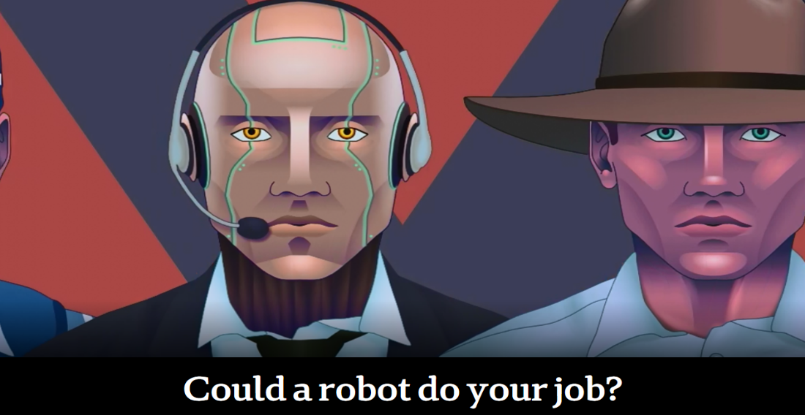
- What was the most surprising thing you learnt?

BTN Stories
As a class watch one or more of the following BTN stories to learn about the future of jobs and the impact of artificial intelligence on work. After watching any one of the BTN videos ask students to respond to the discussion questions (to find the discussion questions and teacher resources go to the related BTN Classroom Episode and download the Episode Package).
Future Jobs | 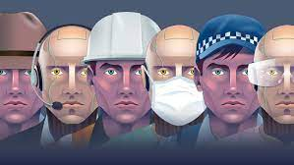  Robot Jobs | 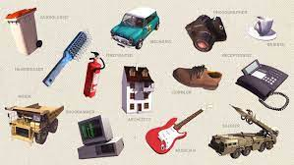  Future Careers
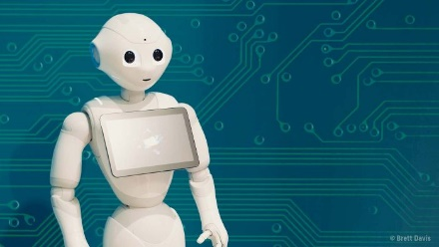  Artificial Intelligence Jobs | 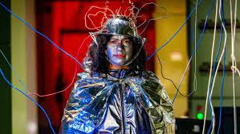  Sentient AI | 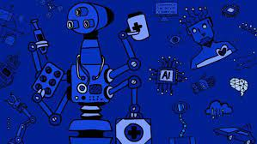  Robot Revolution

Useful Websites

National jobs summit a chance for Australia to hit reset on artificial intelligence, say business leaders – ABC News
- Women in industries under threat from AI and automation urged to `upskill’ – ABC News
- Future Jobs – BTN
- Artificial Intelligence – BTN
- Robot Jobs – BTN

EPISODE 26
6th September 2022

KEY LEARNING
Students will learn more about NASA’s plan to go back to the Moon with the Artemis mission.

CURRICULUM
Science – Year 5
Scientific understandings, discoveries and inventions are used to solve problems that directly affect peoples’ lives.

The Earth is part of a system of planets orbiting around a star (the sun).

Science – Years 5 & 6
Scientific knowledge is used to solve problems and inform personal and community decisions.
Science – Year 6
The growth and survival of living things are affected by the physical conditions of their environment.
Science – Year 7
Predictable phenomena on Earth, including seasons and eclipses, are caused by the relative positions of the sun, Earth and the moon.
Scientific knowledge has changed peoples’ understanding of the world and is refined as new evidence becomes available.

  - Teacher Resource

Artemis Launch

Focus Questions
Discuss the BTN story as a class and record the main points of the discussion. Students will then respond to the following:
- When was the last mission to the Moon?
- The first Artemis mission will have astronauts on the spacecraft. True or false?
- What is the name of the spacecraft being used in the Artemis mission?
- Where is the Kennedy Space Centre?
- Which two astronauts will step on the Moon as part of the Artemis program?

Activity: Moon Quiz
Begin the Artemis activity with a quick true or false quiz. Circle the correct answer.

- Man first walked on the Moon in 1969. | True False
- In Greek mythology, Artemis is the twin sister of Apollo and goddess of the Moon. | True False
- Humans can breathe easily on the Moon because the atmosphere is similar to that on Earth. | True False
- The temperature on the Moon is similar to temperatures on Earth. | True False
- From Earth, we always see the same side of the Moon. | True False
Answers: 1 True, 2 True, 3 False, 4 False, 5 True

Activity: Class Discussion
Students will discuss the BTN story in pairs and then share their thoughts with the class.
- When was NASA’s last mission to the Moon?
- What is the aim of the Artemis 1 mission?
- Is space exploration important? Why or why not?
- What questions do you have about the Artemis Launch story?

Activity: Glossary
Students will brainstorm a list of key words that relate to the BTN Artemis Launch story. Here are some words to get them started.
LUNAR | MISSION | EXPLORATION
UNCREWED | ORBIT | GRAVITATIONAL PULL

Activity: KWLH
Discuss the information raised in the BTN Artemis Launch story. What questions were raised in the discussion and what are the gaps in students’ knowledge? The following KWLH organiser provides students with a framework to explore their knowledge on this topic.

What do I know? | What do I want to know? | What have I learnt? | How will I find out?

Students will develop their own question/s to research or choose one or more of the questions below.

- Research and prepare a profile on Earth’s Moon. Include the following information: distance from Earth, how long it takes to orbit Earth, the minimum/maximum temperatures of the Moon and geographical features of the Moon. Include any other interesting facts you find.
- What are the relationships between Earth, the Moon and the Sun? Draw a diagram showing the relative sizes and movement of Earth, the Moon and the Sun. In your description include words like orbit, revolution and axis.
- How does gravity affect the Moon? Investigate Earth’s gravitational pull on the Moon and explain why we only ever see one side of the Moon.
- Investigate why the discovery of water on the Moon is significant. Apart from drinking, how can it be used?
- How can we see the Moon? Explain why we can sometimes see the Moon during the day.
- Can humans survive and thrive on the Moon?
- Who are the astronauts on the Artemis mission? Find out more about the men and women who have been selected for future missions.
- What is Australia’s involvement in the Artemis mission?

Activity: Lunar Living
Students will explore the possibility of one day living on the Moon. They can watch The Living on the Moon video and the BTN Moon Living video to as a starting point for their research. Students will then find out more about the conditions on the Moon so they can plan and design a settlement on the Moon that will sustain human life. Things they will need to consider include:

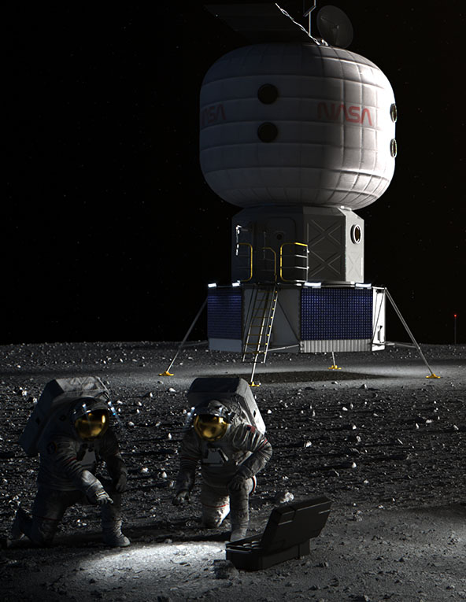
- What are the three basic things we need to survive?
- What are the conditions like on the Moon?
- What needs to be considered when planning a colony on the Moon? For example:
  - Water supply
  - Atmosphere
  - Temperature
  - Solar radiation
  - Food Production
  - Waste Management
  - Gravity
- What materials could be used to build a space settlement? Investigate the idea of using Moon dust and Sulphur to make bricks.
- What do you think it would be like to live on the Moon?
- What are the benefits of having a space settlement on the Moon?
- What are the challenges?

Further Investigation
Find out more about the Artemis Base Camp - NASA’s plan for a lunar colony.

Activity: What would you pack for the Moon?
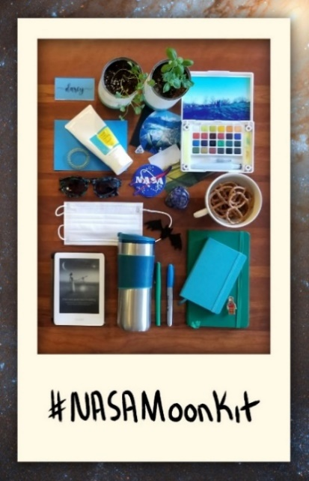
What would you pack in your lunar suitcase if you were going to the Moon? Astronauts on the International Space Station are only allowed a 12.7cm x 20.3cm x 5.1cm case to carry personal belongings. Students can challenge themselves to select items that fit within this space. Ask them to make a list of what they would pack and their reason for taking it. Students can share their suitcases with the class.

Activity: Apollo 11 Mission
Artemis 1 is NASA’s first mission to the Moon since Apollo. Students will explore the Apollo 11 space mission in detail and use the following questions to guide their research.
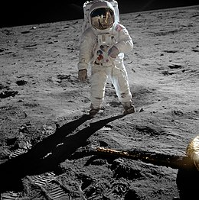
- Summarise the mission.
- When did the mission take place?
- What was the purpose of the mission?
- Who was the crew? What were their roles?
- What did the mission discover?
- Which countries were involved in the mission?
- How has the mission helped us understand the Solar System and beyond?
- What were some challenges of the mission?
- Include photographs and diagrams in your research project.

Source of image
Further investigation
Students will choose one of the following to investigate further:
- Imagine you are one of the astronauts on the Apollo 11 mission. Write a journal entry in your diary about your experiences before, during or after the mission.
- How has space exploration changed since the first landing on the Moon? Make comparisons between now and then. Make predictions about future space missions and exploration. Include illustrations with your prediction.

Useful Websites
- Artemis – NASA
- Moon Water Discovery – BTN
- Moon Landing Anniversary Special – BTN
- NASA Artemis: Newsround’s guide to the next Moon missions – Newsround
- Moon Exploration – BTN
- Track Artemis 1 Mission in real time – NASA

  - Teacher Resource

BTN Transcript: Episode 26- 6/9/2022

Hey, I'm Amelia Moseley and you're watching BTN. Thanks for hanging out with us again. Let’s check out what’s coming up on today’s show. We find out about NASA's upcoming mission to the Moon, should junk food ads be kept off kids TV? And how to stay safe around swooping magpies.

Future of Work

Reporter: Joe Baronio

INTRO: But first today, let's talk about the future of jobs because that's what the government, experts and business leaders were all talking about at a big jobs summit in Canberra last week. Here's Joe to explain.
JOE: So, tell me, what's on your mind?
ROBOT: [Electronic noises]
JOE: Mmhmm, yes.
ROBOT: [Electronic noises]
JOE: I think what you said was your job is stressing you out?
ROBOT: [Electronic noises]
JOE: Oh, you're looking for a career change? Well, let's talk about that, shall we? Oh, what do you want to do?
A robot careers counsellor might seem like a little farfetched as a job right now, but you never know what the future might hold.

JOE: You could be a Teletubby, nobody’s thought of that before. Why don’t we bring back the Teletubby?

Some of the jobs we do now would seem weird to people in the past, and there are plenty of jobs from the past that seem weird to us. Like knocker uppers, whose job it was to wake people up by tapping on their windows, or aircraft listeners, who, well, listened for aircraft during the war. But as technology advanced and society changed, so did people's jobs, and the same thing is happening now. That was one of the big topics being discussed at last week's national Jobs and Skills Summit, where hundreds of experts, businesses, and members of the government got together to talk about, you guessed it, jobs. They looked at things like wages, equality in the workplace, how to get people into jobs, and how to prepare for future jobs.
So, what do experts think the future will hold? Well, we don't know for sure, but we can look at some big global trends, or megatrends, that could impact the future of work, like automation. That's basically robots doing the jobs humans used to do.
ROBOT: [Electronic noises]
JOE: Oh, you want to be a BTN reporter? interesting, my great grandfather was one of those. Is that show still going?
Robots have been working in places like factories and warehouses for quite a while, but now we're seeing them in new roles that used to be done by humans, and it's not just robot labour. We're also using a lot more robotic brainpower or artificial intelligence. AI helps us to navigate, investigate, and operate, and as it's gets better, it could even start doing the more creative jobs that used to be just for humans. In fact, experts reckon that by 2030, AI tech could replace as much as half of the work that is done today.
JOE: Who knows? Maybe one day one of you will take my job.

ROBOT: [Electronic noises]

JOE: Oh, that's possible, isn't it?

ROBOT: [Electronic noises]
Technology could also change how and where we work. In the last couple of years, we've already seen a lot of people working from home and developments like virtual reality could make that even easier. Another megatrend driving the future of jobs is climate change. Countries around the world are shifting away from fossil fuels, and that's having a big impact on people who work in those industries. But it's also creating new types of jobs and opportunities.
Experts reckon it's important to be aware of trends like these so that you guys can be ready for your future job, whatever that may be.
ROBOT: [Electronic noises]
JOE: Yeah, I think I need a career change too. Maybe I should try that BTN reporter thing you mentioned earlier. Yeah, there’s your notes, good luck.

Mikhail Gorbachev

Reporter: Cale Matthews

INTRO: People around the world are remembering Mikhail Gorbachev who died at the age of 91. The former world leader and winner of the Nobel Peace Prize is seen as one of the most important people of the last century and Cale found out how he helped change the world.

Mikhail Gorbachev was one of the most influential people of the 20th century. In 1985 he took over and ultimately became the last leader of the Soviet Union. That was a collection of countries formed in the 1920s, the biggest of which is now Russia. It was communist and the government controlled a lot of what people could say and do. After World War II, tensions between the Soviet Union and another big superpower, the USA, led to what's known as the Cold War. The Soviets separated themselves from the world, both politically and literally, putting up the Berlin Wall, dividing West Germany and its communist neighbour East Germany. When Gorbachev came to power things began to change. He had meetings with the US President Ronald Reagan because he was worried about nuclear war.

In 1989 the Berlin Wall was taken down and many people saw this as the end of the Cold War. Change didn't stop there. Gorbachev introduced a policy called "Glasnost", which translates to openness. It encouraged freedom of speech, and criticism of leaders in the Soviet Union. Protests started popping up and countries declared their independence. Pretty quickly, even though it wasn't exactly his goal, the Soviet Union collapsed and while a lot of people in Russia were angry at him, he was praised around the world. Mr Gorbachev won the 1990 Nobel Peace Prize for his role in ending the Cold War and today he's still being remembered as someone who changed the course of history.

Artemis Launch

Reporter: Jack Evans

INTRO: Over in Florida, a lot of people have been anxiously waiting for a very big rocket to take off. NASA's Artemis mission was supposed to have launched by now, but sadly, things haven't quite gone to plan. Still, Jack thought he'd find out more about Artemis and what will happen when it finally lifts off.

WESLEY: Yes, hello, my name is Wesley, and I'm a werewolf. Well, it's a bit of a long story, I was bitten by a werewolf on a full moon and now I am one, I guess that wasn't really a long story, was it? Needless to say, I'm now obsessed with the Moon. Yeah, so, when I found out that NASA was planning a trip to the Moon, I thought, gee, I got to get in on that. Yes, hello NASA.
Yep, NASA is heading to the Moon. Unfortunately, I don't think werewolves are invited.
WESLEY: Alright, well all I'm saying is just watch out on a full moon that I'm not around. Sorry I didn't mean that.
For the first time since Apollo 17 back in 1972 people will get to do this again. It's part of a program called Artemis, which will involve several missions, and eventually aims to set up a long-term human presence on the Moon. So, I bet you're probably wondering.
WESLEY: Hooowl.
Ah no, I was going to say you're probably wondering what is going to happen during the missions.
WESLEY: Okay, well then, whaaat? Whaaat.
The first Artemis mission is an un-crewed test flight, only crash test dummies are allowed. Moonikin Campos, Helga and Zowar are covered in sensors and will be used to test out what it's like in the brand new Orion Spacecraft, which was planned to launch early last week. But unfortunately, to the disappointment of those watching nearby it was delayed and pushed back, not once, but twice because of engine problems and a fuel leak.
BILL NELSON, NASA: This is a brand new rocket. It's not going to fly until it's ready.
When the rocket is ready it'll take off from the Kennedy Space Centre in Florida. The Orion Spacecraft won't actually be stopping on the Moon though. It'll be flying about 64,000 kays past it where it will launch tiny little satellites that will be used to conduct experiments. Then using the Moons gravitational pull Orion will enter a lunar orbit. It’ll stay there for about a month before heading back to Earth where it will, hopefully, land safely.
STANLEY LOVE, NASA: Falling from the Moon at something like 24,000 miles an hour, 5,000 degrees on that heat shield, and we hope it stays nice and cool on the other side of that heat shield where we're going to put the people one day.
Stanley is referring to NASA's 2nd Artemis mission aptly titled, Artemis II. During that mission NASA plans to basically do the same thing as the Artemis I mission but with real-life astronauts.
WESLEY: Oh, and ah, Wesley the Werewolf.
Perhaps, but if you want to actually land on the Moon, you'll have to wait until 2025 for the 3rd mission Artemis III.
WESLEY: Oh, c'mon.
Artemis III will see two astronauts, the first woman and the first person of colour, step onto the Moon.
CHELSEA PARTRIDGE, NASA: This is something that's going to be taught in history books someday.
The pair will spend about 6 days conducting space walks, observations and they'll also leave a moon rover up there for future lunar explorations. As for Artemis IV and V, those missions will be focused on assembling the Gateway Space Station. Which will orbit the Moon and be used as a communication hub, a science lab, a place for astronauts to stay, as well as a holding area for rovers and other robots and it will help with setting up a permanent base on the Moon.
STANLEY LOVE, NASA: We hope to have a sustainable presence on the moon and that is all focused on taking that next great step about a thousand times further into space than the Moon, in rough numbers, to the planet Mars.
WESLEY: Mars? But I don't want to go to Mars. I want to go to the Moon.

Advertising Laws

Reporter: Justina Ward

INTRO: Next up, there's been a lot of talk about whether Aussie kids are seeing too many ads for things like junk food. and gambling. And a new study's found that a lot of people would like to see less of them on TV. Justina looked into it.

Do you love cheese? Well, you'll love our new loaded cheeseburger with extra cheese. Mmm cheesy. Only available at Cheesy Burgers. Cheesy Burgers, the cheeses that pleases. We've all seen ads like this promoting things that we know aren't good for us. And sometimes it kind of works.
JUSTINA, REPORTER: What?
Studies have shown that kids see hundreds of junk food ads on TV every year, not to mention all the ads we see in other places like this, this or this. And it's not just junk food. Through TV, social media, sports and just living in the world. You guys are often seeing ads for things like alcohol and gambling.
KID 1: I see a lot of gambling and junk food ads but not many alcohol ads until it's like, just before my bedtime.
KID 2: Oh yeah you can see them sometimes on like busses, billboards, definitely on YouTube.
And that's something these brand new MP’s want to change. Sophie Scamps and Zoe Daniel are Independents which means they don't belong to a political party, but they do have a few issues that they're both pretty passionate about. One of those is laws around advertising to kids. Sophie Scamps wants to bring in a law which would restrict when and where junk-food ads could be shown.
SOPHIE SCAMPS, MP: There is evidence to show that there is a direct link between junk food advertising and rates of obesity. Something that they're doing in the UK, they're going to introduce it in 2024 is restricting junk food advertising before 9 pm on TV but we also have to look at social media platforms as well, because children are also targeted on things like TikTok and Instagram.
And it seems like a lot of Aussies feel the same way. Last week a survey showed that 66 percent of people would support a ban on junk food ads during children's viewing. Even more would like to see a ban on gambling ads during TV shows that kids watch. That's something MP Zoe Daniel feels strongly about.
ZOE DANIEL, MP: I have two teenagers, they're 13 and 15. And particularly my son, who is very keen on sport, has started talking more and more about gambling, which seems quite strange to me because we're not a family that gamble's.
She reckons that sort of advertising is making gambling seem like a normal thing to do, even though kids aren't legally allowed to gamble.
ZOE DANIEL, MP: I know that there were kids who bet on me during the election, as a candidate to win and make money from that. And I just think that the normalisation of that kind of behaviour through advertising and in some ways, preying on kids love of sport, is something that we should have a look into.
She wants the government to look into laws around gambling ads to see if changes need to be made to protect kids. Of course, not everybody thinks that banning ads is the answer. Some reckon we should be free to make up our own minds and kids should be taught to make healthy choices. So, what do you guys think?
KID 3: I think there should be a ban on gambling and alcohol ads because they're not really kid appropriate, but I mean, quite a few kids already have fast food so it doesn't really matter about that I don't think.
KID 4: I think there should be a ban or some sort of restrictions since alcohol ads are a bad influence for kids, and fast food as well, it's not really healthy for them.

Magpie Season
Reporter: Joe Baronio

INTRO: Well, spring is here. Which is pretty awesome really, for the most part, except for one little black and white problem. Magpies. We're now entering peak swooping season and if you've ever been swooped, you'll know it's not fun. Luckily Joe has some tips to stay safe.
MAGPIE: How you doing? I'm a magpie. Word around town this time of year is that I'm a bad guy, but truth is I'm not. Sure, I get a little cranky every now and then, but you humans, you know how to rustle a birds' feathers.
Yep, if you're a human, which if you're watching this, you probably are, then listen up because you don't want to accidentally annoy these guys. See it's magpie season, which happens around every spring, and lasts about 6 weeks. It's the time of year that baby magpies start hatching and that makes adult magpies, particularly the dads, quite, what was the word? Oh, cranky. You've probably seen plenty of videos of people getting swooped and it may have even happened to you.
KID: I've been swooped by a magpie, but it didn't hurt me.
KID: Yeah almost. I was at the park on the skate park once and I saw it coming towards me, so I went down the ramp and I avoided it. But just.
MAGPIE: Ay, I'm a family man at heart. Don't take it personally, I'm just trying to protect my babies, know what I mean? To us, you humans look all big and scary and threatening, so if you come walking onto my turf, I'm thinking you want a piece of me, and a lot of you are walking on my turf.
Yeah, maggies are very protective of their territory, or turf, I guess. Anyone or anything that's within about 100 metres of their nest is in the danger zone, which in suburbia can sometimes be hard to avoid. And if you feel like a certain magpie, has it out for you, you're probably right. Studies have shown that magpies have really good memories and can remember more than 30 individual human faces. Add on the fact that they return to same nesting spot every year and they'll know if you've come back for round two.
MAGPIE: Look at this schmuck. He waltzed through here yesterday, probably thinks I've just forgotten. Can't say I didn't warn him. You wanna piece of me?
When a maggie does decide to give you a piece of them, well, it can actually be really dangerous. Some people have reported being cut, bruised, and even suffering serious eye injuries from these birds. But there are plenty of ways to stay safe.
KID: Like, if they're coming towards you just try to scare them or dodge them.
KID: Just leave them alone, probably go somewhere else if you see a bunch of them.
KID: The easiest way out is to just take another path.
Yep, the best way is just to stay away from their territory completely. But if you can't, experts say wearing things like broad-brimmed hats, sunglasses or sheltering under an umbrella is a good idea, and dressing or acting weirdly, like with masks and stuff, can also help discourage attacks.
MAGPIE: What's this guy doing?
And if you're on a bike, attaching spikey things or sticking eyes on the back of your helmet might scare them away.
MAGPIE: He's staring at me.
But whatever tactic you choose, just remember, these guys are only looking after their families.
KID: Half the time they're harmless if you just walk by them, look at them, and they're very cute birds, to be honest, they’re very cute.
MAGPIE: You stay away from me, I stay away from you, bada bing bada boom, we're all pals, eh?

Serena Williams Retires

Reporter: Michelle Wakim

INTRO: Over the weekend, Serena Williams, one of the greatest tennis players of all time, played what may be the last match of her career. Michelle found out more about Williams and how she became a role model for a lot of young people.

And with that signature twirl, Serena William's tennis career looks to have come to an end.
SERENA WILLIAMS: Thank you daddy, I know you're watching. Thanks Mum.
Serena had signalled the US Open would probably be her last tournament and was emotional after being knocked out by Aussie Ajla Tomljanovic.

SERENA WILLIAMS: I just honestly am so grateful that I had this moment, that I’m Serena.

Serena's journey started more than 30 years ago at her local courts in Compton, California. She won her first Grand Slam at 17 and spent the next two decades dominating the sport alongside her sister Venus.

SERENA WILLIAMS: I wouldn’t be Serena if there wasn’t Venus, so thank you Venus.

Tributes have been flowing from athletes, celebrities, and fans around the world for one of the greatest to ever play the game.

FAN 1: I think what she has accomplished in unparalleled.

FAN 2: It’s really sad because nobody’s ever gonna match her talent, and in my opinion, she was the greatest.

FAN 3: She represents us all.
Sport

Aussie Ajla Tomljanovic is still going strong at the US Open. She's through to the quarter finals after beating Ludmilla Samsonova in straight sets 7-6 6-1. Nick Kyrgios put on an absolute show in the fourth round, beating world number 1 Daniil Medvedev in 4 sets. Kyrgios is now through to the quarter finals for the first time ever at the US Open.
What a weekend of AFL footy finals. Every game was a close one. In front of more than 90,000 fans at the MCG, Geelong beat Collingwood by just 6 points and what a comeback by Fremantle. They were down 42 to 1 in the first quarter against the Western Bulldogs, but then kicked 10 of the next 11 goals to win by 13.
Charlotte from Warakurna - Heywire

Rookie Reporter: Charlotte

INTRO: Finally, today, we're going to meet one of the winners of the ABC's Heywire Competition. Every year it asks young people living in regional areas to tell their stories, their way and Charlotte is going to tell us, in her own language, about her home and how it's under threat from camels. Check it out.

1,700 kilometres from Perth in the middle of the Gibson Desert, in the Ngaanyatjarra Lands, there is a small community called Warakurna. A community I call home. I’m a proud Ngaanyatjarra woman, and I love to go out bush with my family to hunt and collect bush foods. My parents taught me to collect honey around Warakurna. In our language, Ngaanyatjarra, we call it Yurran. It tastes amazing.

Warakurna is beautiful. But we have one big problem out here. When it gets very hot, camels come into the community. They look everywhere for water and food. Camels destroyed our taps and fences. They flattened the high grass. The camels destroyed the Yurran tree. It’s hard to collect bush honey now. The camels even destroyed the place my great, great grandparents used to live, Yirriya. And they ruined where my family used to get water.

My great grandmother died in Yirriya. She’s buried there. Once she saw a dead camel lying in the water. That’s when I knew camels were no good. They’ve ruined our water and country. I hope one day we will be able to hunt honey again. We can have special moments with family on country. And we’ll be able to enjoy our home, like my great, great grandparents did.

Closer

Thanks so much for that Charlotte, and just letting you know, the Heywire competition is still open for this year. You can check out the details online. And that's it for this week's show. I hope you've enjoyed it. I’ll catch you next week. Bye for now.

