EPISODE 26
7th September 2021

KEY LEARNING
Students will view a range of BTN stories and use comprehension skills to respond to a series of focus questions.

CURRICULUM
English – Year 4
Use comprehension strategies to build literal and inferred meaning to expand content knowledge, integrating and linking ideas and analysing and evaluating texts.

English – Year 5
Use comprehension strategies to analyse information, integrating and linking ideas from a variety of print and digital sources.

English – Year 6
Use comprehension strategies to interpret and analyse information and ideas, comparing content from a variety of textual sources including media and digital texts.

English – Year 7
Use comprehension strategies to interpret, analyse and synthesise ideas and information, critiquing ideas and issues from a variety of textual sources.
  - Teacher Resource

Focus Questions

9/11 20th Anniversary
- As a class, discuss the 9/11 20th Anniversary story. What were the main points of the discussion?
- In which city was the World Trade Centre?
- What was the World Trade Centre also known as?
- What is the American Defence headquarters called?
- Which terrorist group was responsible for the 9/11 attacks?
- Who was the leader of Al Qaeda?
- Which country did the US, and its allies send troops into after September 11?
- What impact did the attacks have on security?
- Do you think it’s important for us to remember what happened on September 11? Explain your answer.
- What did you learn watching this story?

Threatened Species Day
- Discuss the Threatened Species Day story in pairs. Record the main points of the discussion.
- Australia has the world’s second biggest collection of species of plants and animals that are found no-where else in the word. True or false?
- About how many native plant and animal species in Australia are threatened?
  - 19
  - 190
  - 1,900
- What are some threats to native species?
- What is the conservation status of the Orange-bellied parrot?
- What are the threats to the Orange-bellied parrot?
- How many of the species are left in the wild?
- When did the Tasmanian tiger become extinct?
- What can people do to help protect threatened species and their habitats?
- What questions do you have about this story?

Check out the Threatened Species Day resource on the Teachers page.

Preventing Fatbergs
- Summarise the Preventing Fatbergs story.
- Explain what happens at the Waste Water Treatment Works.
- How is the treated wastewater reused?
- What sorts of objects do they find at the treatment works?
- What are the `three P’s’ that should be flushed down the toilet?
- What thing is being flushed down the toilet and causing big problems for our sewerage systems?
- What is a fatberg?
- Products are advertised as flushable even when they are not. True or false?
- What is being done to prevent the problem of fatbergs forming?
- What was surprising about the BTN story?

Check out the Preventing Fatbergs resource on the Teachers page.

Brydi: Just Like You
- Retell Brydi’s story using your own words.
- How old is Brydi?
- Which wheelchair sports does Brydi participate in?
- What does she like about wheelchair sports?
- What challenges has Brydi faced at school?
- What does the program, Just Like You, teach primary school students about?
- What is Brydi’s biggest goal at the moment?
- Where is the next Paralympics being held?
- Which events does Brydi want to compete in at the Paralympics?
- How did Brydi’s story make you feel?

  - Teacher Resource
EPISODE 26
7th September 2021

KEY LEARNING
Students will learn more about the importance of preserving threatened species of plants and animals.

CURRICULUM
Science – Year 4
Living things have life cycles.

Living things, including plants and animals, depend on each other and the environment to survive.

Science – Year 5
Living things have structural features and adaptations that help them to survive in their environment.

Scientific knowledge is used to inform personal and community decisions.

Science – Year 6
The growth and survival of living things are affected by the physical conditions of their environment.

Threatened Species Day

Focus Questions
- Discuss the Threatened Species Day story in pairs. Record the main points of the discussion.
- Australia has the world’s second biggest collection of species of plants and animals that are found no-where else in the word. True or false?
- About how many native plant and animal species in Australia are threatened?
  - 19
  - 190
  - 1,900
- What are some threats to native species?
- What is the conservation status of the Orange-bellied parrot?
- What are the threats to the Orange-bellied parrot?
- How many of the species are left in the wild?
- When did the Tasmanian tiger become extinct?
- What can people do to help protect threatened species and their habitats?
- What questions do you have about this story?

Activity: Class Discussion
After watching the BTN story as a class, respond to the following questions:

- What did you SEE in this video?
- What do you THINK about what you saw in this video?
- What does this video make your WONDER?
- What did you LEARN from this story?
Hold a class discussion about the information in the BTN Threatened Species Day story. Use the following questions to guide discussion:
- What are some threats to native species?
- Why is it important to protect and conserve living things?
- What is biodiversity and why is it important?
- What questions do you have about this story?

Activity: Match these terms to their definitions

Term | Definition
Threatened species | This species is facing a high risk of extinction in the wild in the medium-term
Extinct | There is no immediate threat to the survival of this species
Least concern | This species is facing a very high risk of extinction in the wild in the near future
Vulnerable species | This species may be considered threatened in the near future
Endangered | This species is no longer in existence
Near threatened | Species that only grow or live in captivity or they are no longer living in their normal habitat
Extinct in the Wild | A species that may be considered threatened with extinction in the near future
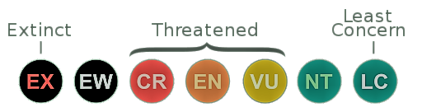

Activity: Threatened Species Research
After watching and discussing the BTN Threatened Species Day story, what questions do students have and what are the gaps in their knowledge? They can develop their own question/s to research or select one of the questions below.
- What is causing species loss? Explore issues such as habitat loss, introduced species, pollution, population growth and overharvesting/hunting.
- Which species have become extinct in modern times? Choose a species to investigate in depth and create a news report explaining how the species became extinct.
- What happens when an animal becomes extinct? If one species in the food chain becomes extinct how would it affect the rest of the chain? Choose an endangered species and explore its role in the food chain.
- Who do you think should be responsible for addressing the problem of species loss? List some of the responsibilities of individuals, communities and the government.

Activity: Threatened Species Research Project
Students will choose a threatened Australian species (plant or animal) to learn more about (they may want to choose one that is local to their area). Use the template below to help guide their research.
COMMON NAME:
SCIENTIFIC NAME:
APPEARANCE:

POPULATION:

Illustration/photo
THREATS TO SPECIES:

CONSERVATION STATUS (highlight):
Least concern | Near threatened | Vulnerable | Endangered | Critically endangered | Extinct in the wild | Extinct
LC | NT | VU | EN | CR | EW | EX

RECOVERY ACTION (WHAT IS BEING DONE TO PROTECT THE SPECIES)

INTERESTING FEATURES OR FACTS:

Activity: Threatened Species Day
Threatened Species Day was declared in 1996 to commemorate the 60th anniversary of the death of the last remaining Tasmanian tiger (thylacine). Threatened Species Day is a time to think about what happened in the past and how we can prevent other native plants and animals from becoming extinct.

Watch the BTN Tassie Tiger story then respond to the following questions:
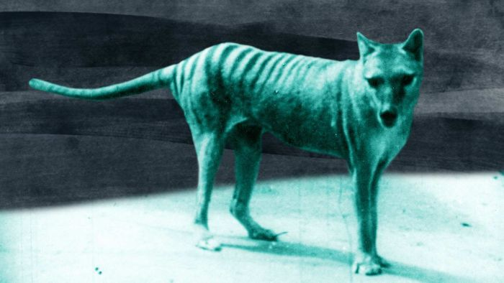
- What evidence is there that the thylacine is extinct?
- What impact did European settlers have on the thylacine?
- What can we learn from the extinction of the thylacine?
- How will our knowledge of the thylacine help us make informed decisions about species preservation?

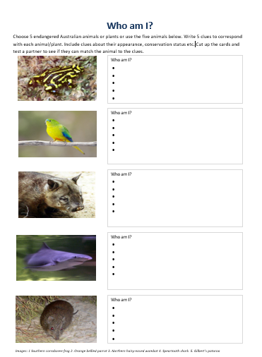
Activity: Who am I?
Students will make their own Who am I? game to learn more about endangered Australian animals or plants. There is an example at the end of this activity.
- Students will research and write 5 clues to correspond with each animal/plant in the Who am I? worksheet at the end of this activity, with the first clue being the hardest and the last clue being the easiest.
- Include clues about their appearance, conservation status etc.
- Students will test their game on a partner.

Activity –Citizen Science
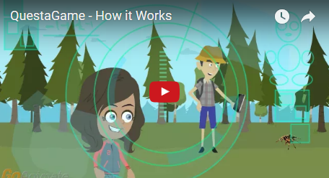
Become the greatest bio-adventurer of all time! Download the QuestaGame app then discover and help preserve species by taking photos and submitting them. They’ll score gold for every sighting and extra gold if they can find something rare or interesting. The information is shared with CSIRO’s Atlas of Living Australia and the Global Biodiversity Information Facility which helps researchers understand how we can protect biodiversity.

Useful Websites
- Threatened Species Day – NSW Department of Environment
- National Threatened Species Day – WWF

Activity: Threatened Species stories
Students can watch one or more of the BTN stories below to learn more about threatened species.
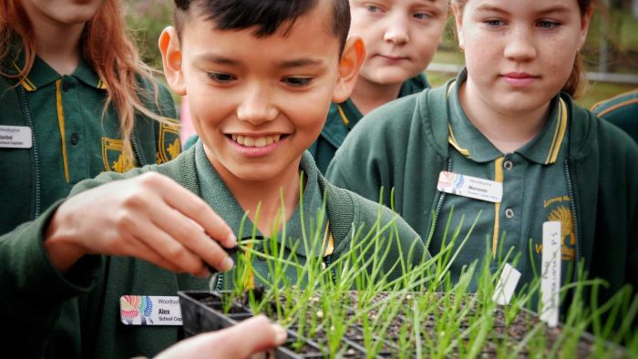  Endangered Seeds | 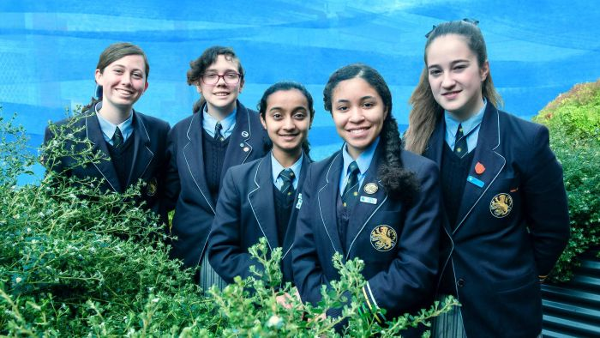  Threatened Flora
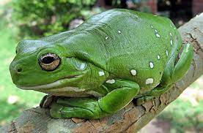Frog spotting | 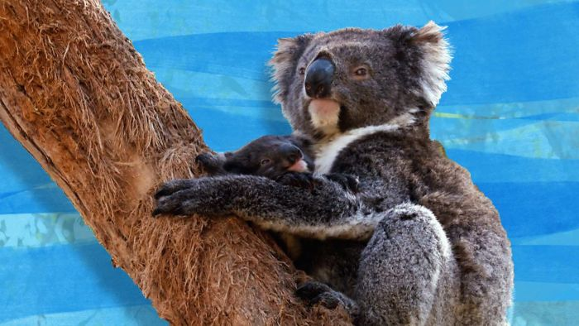  Koala Threat
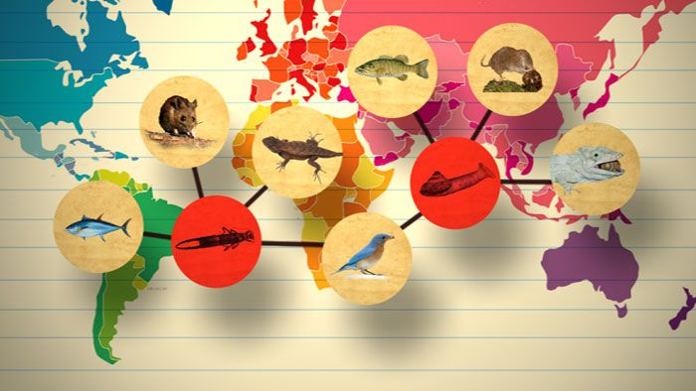  Species List | 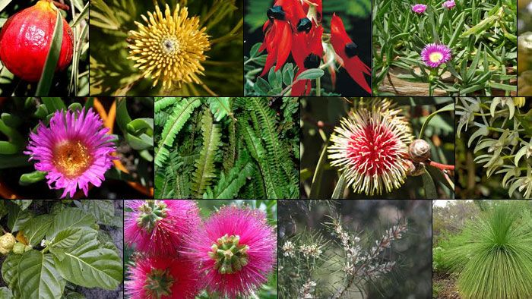  Plant Bank
Extinction Report | 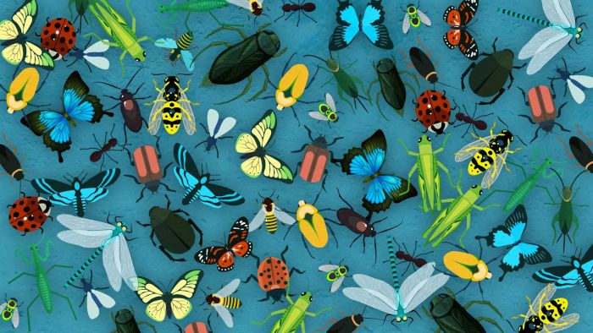  Insect Extinction

Who am I?
Choose 5 endangered Australian animals or plants or use the five animals below. Write 5 clues to correspond with each animal/plant. Include clues about their appearance, conservation status etc. Cut up the cards and test a partner to see if they can match the animal to the clues.
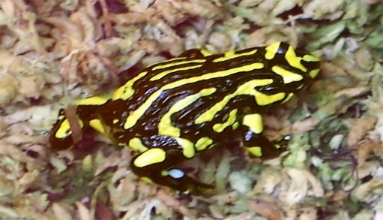 |  | Who am I?
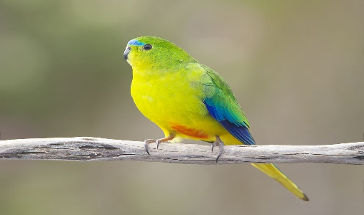 |  | Who am I?
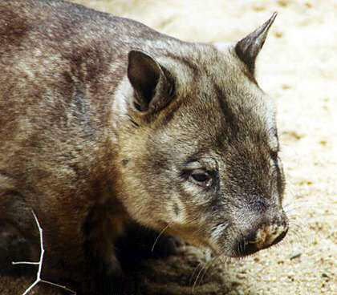 |  | Who am I?
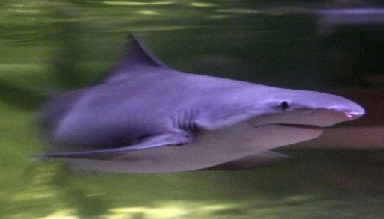 |  | Who am I?
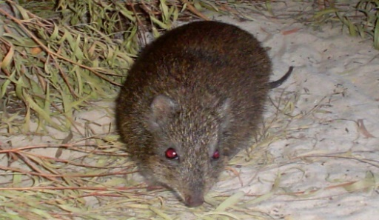 |  | Who am I?
Images: 1 Southern corroboree frog 2. Orange-bellied Parrot 3. Northern hairy-nosed wombat 4. Speartooth shark 5. Gilbert’s potoroo

EPISODE 26
7th September 2021

KEY LEARNING
Students will explore where water comes from, how it is accessed and where it goes after we use it. Students will design a public awareness campaign targeting fatbergs.

CURRICULUM
HASS – Year 4
Reflect on learning to propose actions in response to an issue or challenge and consider possible effects of proposed actions.

HASS – Year 5
Use criteria to make decisions and judgements and consider advantages and disadvantages of preferring one decision over others.

HASS – Year 5 & 6
Develop appropriate questions to guide an inquiry about people, events, developments, places, systems and challenges.

HASS – Year 7
Construct significant questions and propositions to guide investigations about people, events, developments, places, systems and challenges.
  - Teacher Resource

Preventing Fatbergs

Focus Questions
Discuss the BTN story as a class and record the main points of the discussion. Students will then respond to the following:
- Summarise the Preventing Fatbergs story.
- Explain what happens at the Waste Water Treatment Works.
- How is the treated wastewater reused?
- What sorts of objects do they find at the treatment works?
- What are the `three P’s’ that should be flushed down the toilet?
- What thing is being flushed down the toilet and causing big problems for our sewerage systems?
- What is a fatberg?
- Products are advertised as flushable even when they are not. True or false?
- What is being done to prevent the problem of fatbergs forming?
- What was surprising about the BTN story?

Activity: Note taking
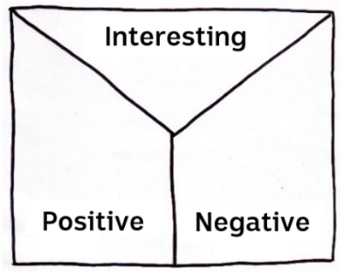
Students will practice their note-taking while watching the BTN Preventing Fatbergs story. After watching the story, ask students to reflect on and organise the information into three categories. What information in the story was...?
- Positive
- Negative or
- Interesting

Activity: Class Discussion
Hold a class discussion about the information raised in the BTN Preventing Fatbergs story. Create a class mind map with FATBERG in the middle. Use the following questions to guide discussion:
- What is a fatberg? Write a class definition.
- What causes fatbergs?
- Why are fatbergs a problem?
- What can we do to stop fatbergs from forming?
- Whose responsibility is it to stop fatbergs?

Activity: Education campaign
Students will design a public education campaign targeting bad waste disposal. Students can choose one of the following to focus their campaign on:
- Fatbergs
- Fast fashion
- Recycling
- E-Waste

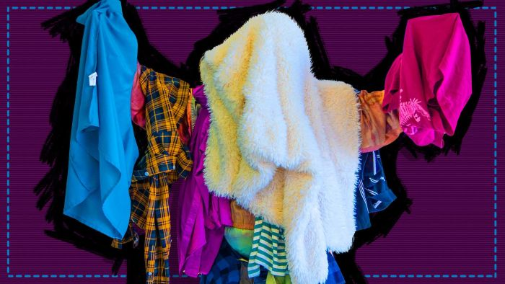  BTN Fast Fashion | 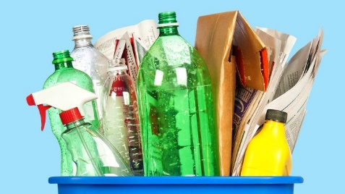  BTN Recycling Problem | 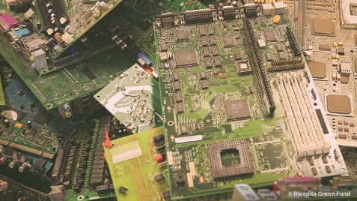  BTN War on E-Waste

Students will need to think about their campaign’s aim, target audience, and the value of raising awareness at their school and in the broader community. To create an awareness campaign, students will need to identify the following:
- What is the problem?
- What causes the problem?
- How does the problem impact on the environment and people?
- What are some good practices or ways to avoid the problem? Write step-by-step instructions.
- Whose responsibility is it to help solve the problem?
- Why is it important to raise awareness about the issue?
- How can you encourage people to change their behaviours?

Some questions for students to consider when designing their campaign:
- What is the campaign’s main aim?
- Do you have a slogan or message? What is it?
- Do you have a jingle?
- Who is your target audience?
- What is the best way to communicate the message?

Discuss with students how they will get their message out there to help raise public awareness. Some possibilities include:
- Short film or animation.
- Community service announcement (for television or radio).
- Press release.
- Use Canva to design a poster to put up around your school and contact your local council to ask if they can support your campaign.

Activity: Science investigation
Class discussion
Do you know what happens to the water after you flush? Facilitate a class discussion to find out what your students already know about where water comes from, how it is accessed and where it goes after we use it. Use one or more of these questions to get the discussion started:
- How do you use water?
- How is water used at school, at home and in the community?
- Where does water come from?
- What is the cycle of toilet water?
- What are some natural and man-made systems associated with water?
- What are some ways to use water responsibly?

School investigation
Provide your students with the opportunity to investigate water use around their school. Working individually or in small groups, students will use the following to guide them during their investigation.
- Investigate how water is used in and around your school. Walk around your school and identify where water is accessed and used (for example, taps, garden hoses or sprinklers, toilets, sinks, water fountains, pools, drinking fountain, dishwasher).
- Write down as much information as you can about what you discover. Consider taking photographs or drawing a simple map of your school which highlights where water can be found and is accessed. Ask your principal if they can provide a copy of a detailed plan of your school which shows plumbing and water access points.
- What did you discover during your exploration? Is water at your school being used responsibly or irresponsibly? How can water be used more sustainably at your school? Make suggestions.
- Write a report on the discoveries you made during the investigation. Include the following in your report: photos, labelled diagram, and a map.

Visit a sewage treatment plant
As a class, students will discuss ways that they can learn more about the sewage treatment process and what happens after you flush. For example, you may want to plan a trip to your local sewage treatment plant to gain insight into what happens at each stage of the sewage treatment process. Alternatively, if you are unable to physically visit a sewage treatment plant go on a virtual tour!

Use the following framework to guide your students, before, during and after your excursion to a sewage treatment plant.

Before | - What do I already know about the sewage treatment process?  - What do you think the plant will look like? How big do you think it will be? Find it on a satellite map.  - Where is it? How far is it from your school?  - What do I want to learn? Make a list of 5 questions to ask an expert.  - What do I need to take with me? For example, a notepad, pencil, sketch pad, ruler and camera.
During | Record as much as you can during the excursion. What do you see, think and wonder?
After | Respond to one or more of the following questions:  - Name and explain one step in the water treatment process.  - What is removed from the water during treatment? List two things.  - What happens to the water after it leaves the sewage treatment plant?  - What can you do to ensure fatbergs don’t form?

Activity: Choose a project
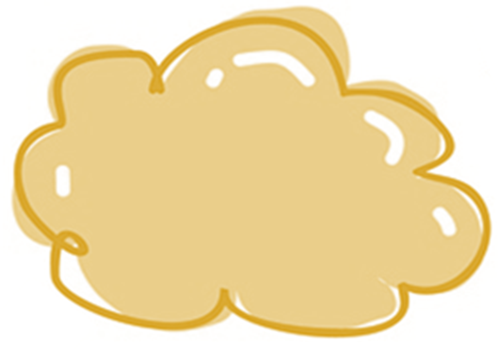
Individually or in small groups, students will choose one of the following projects to work on and then present their findings to the class.
Take the lead
Get your students to take the lead in educating their school or families about how to protect our sewers! Students will create their own lesson and teach it.
Dirty water project
Experiment with different materials to turn dirty water into clean water. Materials: dirt, water, rocks, cotton balls, cup, kitty litter, coffee filter and a plastic bottle cut in half. What worked well and what didn’t work so well?

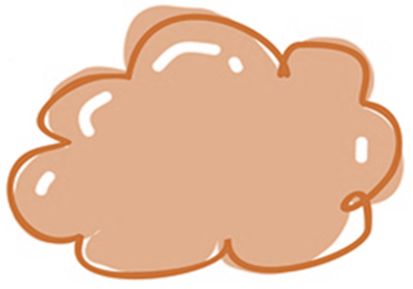
True or false?
Find out as much as you can about fatbergs and the sewage treatment process. Create a true or false quiz and test your classmates. Alternatively, create a word find or crossword.
National Water Week
Think of a way that your class or school can get involved and celebrate National Water Week in October. Find a water expert to talk at your school.

Useful Websites
- Fatbergs – BTN
- What is a fatberg? – Newsround
- New 'flushability' standard will help to end 'fatbergs' from clogging our sewerage network – ABC News
- Fatbergs can cost millions to remove each year. Here's how to stop them – ABC News
- Fatbergs targeted by SA Water jingle and social media campaign about what waste to flush – ABC News

  - Teacher Resource

BTN Transcript: Episode 26 - 7/9/2021

Hey, I’m Amelia Moseley and you're watching BTN. Here’s what’s coming up. The world marks 20 years since a world-changing act of terror, a push to protect Australia’s threatened species and the fight against the dreaded fatberg.

9/11 20th Anniversary

Reporter: Amelia Moseley

INTRO: We'll get to that soon. But first to a big anniversary that's being commemorated this weekend. People in the US and right around the world will mark 20 years since a really tragic event known to most people as September 11 or 9/11. That's when hijacked planes were flown into buildings in the US in the worst act of terrorism the world had ever seen. Let’s find out more.
If you watch an old movie or TV show set in New York before 2001, you might spot two huge towers in the skyline. They were the World Trade Centre buildings, sometimes known as the Twin Towers and for decades they were an iconic sight in an iconic city.

But on September 11, 2001, everything changed. On that morning, while people arrived for work and tourists took out their cameras two hijacked planes were flown into the 110-floor skyscrapers. First one, then the other and millions of people watched live on TV even kids like me over in Australia, as the two buildings eventually collapsed. Another hijacked plane was flown into the American Defence headquarters known as the Pentagon. And a final plane was also thought to be heading to America’s capital before passengers fought back and caused it to crash so it wouldn't hit its target. By the end of this sad day, nearly 3,000 people had died and thousands more were injured. It was an attack designed to shock the world and create fear. The US Government said it was determined to find those responsible and hold them to account.
GEORGE W BUSH, FORMER US PRESIDENT: These acts shatter steel, but they cannot dent the steel of American resolve.
Investigations showed that known terrorist Osama Bin Laden and his group Al Qaeda were behind the attacks. They'd trained in Afghanistan and the Taliban, the extremist Islamic group controlling the country, was protecting them. So, America's next move was to target Al Qaeda bases there.
US soldiers and troops from allied countries like Australia were sent to the Middle East and the war in Afghanistan began. Ten years later the US found and killed Osama Bin Laden, but the war in Afghanistan became America's and Australia's longest. And it's only this year, 20 years later, that the final Aussie and American troops were withdrawn as the Taliban takes control of Afghanistan again.
The attacks had other huge impacts on the world too. Before September 11, American passengers could sometimes take pocket knives on flights and kids could even visit the plane's cockpit. After the attacks the doors were locked and bullet-proofed and security in many countries ramped up and remains super strict today, including right here in Australia.
In the 20 years that have passed since 9/11 New York City's built a new World Trade Centre, a museum and two huge memorials on the exact spot where the buildings stood. And on the anniversary of September 11, people will gather to remember one of the darkest days in American history. One that many people around the world will never forget.

Kids Reflect on 9/11

Reporter: Rookie Reporters
INTRO: Of course, like you guys, kids in New York today weren't around to see the Twin Towers and don't remember the attacks. But they've had a huge impact on the city they live in and the people around them. We've spoken to some kids about what it's like to grow up in New York after 9/11. Take a look.
JAYDEN: Hi BTN, I'm Jayden. I'm 12 years old and I live in New York City with my parents and my cat Kako.
ZARA A: Hi, I'm Zara Allen and I live in New York City in the USA with my mum and dad.
ZARA S: Hi BTN, my name is Zara and I'm a junior in high school in Brooklyn, New York. I live here with my parents and my two younger brothers.
JAYDEN: I like how there's a bunch of things to do like going to the beach or to museums, the Natural History Museum, the Transit Museum. It's diverse and you can get any type of food all over the world you want.
ZARA S: I live in New York. So, this is where 9/11 happened, where the plane flew into the Twin Towers, which is in Manhattan, which is in New York City. It's such a tragic event that happened.
ZARA A: I hate talking about September 11, it makes me feel awful and sad. I feel really bad for everyone who was affected in this crisis.
ZARA S: It makes me like, really sad to think that someone would, you know, try to just destroy so many lives just for like their own cause. I think violence is not a way to try and prove a point right or wrong.
JAYDEN: It makes me feel mad because of the people that did it, they knew it was going to happen, and they knew how sad their families would be and that they were going to kill thousands of people.
ZARA S: I'm here with my mom, Jane.
JANE, MUM OF ZARA S: Hi.
ZARA S: So, today I wanted to ask you, what do you remember about 9/11?
JANE, MUM OF ZARA S: I was off on 9/11 and I remember waking up to seeing the towers appearing to be on fire. It was quite terrifying. Trying to find family members. I had a cousin who works pretty close to the Twin Towers, and for many hours, I wasn't able to get in contact with her. But luckily, she was safe and survived, but she was not as lucky as other people.
PIER, MUM OF ZARA A: The way I was affected by 9/11 was that I was there that day. And I saw the towers come down and I went into work just as the first plane hit the first tower. And there was a call for first responders. So, my friend Jane and I, we signed up to be first responders. There are people with signs, and they were cheering us on as we were going in, but we weren't the real heroes. We were just volunteering to help the heroes and so we got down there, and people came out everyone was helping each other. Everyone was cheering each other on, people were literally giving shirts off their backs and there was this real community and this real desire to make sure that everyone was alright, and that is the thing that 9/11 really means to me.
ZARA S: It's definitely something like on that day that you think about all the time, and everybody talks about, and I wish I could do more. And I have visited multiple times the 9/11. Like there's like, kind of like memorial kind of things with all the names written down. And now we have the Freedom Tower instead. And I think that is a great way to like, appreciate everybody.
JAYDEN: It's important to remember what happened on 9/11 because you have to honour the people that died. But also, to honour the selfless and brave heroes who pulled people out from the debris.
Upsetting News

Now remember if you're upset by that story or anything you see in the news, make sure you talk to someone about it. We've also put together some resources on our website with tips on how to deal with upsetting news so make sure you check that out. Now let’s have a news quiz.

News Quiz

Can you name the hurricane that’s brought deadly floods to New York after battering New Orleans in the US? Was it Sandy, Katrina or Ida? It was Ida. The storm was one of the strongest ever to hit the southern state of Louisiana, then its remnants moved north, brining deadly floods and tornedos to Northeastern states.

If you live in Melbourne and you’re under 12, which of these activities are you allowed to do at the moment? Go to the movies, go to the playground, or go out after 9pm. You can go to the playground, although, sadly, a lot of other things are still out for a while. Victoria’s premier has extended the state’s lockdown until September 23rd.

DANIEL ANDREWS, VICTORIAN PREMIER: There’s going to be very significant restrictions, a lockdown in some form, that’s going to be there to contain cases until we get the vaccination rates as high as possible.

Although he says restrictions will ease up a bit for most regional Victorians.

Now for the good news. New South Wales reached an important vaccination milestone last week. What percentage of 16 and overs have now had at least one dose? 50 percent, 70 percent, or 90 percent? It’s 70 percent while 40 percent of the state is fully vaccinated.

What has the government announced that our Paralympic gold medallists will be getting, along with their medals of course? $20,000, a car or a certificate? They’ll get 20,000 dollars, the same as an Olympic gold medallist. Silver medallists will get $15,000, and bronze will get $10,000. Up until now Paralympians weren’t paid for their medals, but Olympic medallists were, and a lot of people thought that was unfair.

SCOTT MORRISON, PRIME MINSTER OF AUSTRALIA: I’m very pleased to announce the government will provide additional support to Paralympics Australia to ensure our Paralympic medallists will receive equivalent payments to our Olympic medallists, Mr Speaker.

And a dinosaur skeleton named Big John is going up for sale in Paris. What type of dinosaur was he or she? Big John was a Triceratops which roamed the US 66 million years ago.

Threatened Species Day

Reporter: Natasha Thiele

INTRO: Now to a different sort of anniversary. September the 7th is Threatened Species Day, which marks the date on which the last Tasmanian Tiger died back in 1936. It's meant to serve as a reminder of all of the other animals and plants that Australia could lose if we don't act quickly. Here's Tash with more.

If you ask someone from overseas what's special about Australia, they might think of something like this or this. Yep, we're pretty famous for our wildlife which ranges from the adorable to the terrifying, to the downright weird. In fact, did you know that this country has the world’s second biggest collection of endemic species, that is, plants and animals found nowhere else in the word?

But sadly, as most of us Aussies know, a lot of our species are in trouble. More than 1,900 native plants and animals in Australia are listed as threatened because of things like disease, feral predators, development, pollution and climate change. This is the Orange-bellied Parrot, one of 96 Aussie species classified as critically endangered meaning there's a high chance that they'll soon become extinct.
CHAD CRITTLE, SENIOR BIRD KEEPER ADELAIDE ZOO: For Orange-bellied Parrots, there are multiple factors involved. Habitat loss is a key one for them, combined with feral cats, feral foxes and dogs, all contribute to these birds, sometimes in the last 10 years, only having 30 of them left in the wild at one time.
Since European colonisation, Australia has lost around 100 plants and animals like the Tasmanian emu, the long-tailed hopping mouse and the Christmas Island pipistrelle. But if there's one, lone Aussie animal that symbolises the tragedy of extinction it's this one. This is Benjamin, the very last Thylacine or Tasmanian Tiger. By the 1930s his whole species had been driven to extinction by disease, hunting, introduced predators and habitat loss and on the 7th of September 1936 Benjamin died in a Hobart Zoo. Now, we mark that date with National Threatened Species Day, a reminder of just how much we have to lose if we don't protect our remaining native species.
CHAD CRITTLE: It's a great day to stop and remember what's happened in the past so that we learn from those lessons and make sure it doesn't happen again.
Chad is a bird keeper at Adelaide Zoo which is one of many organisations around Australia running captive breeding programs to try to boost the populations of endangered animals like the Orange-bellied Parrot.

CHAD CRITTLE: So, whether that’s just looking after sick animals when they come into our vet hospital, breeding them here, being able to talk to our visitors about them as well. It’s all little things that we do to help make sure that birds like Regent Honeyeaters or Orange-bellied parrots don’t disappear from our skies.

Right around the country scientists, conservationists, and government organisations are working to protect threatened species and their habitats, but experts say we all need to do more, and everyone has a part to play in protecting our native species.
CHAD CRITTLE: So, if it’s getting out with mum and dad in the back garden and helping them plant native trees in your backyard, making sure that when you're putting your rubbish in the bin it's going in the right bin. The more that we can reduce and reuse and recycle the less pressure it puts on the habitats that these beautiful animals call home.
Preventing Fatbergs

Reporter: Jack Evans

INTRO: Now, how much thought do you give to what you flush down the loo? Well, experts say it's something we should think about a bit more because way too much stuff that's not flushable is ending up down there and it's causing big problems. It's why by next year we could have a new set of standards for products to let people know what's really safe to flush. Here's Jack.

JACK: Nooooo.
LIV: Jack, what's wrong?
JACK: My favourite wig just got flushed down the toilet, by accident.
LIV: Oh no, you might have blocked the pipes.
JACK: Gee thanks for the sympathy. You know it was one of a kind.
LIV: Oh well, you could always try going to the Waste Water Treatment Works, I guess.
JACK: The waste water what, what?
LIV: You know, the Waste Water Treatment Works. The place where all the stuff that you do in the toilet goes.
JACK: I think you might be right. Yeah, I'll go see if they've got it. Thanks kind stranger.
LIV: Jack, it's me, Liv. We work together. Oh, wait here's your wig it fell behind the toilet. Oh, he's gone.
JACK: Well, this stinks.
LISA: But you get used to it.
JACK: I'm not talking about the smell, although yeah it does smell pretty bad here. I flushed my favourite wig down the toilet.
LISA: Your Wig?
JACK: Yeah.
LISA: You shouldn't be flushing a wig down the toilet.
JACK: I know that. It was an accident. Do you think it might be here somewhere?
LISA: Could be, shall we have a look?

JACK: Alright, this way?
If you haven't worked it out yet the Bolivar Waste Water Treatment Works is one of the places the stuff, we flush down the toilet ends up.
LISA, SA WATER: So, here at Bolivar, we have around 150 million litres of wastewater come into the treatment plant every day. It first goes through a screening process where we remove some gross solids, we then have a bit of a settling phase. The wastewater then comes into some tanks, which are just next to me here called clarifiers and we separate out the water and the solids. And then they go in two separate directions, the water part goes out to be disinfected through some large ponds, and then we can largely use it for beneficial reuse. And some of it does get released into the environment as well.
Thanks to some very clever engineering a lot of our waste, doesn't go to waste. But Lisa says a lot of things are ending up here that really shouldn't.
LISA: Golf balls to dog toys to false teeth to rubber chickens to all sorts of things.
That's a problem and not just for the people who lose their teeth or wigs. But also, for the workers who have to remove them to keep things working properly. And while most of this stuff is clearly not designed to go down the loo. There are other less obvious unflushable things causing big problems in our sewerage systems.
LISA: Have you ever heard of a fatberg.
JACK: Yeah, one of them destroyed the Titanic.
LISA: No, that was an iceberg. A fatberg is a really gross thing and they're normally made up of fats and oils with wet wipes and paper towel.
JACK: Gross.
Gross indeed and experts say part of the problem is products that are allowed to advertise themselves as flushable, when actually they're not.
LISA: We know that there are items that physically can be flushed away. But they do create problems. So, we're really excited that some work is being done by Standards Australia to develop some new standards around what should not be flushed down the toilet.
If they are adopted, the new standards will mean products that are actually flushable, can carry a logo to let customers know. No logo means no loo. In the meantime, Lisa says the only things that should be flushed are the 3 P's. Say them with me now poo, pee, and paper, toilet paper that is. As for me, I've learnt my lesson. I'll never wear a wig in the toilet again. Unless it's made out of toilet paper, cause if that falls in, hey, no problem.

Ask a Reporter

Do you have a question about that story? Well, you can ask me live on Friday during Ask a Reporter. Just head to our website for all the details.

Sport

Tokyo has officially farewelled the Paralympics after 12 days of competition and it was a great time for Australia. So, let's take a look back at how we did.
Australia finished 8th on the medal tally winning a remarkable 80 medals including 21 golds. On the final day of Paralympic competition Madison de Rozario and Jaryd Clifford won gold and silver respectively. Dylan Alcott successfully defended his Paralympic tennis title from the 2016 Rio Games, winning gold in the quad wheelchair singles final. A very special win, as he said this was his last Paralympics ever.
It was also the final games for Australia's most decorated female Paralympian Ellie Cole who was given the honour of flag bearer at the emotional closing ceremony. IPC President Andrew Parsons said the Games were not just historic but fantastic and the good news is, it's only 3 years until Paris.

Brydi: Just Like You

Rookie Reporter: Brydi

INTRO: Finally, today we're going to hear from our rookie reporter Brydi. She's a talented athlete and last time we checked in with her she told us about her ambitions to make it to the Paralympics. But today she's going to tell us about a program she's involved in which is helping to combat bullying in schools and show that kids with disabilities are just like you. Check it out.

Hi BTN, I’m Brydi and I'm 11 years old. I live in Brisbane, and this is my family. There's mum, dad, my two brothers and my sister. And this is my wheelchair. For the past 3 years I've been wheelchair racing competitively and this year I’ve started playing wheelchair basketball too. My favourite thing about wheelchair racing and wheelchair basketball is I can go super-fast and for wheelchair basketball it's really tough.
Some of you guys might have seen me before on BTN with some of my favourite wheelchair athletes. But today I want to tell you about something else I've been doing. You see while being in a wheelchair hasn't ever held me back having a disability can sometimes make it hard for kids at school. When I started school, I didn't really have any friends and a lot of the other kids used to bully me to the point where I didn't feel like being at school. I work hard on my self-esteem and don't let the bullies get to me.
A little while ago the children's charity Variety approached me to be a part of a program called Just Like You. Since 2015 it's been teaching primary school kids around Australia how to accept and include people living with a disability. It gives kids with a disability a chance to share our stories with other kids and it helps them to understand that, really, we're just like them. Now the program has come to my home state, Queensland.
I'm excited to be in the program so I can teach kids that they can overcome bullying. While also showing able bodied kids that people with a disability can do awesome things like I'm doing. My biggest goal is to go to Paris for the Paralympics in 2024. I am training really hard with my coach and former Paralympian Louise Sauvage to make it to the Games. I want to compete in the 100, 200 and 10 kay races, and I want to be in the wheelchair basketball team. No matter what happens I'm going to put in my biggest effort and achieve big things.
Closer

Thanks so much Brydi. Well, that's it for BTN today. I hope you enjoyed it. We'll be back with our last show for the term next week. In the meantime, you can check out our website or our YouTube channel if you're 13 or over. Plus, there's Newsbreak every weeknight. Have an awesome week, look after each other and stay safe. Bye.

