
EPISODE 13
19 May 2026

KEY LEARNING
Students will view a range of BTN stories and use comprehension skills to respond to a series of focus questions.

CURRICULUM
English – Year 4
Use comprehension strategies such as visualising, predicting, connecting, summarising, monitoring and questioning to build literal and inferred meaning, to expand topic knowledge and ideas, and evaluate texts.
English – Year 5
Use comprehension strategies such as visualising, predicting, connecting, summarising, monitoring and questioning to build literal and inferred meaning to evaluate information and ideas.

English – Year 6
Use comprehension strategies such as visualising, predicting, connecting, summarising, monitoring and questioning to build literal and inferred meaning, and to connect and compare content from a variety of sources.

  - Teacher Resource

Focus Questions
As a class, discuss the stories featured in the episode of BTN Classroom and record the main points of the discussion. Students will then respond to the following focus questions.

Housing Crisis
- What is the median house price in Australia?
- How do house prices in the 1970s compare to house prices now?
- Complete this sentence. There is too much demand for housing and not enough ___________.
- What has the federal government included in this year’s budget to help with the housing crisis?
- What questions do you have about the BTN Housing Crisis story?

Quarantine
- When was quarantine first introduced?
- Where does the word quarantine come from and what does it mean?
- How does quarantine help prevent the spread of disease?
- What is an example of a disease that would require quarantine?
- Name three facts you learnt while watching the BTN story.

Check out the teacher resource on the Archives page.

Eurovision
- Which European country hosted Eurovision 2026?
  - Bulgaria
  - Spain
  - Austria
- When and why was Eurovision created?
- Which countries are boycotting Eurovision and why?
- Australia participated in Eurovision 2026. True or false?
- Who won Eurovision 2026?

World Bee Day
- Working in pairs, record what you know about bees. Share your work with other students.
- What role do bees play in food production?
- What threats are bees facing?
- Why is it important to protect bees?
- Find 3 interesting facts about bees. Share with the class.

Check out the teacher resource on the Archives page.

Marley’s Volunteering
- When did Marley start volunteering?
- Where is Sovereign Hill? Find on a map.
- How does Marley dress when she volunteers at Sovereign Hill?
- What is Sovereign Hill?
- What does Marley do when she volunteers at Sovereign Hill? Explain her role.

EPISODE 13
19 May 2026

KEY LEARNING
Students will learn about the history of quarantine and its importance in helping stop the spread of disease.

CURRICULUM
Science – Years 5 & 6
Scientific knowledge is used to solve problems and inform personal and community decisions.

Communicate ideas, explanations and processes using scientific representations in a variety of ways, including multi-modal texts.
Science – Year 7
Solutions to contemporary issues that are found using science and technology, may impact on other areas of society and may involve ethical considerations.

  - Teacher Resource

Quarantine

Focus Questions
Discuss the BTN story as a class and record the main points of the discussion. Students will then respond to the following:
- When was quarantine first introduced?
- Where does the word quarantine come from and what does it mean?
- How does quarantine help prevent the spread of disease?
- What is an example of a disease that would require quarantine?
- Name three facts you learnt while watching the BTN story.


Activity: Class Discussion
Before watching
Before watching the BTN Quarantine story students will discuss in small groups what they already know about the term quarantine.
What do you know about quarantine?

After watching
Students will respond to one or more of the following questions after watching the BTN story:
- What did you SEE in this video?
- What do you THINK about what you saw in this video?

- What did you LEARN from this story?
- What was SURPRISING about this story?
- Why do you think it is important to hear about this topic?
- Think of three QUESTIONS you have about the story.

Activity: Glossary
Students will brainstorm a list of key words that relate to the BTN Quarantine story. Here are some words to get them started.

QUARANTINE | PLAGUE | DISEASE
HANTAVIRUS | CONTAGIOUS | INFECTIOUS

Ask students to write what they think is the meaning of each word (including unfamiliar words). They will swap definitions with a partner and ask them to add to or change the definition. Check these against the dictionary definition.

Further activities for students:
- Did you know the word quarantine comes from the 14th-century Venetian Italian phrase quaranta giorni, which means "forty days". As a class, discuss the origin of the word ‘quarantine’ and what it means.
- What is the difference between quarantine and isolation? Find a definition for both words to help understand the difference.
- Did you know the classic children’s rhyme about a “pocketful of posies” dates back to the bubonic plague in England. Read this ABC article to learn more.

Activity: Inquiry Research
Discuss the information raised in the BTN Quarantine story. What questions were raised in the discussion and what are the gaps in students’ knowledge? The following KWLH organiser provides students with a framework to explore their knowledge on this topic.

What do I know? | What do I want to know? | What have I learnt? | How will I find out?

Students will develop their own question/s to research or choose one or more of the questions below. Encourage students to collect and record information from a wide variety of sources and present the information they find in an interesting way.
- What is quarantine and why is it important?
- What are some historical events that have required quarantine? (e.g. Black Death, Spanish flu or Covid-19). Choose one and answer these questions. What disease was spreading? What quarantine rules were used? Did the quarantine help? Why or why not?
- What are some ways that people can help stop viruses from spreading? Give 2-3 examples.
- Why do we quarantine animals and goods entering a country? Find examples.

Activity: Visual Literacy
In this activity students will analyse a range of historical images which illustrate the impact of disease and quarantine in Australia. Students will choose one or more of the images below and respond to the following:
- What do you see in the image? Write down what you notice.
- What moment in history is captured in the image? Create a caption for the image.
- How does the image make you feel?
- What does the image tell you about the impact that disease and quarantine can have on a community?
- What questions do you have about what you see in the image?

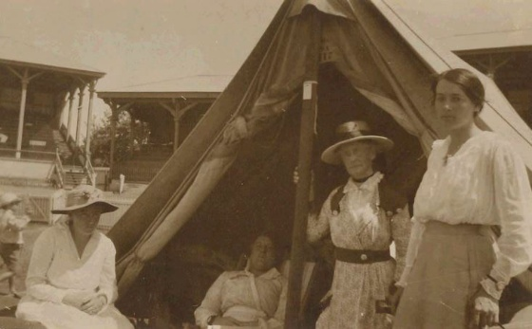  Adelaide University | 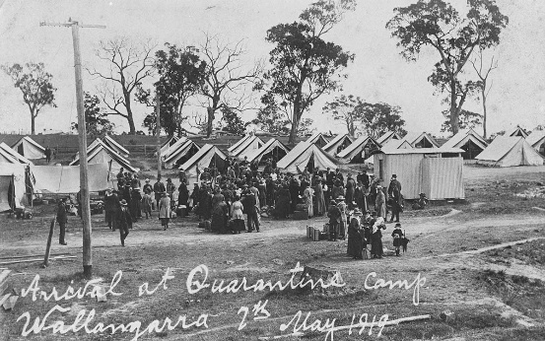  National Australia Museum
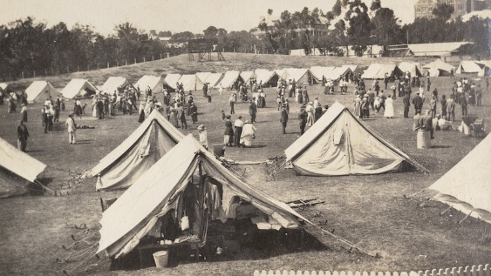  ABC News | 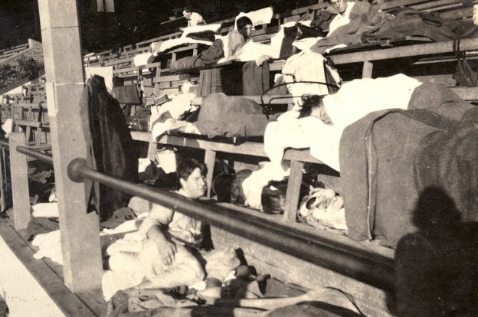  ABC News
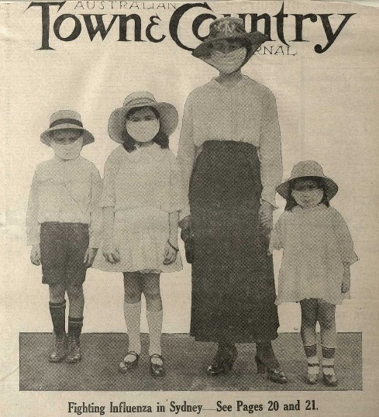  National Museum Australia | 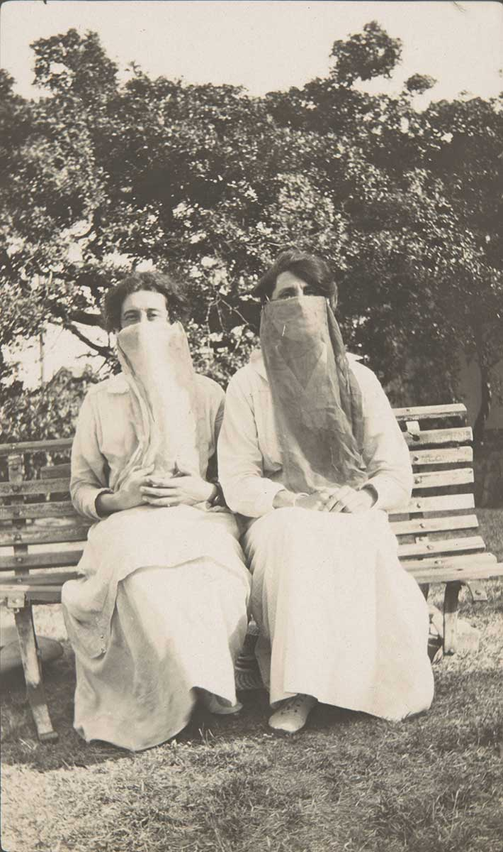  National Museum Australia

Activity – Choose a project
Individually or in small groups, students will choose one of the following projects to work on and then present their findings to the class.


Coping during Quarantine
What are some tips for coping with quarantine and how can we help others in quarantine? Make a list of some of the difficulties of quarantine.
Compare meanings
What is the difference between quarantine and isolation? Find simple definitions and use each word in a sentence to help understand the difference.

Glitter experiment
Using glitter, experiment with how easily germs can spread through touch! Place a small amount of glitter on your hands and see how far it spreads. Why is handwashing so important?
Poster
Design a public health poster encouraging people to help stop the spread of germs.

Useful Websites
- Quarantine – BTN
- What is a virus? – BTN
- What is the Hantavirus? – BTN Newsbreak

EPISODE 13
19 May 2026

KEY LEARNING
Students will learn more about species of bees and the important role they play in ecosystems.

CURRICULUM
Science – Year 4
Living things have life cycles.
Living things depend on each other and the environment to survive

Science – Year 5
Examine how particular structural features and behaviours of living things enable their survival in specific habitats.

Science – Year 6
Investigate the physical conditions of a habitat and analyse how the growth and survival of living things is affected by changing physical conditions.

  - Teacher Resource

World Bee Day

Focus Questions
Discuss the BTN story as a class and record the main points of the discussion. Students will then respond to the following:
- Working in pairs, record what you know about bees. Share your work with other students.
- What role do bees play in food production?
- What threats are bees facing?
- Why is it important to protect bees?
- Find 3 interesting facts about bees. Share with the class.

Activity: Class Discussion
Students will discuss the BTN World Bee Day story in pairs and then share their thoughts with the class.

- What do you THINK about what you saw in this video?
- What does this video make you WONDER?
- What did you LEARN watching the the story?
- Think of three questions you have about the BTN story.

Activity: Class Discussion
Discuss the BTN story as a class. Create a class mind map with BEES in the middle. Ask students to record what they know about bees. In small groups, ask students to brainstorm responses to the following questions and then share with the class:

- What do you know about bees?
- Why do bees pollinate flowers?
- How do bees make honey?
- What jobs do different bees have in the colony?
- Why are bees important?
- Why is it important to protect bees?

Activity: Key Words
Students will brainstorm a list of key words that relate to the BTN World Bee Day story. Here are some words to get them started.
POLLEN | COLONY | POLLINATOR
ECOSYSTEM | QUEEN BEE | NECTAR

Ask students to write what they think is the meaning of each word (including unfamiliar words). They will swap definitions with a partner and ask them to add to or change the definition. Check these against the dictionary definition.

Activity: Bee profile
Students will research and write a profile featuring a bee species. Encourage students to use a range of sources to find their information.
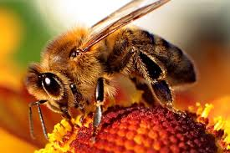
Further Investigation
Students will respond to one or more of the following questions.
- Why are bees important? Investigate the role bees play in food security, biodiversity and ecosystem health.
- If native bees don’t produce honey, do we need them?
- What is the role of the queen bee, drone bee and worker bee? How do they interact? What is a robber bee?
- .
Research
Students will research and create a profile of a bumblebee, honeybee or native bee. Students can use the Animal Profile at the end of this activity.
- Illustration or photo
- Scientific and common name
- Appearance
- Habitat
- Where is it found in Australia?
- Native or introduced species
- Feeding and diet
- Behaviours and adaptations
- Predators
- Interesting facts

Activity: Biological illustration
Students will create their own biological illustration of a bee species. This activity encourages students to develop their observation skills and reinforce their understanding of biological concepts.

Explain to students that in their illustration they need to draw what they see (using photographs/videos that they find in books and on the internet). Students will need to think about size, shape, texture and patterns; and include as much detail as possible.

Students can use the following as a guide as they create their scientific drawing:
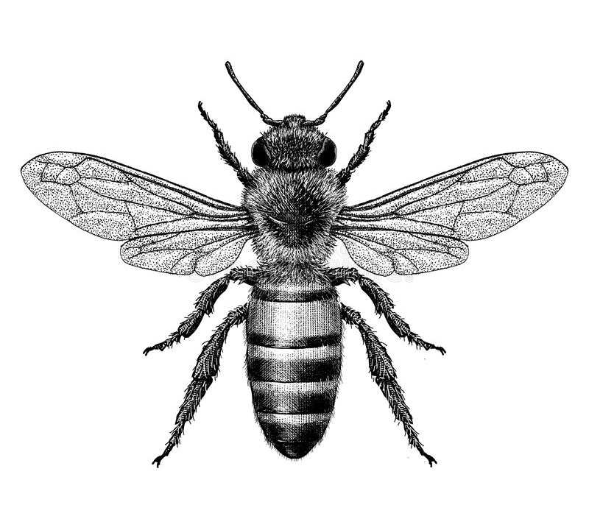
- Find photographs and/or videos of the animal to observe. What key structures and anatomy will you focus on in your drawings?
- Draw the animal to scale (include a ratio on the drawing).
- Include its scientific and common name.
- Add labels – to show size, colour and texture. Include labels to show the bee’s head, thorax and abdomen.

For more information about scientific drawing in the classroom, visit this website Sketching for observation.

Useful Websites
- World Bee Day – BTN
- Junior Beekeepers – BTN
- Bee Heroes – ABC Education
- Curious Kids: How do bees make honey? – The Conversation
- Honey Bee – Australian Museum

  - Teacher Resource

BTN Transcript: Episode 13 - 19/5/2026

Hey, I'm Amelia Moseley and you’re watching BTN. Thanks for hanging out with us again. Let’s check out what’s coming up on today’s show. We find out about the history of quarantine, learn more about the busy work of bees and meet a young volunteer taking people back to the gold rush.

Housing Crisis

Reporter: Joe Baronio

INTRO: Last week we got a look at this year's federal budget and there were some pretty big changes in there aimed at making it easier to buy a house. Joe found out why the cost of homes has become a huge issue in Australia. Take a look.
JOE: Welcome to one of our premier properties, with luxury features including four walls, running water, a roof, and some doors.
COUPLE: Isn't that just the basics?
Yeah, this probably isn't what springs to mind when you think about luxury living, but right now it's what a luxury price tag can get you.

JOE: Not everywhere has all the doors, or even some doors. Some have no doors.

AUCTIONEERS: About 1,000,005? Yep, what have I got? Six 100 and twenty-three and a half $1000 now at 980,000. Sold, congratulations well bought.

Yeah, housing in Australia is really expensive right now, fetching bigger money than ever before.
JOE: How much? This place is only a million dollars.
COUPLE: Oh. Hmmmm.
See, three of the top ten most expensive places to buy a house anywhere in the world compared to income are down under, with median prices for Aussie houses sitting around $900,000 and still rising. That's obviously a lot of money. More than you probably have and more than most people make from their jobs, and that, teamed with other cost of living pressures, means the great Aussie dream of home ownership is getting further away or even completely out of reach for many.
PERSON: We're going to have such, like, a difficult time owning a house in the future, and it's just going to keep surging form there, so...
PERSON: The cost of living at the moment is very hard, especially to rent or even try and get into buying properties.
It wasn't always like this. In the 1970s, houses cost between $20,000 and $30,000 and people would make about $7,000 to $8,000 from their jobs. It meant that most Aussies could afford to buy their own home, and then, in the 1990 the government brought in some tax changes that encouraged people to buy houses as investments. Kinda like a piggy bank. A big one, and house shaped. Some people reckon that had a big impact on the price of houses, added to a lack of new houses being built.
PROF. CHRIS LEISHMAN, HOUSING ECONOMIST: There's basically just too much demand and not enough supply. I mean, it's pretty simple economics, isn't it?
The government thinks so too. So, in this year's federal budget, it's introduced some of the biggest tax changes in a long time.
JIM CHALMERS, TREASURER: In an era where people feel like the system no longer works for them this budget doesn't just acknowledge that, it acts on it by leveling the playing field for first home buyers.
ACUTIONEER: We are sold, congratulations.
Basically, the new changes mean that when people sell a house, they'll have to pay more in tax, and if they rent an existing house out they won't get access to the same tax benefits. The government reckons that will to turn houses from a piggy bank into a place to live, although not everyone agrees. Some reckon discouraging people from investing in houses will result in fewer being built and fewer being rented out.
TIM WILSON, SHADOW TREASURER: If we're being honest about the budget circumstances, we need to acknowledge that there is a real a direct consequence of the proposal they're putting forward.
It will be a while before we know what the consequences of the tax changes are, but lots of young Aussies are hopeful that the great Aussie dream may become a reality again and maybe look a bit better than this.
JOE: So, what we saying? You like it?
COUPLE: Maybe we'll wait.

JOE: OK, all right, cool.

News Quiz

The US president went to China last week to meet with President Xi Jinping. It's the first time the world's 2 most powerful leaders have got together since Mr. Trump was elected for a second time.

It's an honour to be your friend. You're a great leader. Sometimes people don't like me saying it, but I say it anyway because it's true.

But the president didn't come alone. Which of these famous people travelled with him? SpaceX and Tesla CEO Elon Musk, Apple boss Tim Cook, or film director Brett Ratner? Oh, bit of a trick question. It was all of them.

President Trump was accompanied by a whole bunch of billionaires and tech CEOs, along with his son, the secretaries of state and defence, and a film director.

Which of these supermarkets was found to have broken Australian consumer law by a federal court last week? It's Coles. A federal court found that it has misled customers by offering fake discounts by jacking up the price of an item for a short time before putting it on special. Check Coles out. It was 12, it's now 10 from $7.50.

Scientists have found evidence that ancient Neanderthals may have done what medical procedure? Brain surgery, dental work or organ transplants? It's dental work. This 59,000-year-old tooth has a hole which they think was caused by drilling. What they're pretty sure has happened is that this hole has been drilled to treat a cavity, kind of similar to the way a modern dentist would treat a cavity now.

Meanwhile, these archaeologists in Sydney are uncovering Australia's oldest colonial era what? Hub, boat or house? It's a boat, thought to have been used by the British colonists between 1790 and 1830. It was discovered during construction of the Barangaroo metro station in 2018.

Quarantine

Reporter: Kushi Venkatesh

INTRO: Now we're going to find out more about the history of quarantine. It's been in the news recently after an outbreak of a deadly virus on a cruise ship. Passengers have now been sent to their home countries, including Australia, where they'll spend time in quarantine. But what does that actually mean? Khushi went back in time to find out.

CAPTAIN: Ahoy. We have reached our destination. Avast, drop Anchors Matey, this be where the treasure lies. Arrrrr we're going to be rich, rich.

PIRATE: They said we can't.

CAPTAIN: What do you mean we can't.

PIRATE: They said we can't go ashore. We have to quarantine.

CAPTAIN: Arrrrr, shiver me timbers.

KUSHI VENKATESH, REPORTER: Yep, quarantine has been used to stop the spread of disease for thousands of years. The word quarantine actually originated in Venice. Back in the 1300s, authorities there were trying to stop the spread of the bubonic plague or black death.

CAPTAIN: Black death you say? That sounds, bad.

The plague which was spread by the fleas that live on rats killed millions of people across Europe. So, officials decided to keep people out of the city until they were sure they weren’t sick. At first, they were kept on their ships for 30 days or Trentino, but then it was increased to 40 days or quarantina.

CAPTAIN: 40 days? They want me to stay on this ship for 40 days. I’m not even sick. How is this even fair?

Yeah, quarantine wasn't always popular with the people who had to experience it. But for a long time, it was the main tool that societies had to stop diseases from spreading and that’s because if your exposed to an illness it can take days or even weeks before you get sick. Sometimes you don’t get sick at all, but you can still be spreading the disease to other people. Today we still practice quarantine regularly. Whether it’s you staying home when you sick, or authorities quarantining animals entering the country. Then of course there was Covid, when quarantining became a huge part of our lives not that long ago.

TIKTOK: Day 6 of the quarantine. I made this.

TIKTOK: Welcome to day 3 of coronavirus updates.

KUSHI: As the coronavirus was spreading, countries around the world started quarantining anyone who had been exposed or been to places where they might have been exposed. Some were put into hotels that had been specially designated for quarantine and there were newly built quarantine centres like this one in western Australia, which just got 6 new residents.

NEWSREADERS: Board that cruise ship where a deadly hantavirus outbreak has grown to...

You might have heard about this ship the MV Hondius. It’s a Dutch cruise ship that recently had a hantavirus outbreak in the Atlantic Ocean. Hantavirus is a rare but serious disease that you usually only get from rodents like rats and mice. The one that broke out on this ship is an even rarer strain that can be transferred from human to human. People were stuck on the ship for weeks while authorities tried to decide what to do, while also trying to track down people who had already left the ship.

Now the passengers have been carefully transferred to their home countries. Including 5 Australian residents and 1 New Zealander who will be spending at least 3 weeks at the quarantine centre. They'll be regularly tested to make sure they haven't got the virus and treated if they do. While it’s had a lot of people really worried that we could be facing another pandemic, health experts say that’s not going to happen.

DR MARIA VAN KERKHOVE, EPIDEMIOLOGIST: This is not the start of a covid pandemic, this is an outbreak that we see on a ship.

They say hantavirus isn’t nearly as contagious as covid, which means the risks to the public are really low. But as with any serious disease they are taking this really seriously to make sure the people who are affected and everyone else stays safe.

Did you know?

Did you know the crew of Apollo 11 Were quarantined, just in case Moon germs invaded Earth. While it might seem a bit sci-fi, no one at the time knew for sure if the moon was sterile, so just in case, Neil, Buzz and Michael were isolated for three weeks when they got back to Earth.

Eurovision

Reporter: Joe Baronio

INTRO: Eurovision has just wrapped up in Austria and while it was just as colourful and glittery as ever, it was more controversial than usual. This year there were big protests at the event and several countries pulled out. Joe found out why.

JOE BARONIO, REPORTER: What's the one place you can see singing astronauts, dancing pirates, and yellow wolves? I guess? It's Eurovision.
Yep. It's the world's biggest, and possibly weirdest, song contest, and this year it celebrated its 70th anniversary in Vienna. That's right, it all began back in 1956 as a way to unite Europe after the Second World War. At first, it was pretty small. Just seven countries took part, but slowly it grew in popularity and size, transforming the contest into the launching pad for some global superstars.
AGNETHA FÄLTSKOG AND ANNI-FRID LYNGSTAD, ABBA: My, my. At Waterloo, Napoleon did surrender…
52 countries from all over the globe have now taken part in the competition, including a few that aren't technically European, like Israel, which has been in it since 1973, and for the past few years, Australia. And while the competition's mission is to bring people together, it has seen its fair share of controversy over the years, sometimes over voting.

JOE: See, countries aren't allowed to vote for themselves, and there have been a few times that countries have been accused of doing deals for votes, even outright buying them.

Which is what may have happened back in 1968 when the UK's Cliff Richard lost to Spain. In 1975, Greece dropped out of the contest in protest over Turkey's participation after the invasion of Cyprus, and then a year later in 1976, Turkey didn't show up because Greece's entry seemed to reference the conflict. More recently, Russia was banned from Eurovision in 2022 over the invasion of Ukraine, and some reckon the same should have happened to Israel this year.
HAIM BRESHEETH, ACTIVIST: This song contest has been and should be about peace.
Spain, the Netherlands, Ireland, Slovenia and Iceland refused to broadcast the contest or send performers to compete this year because of Israel's involvement in the competition. Protesters said that Israel shouldn't be allowed to take part in Eurovision because of accusations of war crimes in Gaza. But there were also protesters supporting Israel's participation.
AVI BEN DAVID, FLASH MOB PARTICIPANT: Music is about music and it's not about politics.
NOAM BETTAN, ISRAEL'S EUROVISION ACT: I wish and I hope that next year, like all the countries could be here, you know, all the countries could be here and could sing and could give their colours to the world, because the world, the world needs it.
As for Australia, the event broadcaster, SBS, said it was their job to be neutral, and agreed that Eurovision is about bringing people and cultures together through music. Our representative was Delta Goodrum, and while Bulgaria took the number one spot Delta wasn't far behind, finishing in fourth place.
DELTA GOODRUM, AUSTRALIA'S EUROVISION ACT: Thank you for supporting, I love you all, I'm breathing it in, I'm feeling very grateful.
FANS: She's still our winner. She's still our winner. She's still a star, thank you, Delta.
Quiz
Who was Australia's first ever Eurovision contestant? Was it Jessica Mauboy, Guy Sebastian or Dami Im? It was Guy. He was our first official contestant in 2015. While Jessica Mauboy performed the year before, it wasn't part of the competition.

World Bee Day

Reporter: Aiden McNamara

INTRO: Wednesday, May 20th. is a very important day that the UN dedicated to a very important insect, bees. Aiden found out more about what these little guys do and why they need our help.
AIDEN MCNAMARA, REPORTER: Alright, it's smoothie time. Wow, the blueberries must be really out of date. I guess we're doing double mango. Maybe almonds? Alright just regular plain milk and a drizzle of honey?

KUSHI: Aiden. We're re-watching my favourite film. Wanna join?

AIDEN: Oh, Ahhh!

Yeah, without bees, life wouldn't be quite the same. You see, bees don't just make honey. Sick of boring old maps? Well, these bees share directions through this dance called a waggle. Groovy. Some can remember rhythmic patterns we make, at least if they're bribed with sugar. And if all this isn't enough to impress you, have you of something called like a third of the food we eat?

This fine powdery dust is called pollen. Most flowers and plants make the stuff and if it reaches another, they can then grow seeds, flowers, and fruit. Some plants can spread their pollen with just the wind. This is called self-pollination. But lots of other plants rely on creatures like ants, beetles, flies and most of all, bees.

STUDENT: I love bees because they're just so cool.

These students look after thousands and thousands of bees, which they use to pollinate the plants and trees at their school.

STUDENT: Apples, pears, mandarins, macadamias.

STUDENT: Most schools are just inside most of the time and I'm grateful to be able to be out here.

STUDENT: Once you get used to being near the bees and once you understand that the suits are really helpful and protect you, you're not scared anymore.

Have you seen The Bee Movie?

STUDENT: Yes. It's quite unrealistic though.

I was learning a lot. But these little insects are facing some big threats. See in the wild, they often build nests out of beeswax inside hollow trees. But the more trees that get cut down, the harder it is to find a home. And many pesticides that famers spray to protect crops from weeds and other pests can be lethal to bees. And now our bees are facing a new challenge.

STUDENT: Varroa has been detected in Australia. It's a mite. What it does is it catches a ride and an adult bee back to the hive.

Varroa mites can make bees really sick.

STUDENT: And if they're dying, they're not really pollinating much, so the ecosystem struggles.

Varroa mite affects bees around the world. While Australia held it off for a while, it's now widespread in New South Wales and has been detected in a bunch of other states. Which is why every six weeks, these students shake down their hives, scoop up a sample of bees and test for deadly pest.

STUDENT: With proper management, I reckon we can keep it under control.

While managing a hive might not be for everyone, these kids say there's other things you can do to help.

STUDENT: You can like plant lots of natives and like fruit so that they have enough pollen to survive as well.

And they suggest thinking twice before calling an exterminator.

STUDENT: That basically wipes out an entire hive worth of bees, to get someone who is trained well and actively knows how to care for the bees and will relocate them safely.

All this so we don't have to imagine a world without bees.

AIDEN: Think the milk is off.

Sport

After six and a half years with the London club Sam Kerr has officially hung up her Chelsea cleats and bid the team farewell, but not before scoring this winning goal against Manchester United.

COMMENTATOR: It’s a Sam Kerrrrrrrrrrr.

Sam now ties the record for the most goals for Chelsea in the Women's Super League at 116.
Sam Kerr, Soccer Player: I mean it was an amazing day kind of fitting to play against united a team I've scored so many of my favourite goals against and yeah to score one like that today was awesome but the win's the most important and just to say goodbye and thank you to all the fans.
Speaking of impressive goals, Melbourne City has defeated Wellington Pheonix 3 to 1 in the A-League Women grand final. Matilda's Holly McNamara scored twice.

COMMENTATOR: McNamara's going to shoot here! Brilliant!

Helping Melbourne City secure their fifth championship trophy.

COMMENTATOR: And makes it two. It’s a Holly Mac masterclass.
And finally, the AFL has kicked of its Sir Douglas Nichols round and as usual teams have gone all out with their custom guernseys.

WAYNE MILERA, ADELAIDE FC: I'm proud, it's my turn to design an Indigenous guernsey.

The round honours the legacy of Yorta Yorta footballer and activist Sir Douglas Nicholls and celebrates Aboriginal and Torres Strait Islander culture and its impact on the Australian Football League.
Marley's Volunteering
Rookie Reporter: Marley

INTRO: Finally today, let's head over to Ballarat, which has just been taken over by Takeover. It's an ABC competition which asks young people in regional centres to tell stories about things they care about. And to kick it off, we're going to meet Marley.

Mum and I know how to make an entrance. We'll roll in with our favourite R&B blasting. Not exactly the soundtrack you'd expect considering what we're wearing, but it's how we hype ourselves, how we switch from modern world into the 1850s. I first started volunteering at Sovereign Hill as a part of a school program. It's a living museum where you can step back into Ballarat's gold rush days. As volunteers we dress up in period costumes and become part of the town.

Mum and I often work in Wayne's Cottage where the characters are conveniently mother and daughter. We've clocked over 180 hours together.

MARLEY: We've got some animal fat or soap.

A big part of our role is helping on Auslan days when deaf families visit. Hearing loss runs in my family, so we all know how to sign. To say Sovereign Hill, you draw a tent shape. To say Ballarat, it's the letter B with a shimmy upwards. But if you forget to do the shimmy, that means Bendigo.

Another thing I love doing with my hands is metalwork. Luckily Sovereign Hill has a blacksmith shop, and I love dropping by to watch them work. I've learned so much about welding there and now I've got my own welder at home. It takes a bit to set everything up and get suited in the safety gear, but it's worth it. Right now, I'm making Mum a wine rack made out of horseshoes. Somewhere between the 1800s and now, with my favourite R&B track turned right up, I'm finding my own way to mix the old with the new.

Closer

Oh, awesome work, Marley. Thanks for that. And the Takeover Ballarat website has just gone live, by the way, so you can check that out. That's all we have for today, but don't you worry, we'll be back with more news next week. And in the meantime, as always, you can keep up to date with Newsbreak every weeknight right here in the studio. And hey, keep your brain busy with all the things you can see and do online, including BTN High. Have a great week and I'll see you soon. Bye.

