

War on Waste School
- What was the main point of the BTN story?
- What was the mission that the kids in the BTN story set themselves?
- What inspired them to go on this mission?
- Australia is one of the biggest producers of trash in the world. True or false?
- What reusable items did the students buy?
- What is nude food?
- What are the benefits of having nude food at school? Try having your own nude food day.
- What does your school already do to reuse and recycle?
- How well do you know the 5 Rs? Discuss as a class.
- How has your thinking changed since watching the BTN story?

Worm Wee
- Before watching the BTN story discuss what you know about worms.
- Describe the habitat of worms.
- How do the tunnels that worms create in the soil help the environment?
- What do worms eat?
- What food shouldn’t be given to worms?
- Worms are nature's recyclers. What does this mean?
- Some worm species eat their entire body weight every day. True or false?
- What is worm juice?
- What are the kids in the Worm Wee story doing with the worm juice?
- Find an interesting fact about worms.

Endangered Seeds
- Discuss the main issues raised in the BTN Endangered Seeds story?
- How many plant species in WA are threatened with extinction?
- What is a seed bank?
- Where is the biggest seed bank in the world located? Find using Google Maps.
- How many different types of seeds does it hold?
- What type of plants does the seed bank in WA focus on?
  - Native plants
  - Exotic plants
  - Indoor plants
- What are the kids in the BTN story doing?
- What is the name of the plant they are looking after?
- How do the kids know when to harvest the seeds from the plant?
- Why is it important to collect seeds?

Eating Insects
- What did the BTN Eating Insects story explain?
- What type of food are food scientists in the Netherlands making out of larvae?
- Complete the following sentence. Insects can be fed on waste product like offcuts from _______ and ______________.
- What nutrients do insects contain?
- Insects need to be farmed in a large space. True or false?
- What are the benefits of farming insects over traditional livestock?
- Insects need to be farmed in places that have lots of water. True or false?
- Why do scientists say we need to start thinking of different food sources?
- Would you eat insects? Why or why not?
- What was surprising about the BTN story?

Teacher Resource
War on Waste




Students will develop a deeper understanding of what waste reduction is and investigate the changes that can be made at a school level.

Geography - Year 4
The use and management of natural resources and waste, and the different views on how to do this sustainably.

HASS – Year 4
Reflect on learning to propose actions in response to an issue or challenge and consider possible effects of proposed actions.
Science Year 4
Science knowledge helps people to understand the effect of their actions.

Science – Year 5 & 6
Scientific knowledge is used to solve problems and inform personal and community decisions.
Design and Technologies Years 3 & 4
Evaluate design ideas, processes and solutions based on criteria for success developed with guidance and including care for the environment.
Design and Technologies Years 5 & 6
Examine how people in design and technologies occupations address competing considerations, including sustainability in the design of products, services, and environments for current and future use.

- What was the main point of the BTN story?
- What was the mission that the kids in the BTN story set themselves?
- What inspired them to go on this mission?
- Australia is one of the biggest producers of trash in the world. True or false?
- What reusable items did the students buy?
- What is nude food?
- What are the benefits of having nude food at school? Try having your own nude food day.
- What does your school already do to reuse and recycle?
- How well do you know the 5 Rs? Discuss as a class.
- How has your thinking changed since watching the BTN story?


Remember and understand
- Discuss the BTN War on Waste story as a class. What do you THINK about what you saw in this video? What does this video make you WONDER?
  - Think of three questions you would like to ask the kids in the BTN War on Waste story. Remember that good questions are open-ended (have no right or wrong answer and can’t be answered with a ‘yes’ or ‘no’).
  - What does reusing and recycling mean to you? Leave your comment on the BTN War on Waste story page.
  - How do reusable takeaway cups help people and the environment?

  - Write a personal response to the War on Waste story. Leave a comment on the BTN War on Waste story page. Ask students to finish one or more of the following incomplete sentences:
- Reusing is...
- Disposable coffee cups are…
- Cafes can help reduce landfill by…
- Sending less rubbish to landfill is important because...
- It’s surprising that...

  - Students will practise their notetaking while watching the BTN War on Waste story. Ask students to reflect and organise the information into three categories. What information in this story was...?
- Positive
- Negative or
- Interesting
Apply and analyse
- Students will investigate and list the pros and cons of disposable coffee cups compared to reusable coffee cups. Students will organise the information using a graphic organizer like a T-chart. Students will explain the reasons for or against disposable coffee cups and use their research findings to write a magazine article, news report or information report.

- In small groups, students will research and document what their school already does to reduce waste at their school. What do you already know? For example, your school might have recycling programs, rubbish audits or clean up days. Interview someone at your school, like a teacher or principal, to find out more. As part of your research:
- Take photos
- Draw diagrams
- Write a report

- How can consumers be persuaded to make better buying and recycling decisions? Come up with a list of incentives and penalties that you think would make a difference. An example of an incentive is cafes giving discount to customers who bring their own reusable coffee cup instead of using a disposable coffee cup. An example of a penalty is supermarkets charging customers 15 cents for plastic bags.

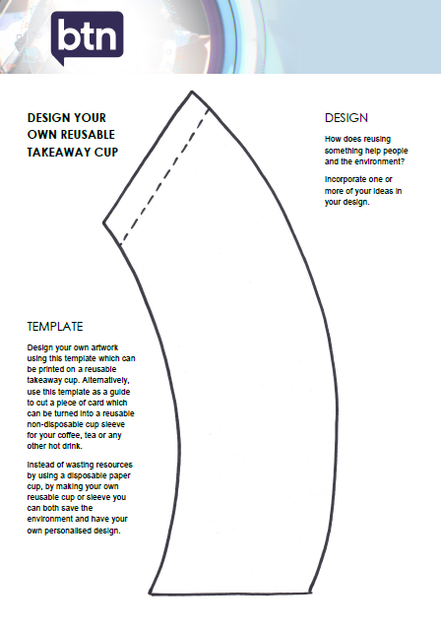
Evaluate and create
- Design your own artwork using this template which can be printed on a reusable takeaway cup. Alternatively, use this template as a guide to cut a piece of card which can be turned into a reusable cup sleeve for your coffee, tea or any other hot drink. Instead of wasting resources by using a disposable paper cup, by making your own reusable cup or sleeve you can save both the environment and have your own personalised design.

- Did it surprise you that disposable coffee cups are really difficult to recycle? Explore student’s general knowledge about what can and cannot be recycled. As a class talk about recycling, using the following questions to guide the discussion. How do you know what can and can’t be recycled? How do you find out if something can be recycled? How can we teach people to choose the right bin? Students will then design an education program to teach kids and teachers at their school about recycling. The practical guide will help people learn which items go to recycling, which items go in the waste bin and which items go in the green bin, compost or worm farm. Students will work with the SRC and canteen to implement the program.

- Can you imagine if your school was able to reduce its waste to just one wheelie bin per week? This is a bold mission that one Australian school set itself to help reduce waste and keep the earth clean (Link to ABC News report). Do you think your school could do more to reduce its waste? In small groups, students will brainstorm how their school can improve its recycling program and think of a bold mission to wipe out waste at their school. Make your idea happen! Each group will pitch their idea to the class or the SRC. Your task is to convince your classmates, teacher or SRC that your bold idea will help reduce waste and put their school at the forefront of recycling.
  - Students will reflect on the process by responding to the following questions. What worked well? What would you do differently next time? What parts of the activity did you enjoy, find challenging or find interesting?


BTN – Fashion Waste
http://www.abc.net.au/btn/story/s4663466.htm

BTN – Wipe out Waste
http://www.abc.net.au/btn/story/s4667338.htm

BTN – Landfill
http://www.abc.net.au/btn/story/s3953606.htm

ABC – War on Waste
http://www.abc.net.au/ourfocus/waronwaste/

BTN – Gorilla Girls Recycling
http://www.abc.net.au/btn/story/s4530722.htm

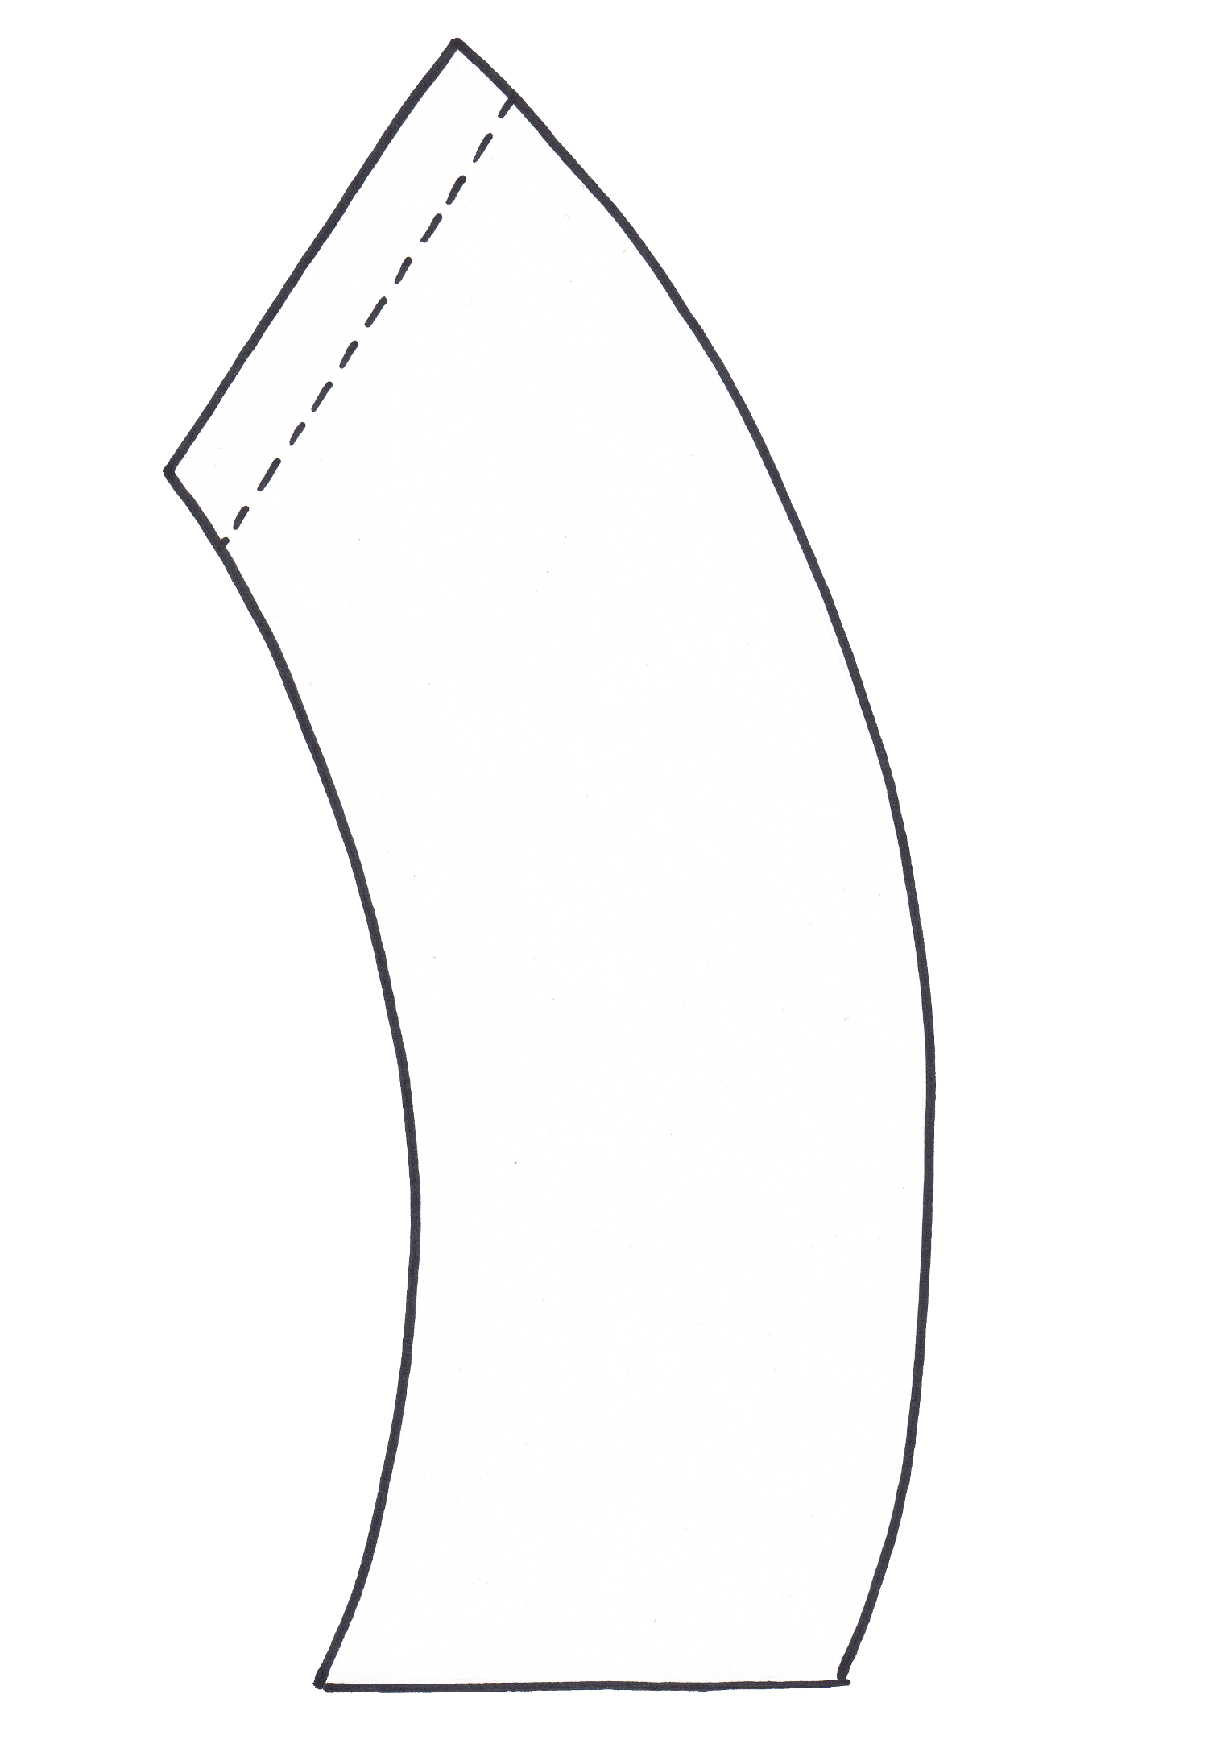
TEMPLATE
Design your own artwork using this template which can be printed on a reusable takeaway cup. Alternatively, use this template as a guide to cut a piece of card which can be turned into a reusable non-disposable cup sleeve for your coffee, tea or any other hot drink.
Instead of wasting resources by using a disposable paper cup, by making your own reusable cup or sleeve you can both save the environment and have your own personalised design.
DESIGN
How does reusing something help people and the environment?
Incorporate one or more of your ideas in your design.

DESIGN YOUR OWN REUSABLE TAKEAWAY CUP

Teacher Resource
Worm Wee
Students will investigate the role of worms in the ecosystem. Students will explore the process of starting and managing a worm farm at their school.

Science – Year 3
Science knowledge helps people to understand the effect of their actions.
Science – Year 4
Living things have life cycles.

Living things depend on each other and the environment to survive.

Science knowledge helps people to understand the effect of their actions.

Science – Year 5
Scientific knowledge is used to solve problems and inform personal and community decisions.

Science – Year 6
The growth and survival of living things are affected by physical conditions of their environment.

Science – Year 7
Interactions between organisms, including the effects of human activities can be represented by food chains and food webs.

HASS – Year 5, 6 & 7
Reflect on learning to propose personal and/or collective action in response to an issue or challenge and predict the probable effects.

- Before watching the BTN story discuss what you know about worms.
- Describe the habitat of worms.
- How do the tunnels that worms create in the soil help the environment?
- What do worms eat?
- What food shouldn’t be given to worms?
- Worms are nature's recyclers. What does this mean?
- Some worm species eat their entire body weight every day. True or false?
- What is worm juice?
- What are the kids in the Worm Wee story doing with the worm juice?
- Find an interesting fact about worms.


Class Discussion
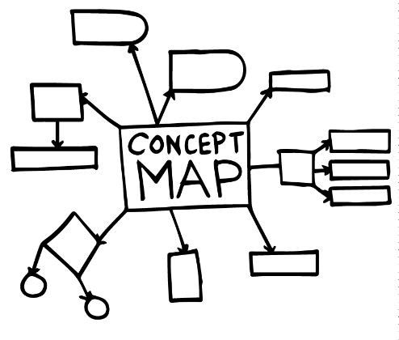
As a class discuss the BTN Worm Wee story using the following questions as a guide. Record the main points of discussion on a mind map with WORM WEE at the centre.

- What do you know about worms?
- What is a worm farm?
- How does a worm farm work?
- What is worm wee?
- What things do you need to make a worm farm? Make a list.
- Why are worms good for the garden? List the benefits.

Students will then respond to one or more of the following:
- Think of a question you would like to ask the kids featured in the BTN Worm Wee story.
- Leave a message in the comments section on the BTN Worm Wee story page.
- Finish one or more of the following sentences:
  - Worm wee is…
  - Worms are important because…
  - Worms can convert all sorts of things into compost by…


Glossary
Students will brainstorm a list of key words that relate to the BTN Worm Wee story. Students may want to use pictures and diagrams to illustrate the meaning and create their own glossary. Here are some words to get them started.

Fertiliser | Decompose | Waste
Food chain | Sustainability | Gardening
Compost | Organic | Decomposer

Scientific investigation
Provide students with the opportunity to think and behave like scientists. In this activity students will be given the mission to explore a natural habitat in their local area, identify worms in their habitat and document what they find. Students will work individually or in small groups and use the following as a guide.

  Plan | Plan a visit to a local nature reserve or your own school yard to explore and identify worms. Write a list of things you may need for the investigation, for example: pen and paper for taking notes, camera and magnifying glass. Predict where you might find worms and what you might see when you find them.
  Explore | Visit the habitat and carry out an exploration of the area. Choose a spot in the environment to investigate. Look and listen for evidence that worms live in the area. Remember worms are very fragile – please make sure worms are treated with care and respect during your observations.
Collect | Collect as much data as you can about worms and record what you find. Write notes and sketch what you see to help in your investigation. Record what you see with a stills or video camera.
Share | Return to the classroom and share/compare your findings.
Analyse | Analyse your findings and write a short summary of your investigation. Respond to the following questions:  - Did you find any worms during your investigation? If yes, identify and describe what you found. If you didn’t see any worms did you find any evidence that worms live in the area?  - What type of environment do worms like to live in?
Research | Research worms in more detail, and respond to one or more of the following:  - What do worms look like? Describe their physical characteristics. Do a scientific drawing of a worm labelling each part.  - What special features or adaptations do worms have to help them survive in their environment?  - What is its classification?  - What is the life cycle of a worm?  - What role do worms play in the ecosystem?  - Why are worms important?
Reflect | Reflect on the investigation by responding to one or more of the following questions:  - What did you enjoy about this investigation?  - What did you find surprising?  - What would you do differently next time?

Questions for inquiry
Students will develop their own question/s for inquiry about worms and their role in the ecosystem, collecting and recording information from a wide variety of sources. Students may develop their own question for inquiry or select one of the questions below.

- Worms are decomposers. What does this mean?
- Why do we need decomposers? Give examples of decomposers other than worms.
- Where are worms in the food chain? Draw a diagram showing what animal feeds on what. Use illustrations or photos to demonstrate this food chain. Explore what would happen to the food chain if there were no worms.
- What are the benefits of worms in the ecosystem?

Worm Farm project
In this activity students will investigate the following questions to learn more about the process of starting and managing a worm farm at school or home.

Students will respond to the following questions to learn more about the process of running a worm farm:
- What do you need to set up a worm farm?
- How do you set up a worm farm?
- Who is responsible for the worm farm?
- What worms are best suited to worm farms?
- How much will a worm farm cost to set up?
- How much will your school save by having a worm farm?
- What scraps can you feed the worms?
- How will you collect the scraps for the worm farm?
- How will you measure the amount of scraps to go in the worm farm?
- How often do you need to feed the worms?
- What environment do the worms need to survive?
- Where will the worm farm be kept?
- Where will the other materials for the worm farm come from? E.g. newspapers, cardboard, soil, brown matter.
- What food shouldn’t go in a worm farm?
- How will you collect the worm wee?
- How will you measure the amount of worm wee produced by the worm farm?
Individually or in small groups, students will then choose one of the following projects to work on and then present their findings to the class.
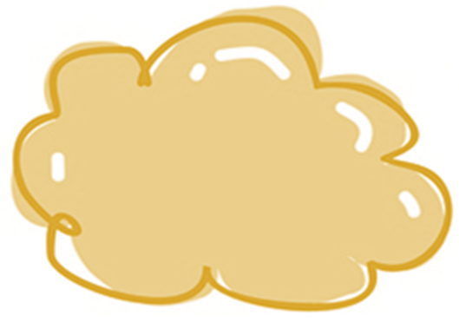

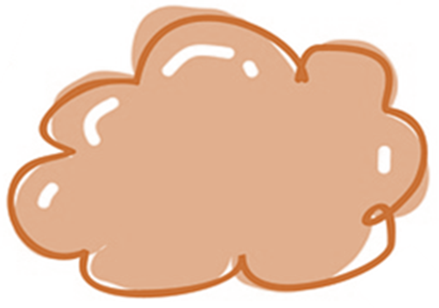
Instruction manual
Write an instruction manual with steps on how to make and care for a worm farm at your school. Consider using illustrations or photos to demonstrate steps in your instruction manual.

Persuasive writing
Write a letter to your principal explaining why your school should setup a worm farm. Research the environmental benefits of worm farms and include these points in your persuasive writing.
Audit
How much organic waste does your school produce? Conduct a waste audit and calculate how much waste your school would save going to landfill if you had a worm farm and composting system.
Poster
Create a poster to celebrate worms and their importance in the ecosystem or create a poster to send to schools with some handy tips on keeping a worm farm at school.



Worms – Australian Museum
https://australianmuseum.net.au/learn/animals/worms/

Worm Farm 101 – ABC Gardening Australia
https://www.abc.net.au/gardening/factsheets/worm-farm-101/11325460

Building a worm farm – Landcare Australia
https://landcareaustralia.org.au/wp-content/uploads/2016/05/Building-a-worm-farm-12.9-LR.pdf

Worms 3 Ways - ABC Gardening Australia
https://www.abc.net.au/gardening/factsheets/worms-3-ways/10838056

Gardening Guide: Worms – BBC
http://www.bbc.co.uk/gardening/gardening_with_children/didyouknow_worms.shtml

Teacher Resource
Endangered Seeds

Students will learn more about the importance of seeds and plants and create a profile of a native Australian plant.

Science – Year 4
Living things have life cycles.
Living things, including plants and animals, depend on each other and the environment to survive.

Science – Year 5
Living things have structural features and adaptations that help them to survive in their environment.

Science – Year 6
The growth and survival of living things are affected by the physical conditions of their environment.
- Discuss the main issues raised in the BTN Endangered Seeds story?
- How many plant species in WA are threatened with extinction?
- What is a seed bank?
- Where is the biggest seed bank in the world located? Find using Google Maps.
- How many different types of seeds does it hold?
- What type of plants does the seed bank in WA focus on?
  - Native plants
  - Exotic plants
  - Indoor plants
- What are the kids in the BTN story doing?
- What is the name of the plant they are looking after?
- How do the kids know when to harvest the seeds from the plant?
- Why is it important to collect seeds?

Reflect on the information in the BTN Endangered Seeds story and respond to the following questions:
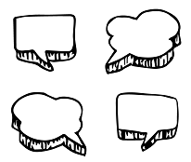
- Why do we need plants?
- What is the difference between a native and an introduced plant?
- What native plants do you know? Make a list.
- What things are threatening our native plants?
- What are seed banks?
- Why is it important to collect seeds?

Glossary of key terms
Students will create a classroom glossary of key words for the BTN Seed Kids story. Students will start by brainstorming words as a class using a mind map to record their responses.
Endangered | Threatened | Native
Conservation | Biodiversity | Species
Research Project: Native Plant Species
Students will choose a native Australian plant and create a profile. They can use the following structure to help guide their research.
Research project – Native Australian plant
Scientific and common name
Describe its appearance
What does it look like (shape, size, colour, special features)?

Locate where this species can be found using Google Maps

How does it survive in its environment? What are some of its adaptations?

Conservation Status
If this species is threatened or endangered, what are its threats?
Interesting facts
- What is your favourite thing about this species?
- What surprised you about your research?

Photograph or illustration

Get to know the plants in your school or back yard
- Students choose a plant in their school grounds or back yard.
- Describe the plant they have chosen using words and an illustration. Describe the different parts of the plant and any other interesting features.
- Can students identify what type of plant it is? Find its botanical name.
- Is the plant native or an introduced species?
- What are the plant’s measurements?
- Are there any bugs or wildlife on or near the plant? Describe.
- How much sun, shade and water does the plant get?

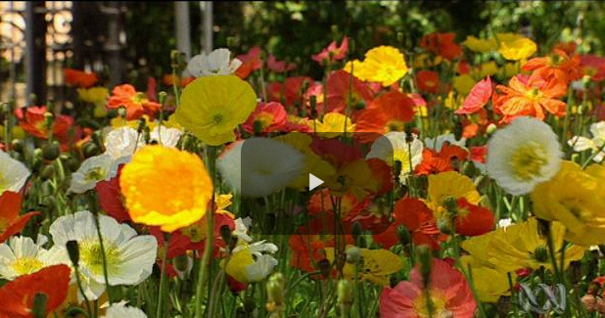
Flower Power
Students watch the video, Flowers: living factories for making seeds and answer the following questions:
- What role do flowers play in seed production?
- What adaptations do plants have to attract insects?
- Explore the different ways plants spread seeds such as wind, water or animals.
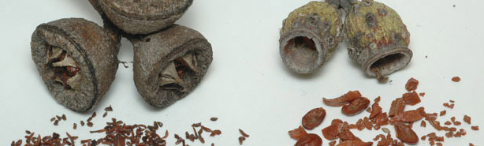
Start Collecting!
Get involved in seed collecting. Students collect samples of plants and remove the seeds for storing. Seeds need to be kept cool and dry in either cloth or paper (not plastic).
Image: Australian National Botanic Gardens

Students can learn more about the Doomsday Seed Vault by watching the BTN story then answer the following questions:
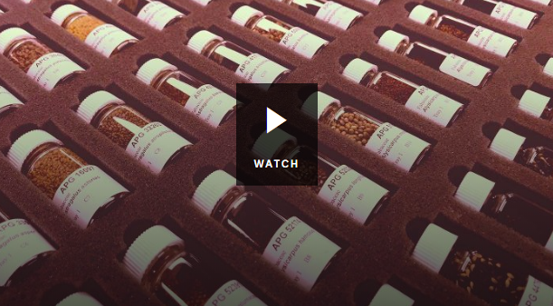
- Describe the Doomsday Seed Vault. What does it look like?
- Why was the seed bank created?
- Why is the seed bank also called the Doomsday Seed Vault?
- How many different types of seeds are stored in the bank?
- List some of the types of seeds that are stored in the seed bank.
- Australia is about to make its biggest deposit to the seed bank. True or false?
- How old is the Doomsday Seed Vault?

BTN – Plant Bank
https://www.abc.net.au/btn/classroom/plant-bank/10529572

BTN – Doomsday Vault
https://www.abc.net.au/btn/classroom/doomsday-seed-vault/10521828

Australian National Botanic Gardens – National Seed Bank
http://www.anbg.gov.au/gardens/living/seedbank/index.html

ABC Education – Curious Kids: Where did the first seed come from?
http://education.abc.net.au/newsandarticles/blog/-/b/3045789/curious-kids-where-did-the-first-seed-come-from

Teacher Resource
Eating Insects
Students will learn more about why people eat insects, the benefits of eating insects and create a profile of an edible insect.

Science – Year 4
Living things have life cycles.

Living things depend on each other and the environment to survive.

Science – Years 5 & 6
Scientific knowledge is used to solve problems and inform personal and community decisions.
- What did the BTN Eating Insects story explain?
- What type of food are food scientists in the Netherlands making out of larvae?
- Complete the following sentence. Insects can be fed on waste product like offcuts from _______ and ______________.
- What nutrients do insects contain?
- Insects need to be farmed in a large space. True or false?
- What are the benefits of farming insects over traditional livestock?
- Insects need to be farmed in places that have lots of water. True or false?
- Why do scientists say we need to start thinking of different food sources?
- Would you eat insects? Why or why not?
- What was surprising about the BTN story?

What do you see, think and wonder?
After watching the BTN Eating Insects story, students will respond to the following questions:

- What did you SEE in this video?
- What do you THINK about what you saw in this video?
- What did you LEARN from this story?
- What was SURPRISING about this story?
- What QUESTIONS do you have about this story?

Class Discussion
As a class discuss the BTN Eating Insects story, using the following questions as a guide. Record the main points of the discussion.
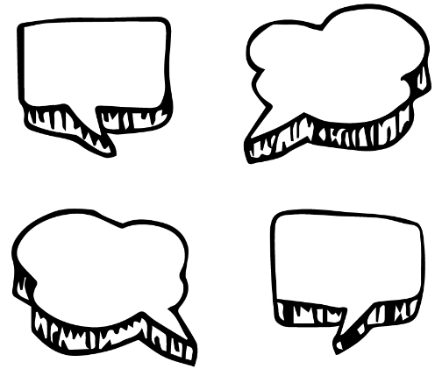
- Would you eat insects? Why or why not?
- What are the benefits of eating insects?
- What are insects a good source of?
- Why do you think there are more people in the world who eat insects than people who don’t?
Further Investigation
What is entomophagy? In which countries is entomophagy common? Locate on a world map.
Research Project: Edible Insect
Students will choose an edible insect and create a profile. Here are some possibilities:
- Cricket
- Mealworm
- Scorpion
- Witchetty grub
- Grasshopper

They can use the following structure to help guide their research.
Research project – Edible insect
Scientific and common name
Describe its appearance
What does it look like (shape, size, colour, special features)?

Habitat – Where does it live?

Life Cycle – Describe the stages of the life cycle

What does it taste like?

Photograph or illustration

Opinion Poll

Would you eat insects? Students will conduct their own opinion poll on the topic of eating insects. Working in groups, students will need to decide who their sample group will be and how many people will be polled. What method will they use to conduct the poll? (Face to face interviews or written responses).
- Ask students to graph the opinion poll results and display in the classroom.
- Students may want to film their interviews and then create a movie to present to other students.
- Students can compare their attitudes to that of their classmates and discuss their findings.

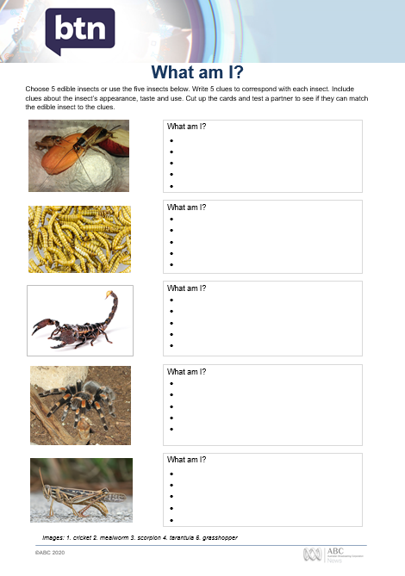
Edible Insects – What am I?
Students will make their own What am I? game to learn more about edible insects. To create the game, they will need to do the following:

- Research and write 5 clues to correspond with each edible insect in the What am I? worksheet at the end of this activity, with the first clue being the hardest and the last clue being the easiest.
- Include clues about the insect’s special features.
- Students will test their game on a partner.

Edible Insect Recipes
The BTN story explained how scientists in Belgium have experimented with insect fat to replace butter in waffles, cakes and biscuits. Ask students to research an edible insect recipe from around the world and find out the following information:
- Where does the recipe come from? Locate using Google Maps.
- What kind of insect is used in the recipe?
- How is the insect cooked?
- Why is this insect eaten in this region of the world?

Students will then design their own recipe that includes edible insects. They will need to think about ingredients, measurements, a procedure, cooking time and equipment required for their recipe. The class might want to collate the recipes to create their own cookbook

Bug Meal – BTN
https://www.abc.net.au/btn/classroom/bug-meal/10530562


What am I?
Images: 1
Choose 5 edible insects or use the five insects below. Write 5 clues to correspond with each insect. Include clues about the insect’s appearance, taste and use. Cut up the cards and test a partner to see if they can match the edible insect to the clues.
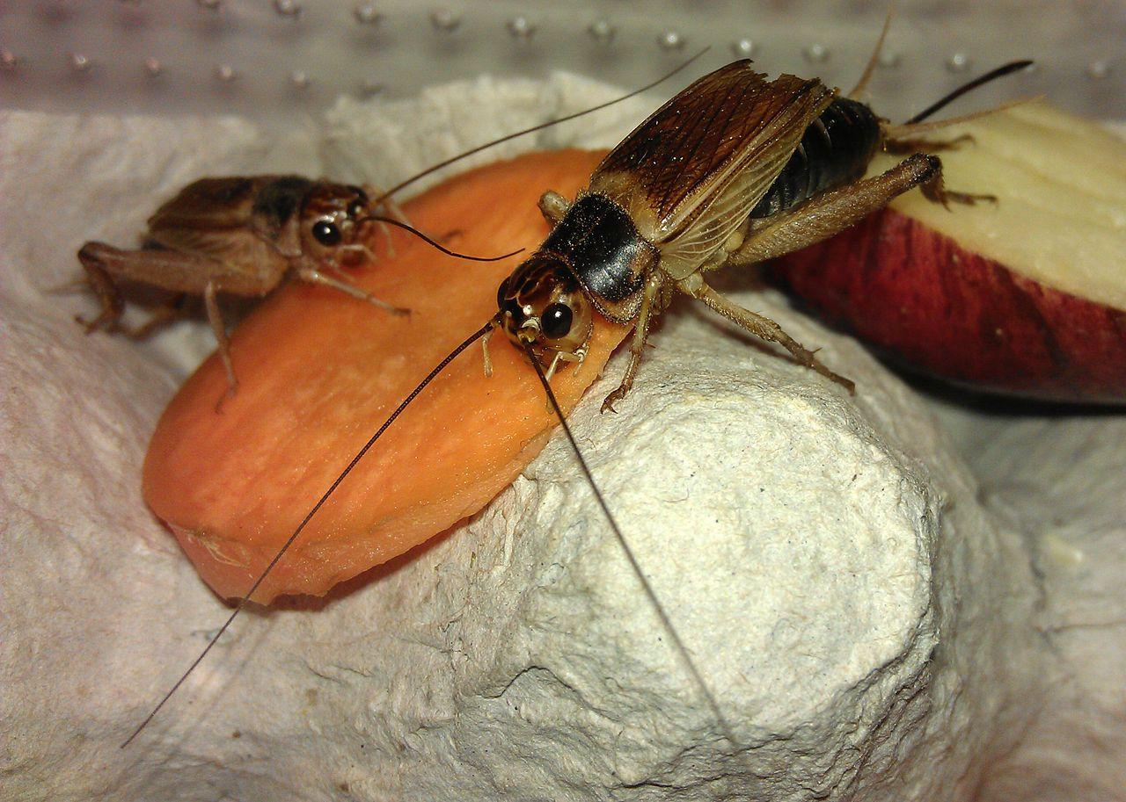
 |  | What am I?
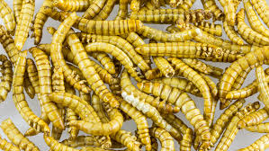 |  | What am I?
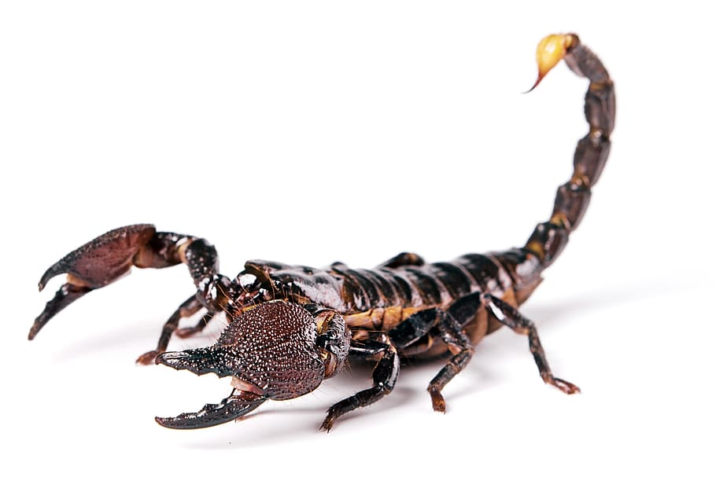 |  | What am I?
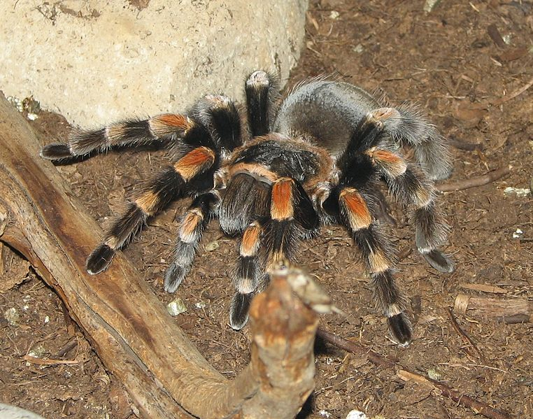 |  | What am I?
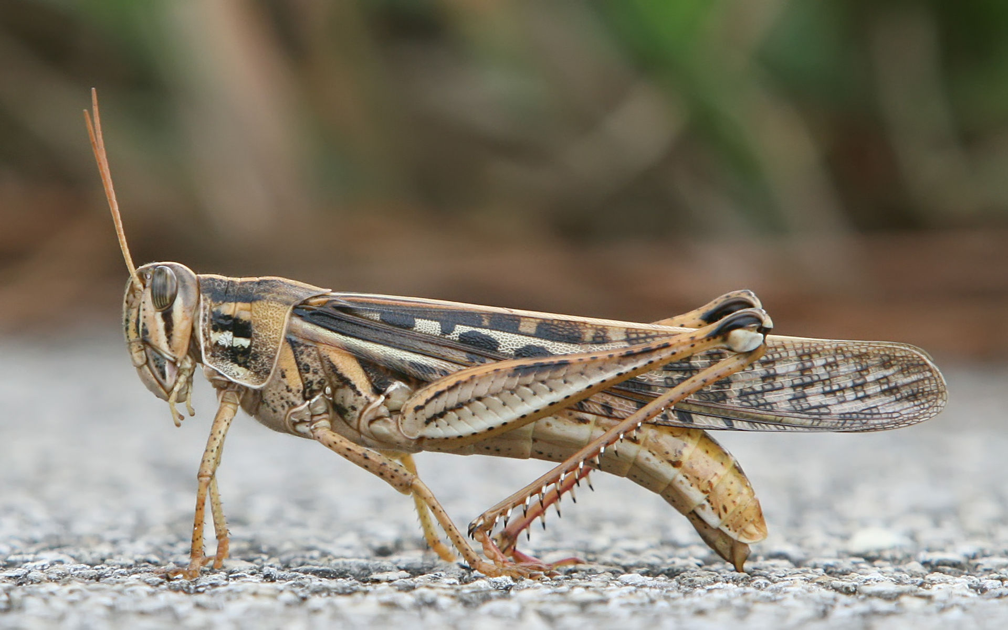 |  | What am I?
Images: 1. cricket 2. mealworm 3. scorpion 4. tarantula 5. grasshopper

