

Magna Carta
- Which special anniversary is Magna Carta celebrating?
- When did King John rule England?
- Why was he considered a bad leader?
- Describe who the barons were.
- Why did King John tax them?
- What happened on the 15th of June at Runnymede?
- What sorts of things did they make King John agree to?
- The rules were written down in a document which would later be known as what?
- Magna Carta is also known as The Great _______________.
- What did Magna Carta represent?
- Where are the principles of Magna Carta found?

What is Democracy?
- Before you watch the BTN story, record what you know about democracy.
- What happened in ancient Greece that led to people wanting a say in decision making?
- The word `democracy’ comes from which two words?
- Monarchies became popular in the Middle Ages. Explain what a monarchy is.
- Why was Magna Carta an important document?
- In Australia we have something called a ________________ democracy.
- Who represents us in parliament?
- What are the values that form the basis of democracy in Australia?
- Give an example of another form of government.
- What do you understand more clearly about democracy?

History of Voting
- Discuss the History of Voting story as a class and record the main points of the discussion.
- Who was allowed to vote in Australia in the 1800s?
- What does suffrage mean?
- Who were the suffragettes?
- When did women get the right to vote in Australia?
- When did all Indigenous people get the right to vote in federal elections?
- In which year did the voting age change from 21 to 18 years of age?
- Voting in Australia is not compulsory. True or false?
- Do you think the right to vote is important? Explain your answer.
- What was surprising about this story?

Teacher Resource

Magna Carta



Students will recognise the importance of Magna Carta in influencing Australia’s parliamentary government. Students will identify key elements of Australia’s system of law and their origins.


Civics and Citizenship – Year 6
The key institutions of Australia’s democratic system of government based on the Westminster system, including the monarchy, parliaments, and courts.

History – Year 6
Key figures and events that led to Australia’s Federation, including British and American influences on Australia’s system of law and government.

History – Years 4,5 & 6
Sequence historical people and events.

Use historical terms and concepts.


- Which special anniversary is Magna Carta celebrating?
- When did King John rule England?
- Why was he considered a bad leader?
- Describe who the barons were.
- Why did King John tax them?
- What happened on the 15th of June at Runnymede?
- What sorts of things did they make King John agree to?
- The rules were written down in a document which would later be known as what?
- Magna Carta is also known as The Great _______________.
- What did Magna Carta represent?
- Where are the principles of Magna Carta found?


Discuss the BTN Magna Carta story. What questions were raised in the discussion (what are the gaps in their knowledge)? The following KWLH organiser provides students with a framework to explore their knowledge on this topic and consider what they would like to know and learn.

What do I know? | What do I want to know? | What have I learnt? | How will I find out?

Magna Carta

Watch this British Library animation about Magna Carta, and respond to the following questions.

- Magna Carta is one of the most famous documents in the world. What does this mean?
- Why was Magna Carta originally created?
- Magna Carta has become a powerful symbol of our rights and freedoms. Imagine what life would be like if Magna Carta didn’t exist.

Students will research, design and illustrate their own comic strip explaining what Magna Carta is and how it has influenced Australian law. Write an informative description to match each illustration. Watch this animation for ideas. Alternatively, provide students with a range of screen grabs (see below) from the animation, and ask students to write a caption for each image.

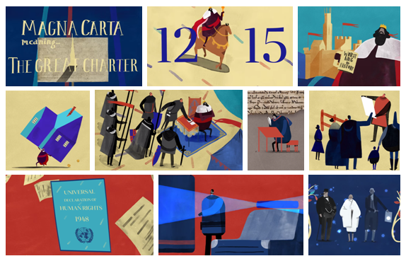

Magna Carta – The right to a fair trial
Magna Carta makes reference to the rights of individuals. One of the most celebrated sections is credited with establishing the principle of a right to a fair trial. It states:

No free man shall be seized or imprisoned, or stripped of his rights or possessions, or outlawed or exiled, or deprived of his standing in any other way, nor will we proceed with force against him, or send others to do so, except by the lawful judgement of his equals or by the law of the land.
To no one will we sell, to no one deny or delay right or justice.

This declaration of individual rights has been seen as an important step towards the development of democracy and has influenced documents such as the Australian Constitution. It gave all free men the right to justice and a fair trial.

Read this part of Magna Carta as a class and then find answers to the following questions.
- What do we mean by democracy?
- Where does the word democracy come from? Find a definition as a class.
(Democracy comes from the Greek words demos meaning ‘the people’ and kratos meaning ‘power’. Effectively, the word ‘democracy’ means ‘people power’ – the right of people to make decisions on how they are governed.)
- Everyone has the right to a fair trial. What does this mean?
- How would our lives be different without democracy?

Class mock trial
Convert the classroom into a courtroom, and conduct a mock trial using this script: Mock Trial - a script and how to guide for the case: Goldilocks v. The Three Bears.

- Before starting this activity teach students about the purpose of trials and the procedure involved. Learn about the roles of the people in a courtroom including the judge, prosecution lawyer, defence lawyer, defendant, witness and jury. Introduce students to appropriate legal vocabulary.

- Consider visiting your local law court to learn more about the courts functions and processes.
  - Courts Administration Authority of SA (virtual tour available)
  - The Law Society of NSW
  - Legal Aid Queensland

- As a class read the Goldilocks and the Three Bears fairy tale. Tell students that Goldilocks is on trial for her crimes and respond to the following questions:
  - What happened in the story?
  - What crime/s did Goldilocks commit?
  - What evidence do you have?
  - Do you think Goldilocks should be punished for her crimes?
  - What would be a fair punishment?
  - What defence does Goldilocks have for her crimes?
  - What questions would you ask Goldilocks in a trial?
  - What questions would you ask the Three Bears?
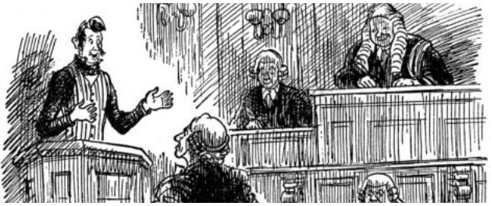
- Set up a mock trial with a judge and jury, to determine the guilt or innocence of Goldilocks. Students should be selected to play the main roles, and then groups formed to assist each witness and lawyer prepare for the trial. Use this play script for your class mock trial, with each role reading their part aloud. Consider rotating students in the various roles to ensure each student is involved in the process. This script may be read over the course of a week. Alternatively, choose an excerpt from the script to give your students an experience of the process.

- Students will develop and write their own persuasive argument either for or against Goldilocks and suggest appropriate punishment (if any). Alternatively, students can prepare a newspaper or TV report of the proceedings.

Historical perspective
In this activity students will understand that key civic terms used in Australia (e.g. democracy, citizen, government and parliament) have been inherited from other times and places.

Australia set up is first parliament in 1901. Compared to some parliaments around the world, Australia’s is quite young, but it is based on practices and ideals from parliaments in centuries past. Research the origins of parliament and present your findings in a timeline which highlights significant events. Include 1 or 2 interesting facts for each event on your timeline. Find similarities and differences between ancient parliament and Australia’s parliament now.

Reflect on ways in which people in ancient societies were governed and compare to Australia today

2500 BC
There is evidence that citizens’ assemblies were held in ancient Mesopotamia as far back as 2500 BC.

509 BC
The Roman Republic was founded. The senate comprised of 300 members who were chosen from wealthy and noble families.

500 BC
The Ancient Greeks establish an assembly. They met 40 times a year and it was attended by male citizens over the age of 18.



Parliamentary Education Office – A Short History of Parliament
http://www.peo.gov.au/learning/closer-look/short-history.html

Parliamentary Education Office – Magna Carta
https://peo.gov.au/understand-our-parliament/history-of-parliament/history-milestones/magna-carta/

British Library – Magna Carta
http://www.bl.uk/magna-carta/videos/what-is-magna-carta

CBBC Newsround – Guide: What is Magna Carta?
http://www.bbc.co.uk/newsround/31093809

Behind the News – Child Rights
http://www.abc.net.au/BTN/story/s4126803.htm

Teacher Resource

What is Democracy?

Students will investigate the main events that led to democracy in Australia. Students will evaluate who represents them on a local, state and federal level.

Civics and Citizenship – Year 5
The key values that underpin Australia’s democratic system of government.

The roles and responsibilities of electors and representatives in Australia’s democracy.

The key features of the Australian electoral process.

Civics and Citizenship – Year 6
The key institutions of Australia’s democratic system of government based on the Westminster system, including the monarchy, parliaments, and courts.
- Before you watch the BTN story, record what you know about democracy.
- What happened in ancient Greece that led to people wanting a say in decision making?
- The word `democracy’ comes from which two words?
- Monarchies became popular in the Middle Ages. Explain what a monarchy is.
- Why was Magna Carta an important document?
- In Australia we have something called a ________________ democracy.
- Who represents us in parliament?
- What are the values that form the basis of democracy in Australia?
- Give an example of another form of government.
- What do you understand more clearly about democracy?



Have your say
Before watching the BTN What is Democracy? story, ask students to make some predictions about what the story might be about. Students will compare and contrast their predictions with other classmates.

After watching the BTN What is Democracy? story, discuss as a class. What questions were raised in the discussion (what are the gaps in their knowledge)? The following KWLH organiser provides students with a framework to explore their knowledge on this topic and consider what they would like to know and learn.

What do I know? | What do I want to know? | What have I learnt? | How will I find out?

Students will develop their own question/s for inquiry, collecting and recording information from a wide variety of sources (internet, books, newspaper and magazines). Alternatively, students can respond to one or more of the following questions.

- Where does the word democracy come from?
- Australia is a democratic society. What does this mean?
- How would our lives be different without democracy?

Glossary
Create your own glossary about democracy. Start by brainstorming words using a mind map to record your ideas. Add to your list of words by downloading the BTN What is Democracy? story transcript and highlighting all the words that relate to democracy. Find definitions for each word. Consider using pictures and diagrams to illustrate meanings.

Democracy | Fair vote | Fair trial
Election | Undemocratic | Politics
Citizen | Government | Rights
Representative | Values | Decisions

Challenge students by asking them to use words from their class glossary to write their own sentences. Alternatively, students can make their own crossword puzzle or word find.

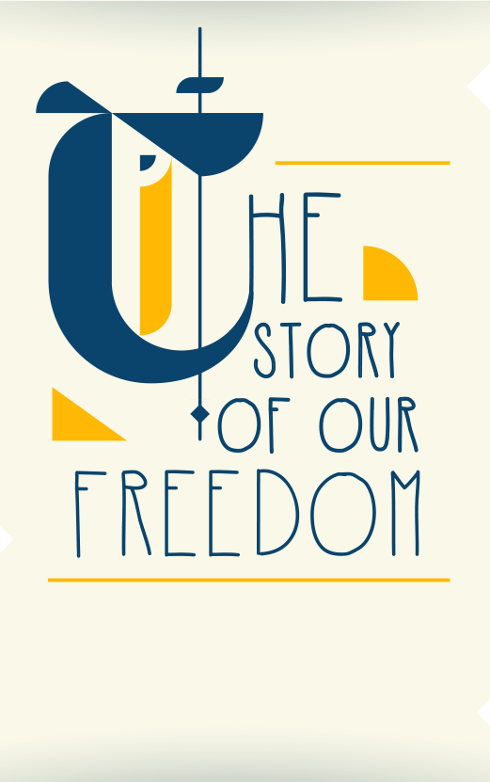

Telling the story of Australian democracy
Take a look at this fun and engaging infographic, The Story of Our Freedom, to get a picture of the origins of democracy and how it has influenced our rights and freedoms today.

Timeline
Create your own timeline highlighting the main events that led to democracy in Australia. Research the origins of democracy and what democracy looks like in Australia today. Include three significant facts about each event. Reflect on ways in which people in ancient societies were represented and compare to Australia today.
Source: Australia Human Rights Commission

Think of a creative way to present your timeline. You may want to use this Read Write Think timeline to organise your information.

Representative Democracy
In Australia we have something called a representative democracy. That means that unlike in ancient Greece where everyone went to meet and vote on laws, we elect a representative to do that for us. They're our politicians and they represent us in parliament. It's their responsibility to keep in touch with their voters and make sure their voices are heard on a national level.

What makes a good representative?
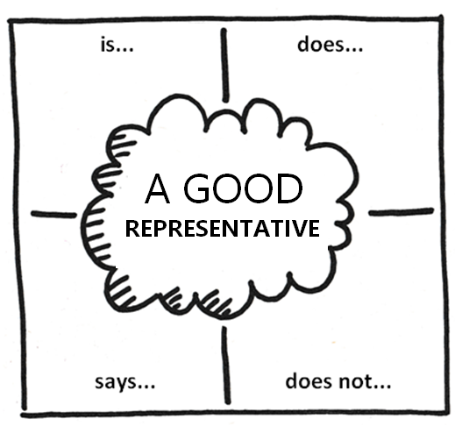
What do you think makes a good representative? Brainstorm and list what a good representative ‘is’, ‘does’, ‘does not’ and ‘says’. Record your ideas on the class whiteboard. For example:
- honest
- good at communicating
- confident
- has a positive attitude
- commitment
- creative
- inspiring

What are some examples of good representatives in politics? Can you name a good representative at the local, state/territory or national level?

Who represents you in your electorate?
Find out which electorate your school is located in and who representatives you in your local area.
- Go to the Australian Electoral Commission website to find your electorate.
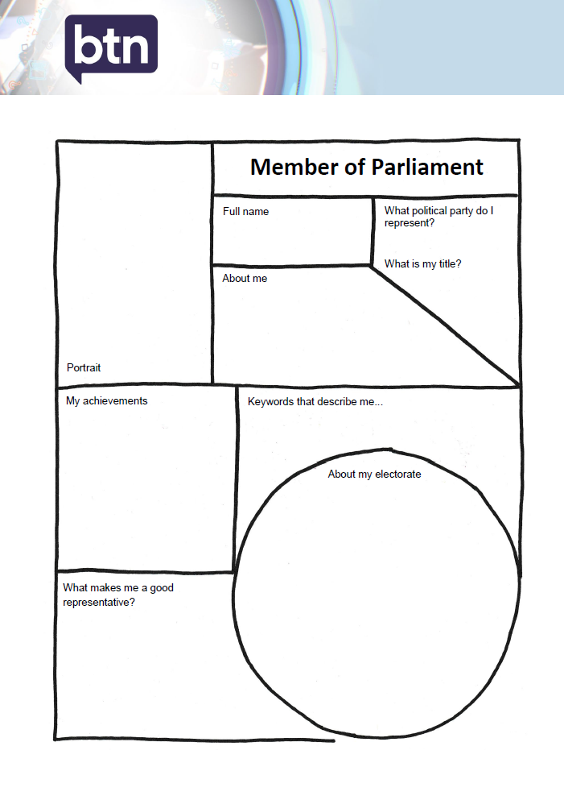
- Find more information on the electorate that your school is situated. On a map locate your school and draw the boundary of your electorate.
- Create a profile on your local Member of Parliament, using the template at the end of this activity.
  - Who is the current member for this electorate?
  - What political party do they represent?
  - Can you find out who else is ‘running’ for this electorate?
  - Is it a safe or marginal seat? Watch this BTN story to learn more about Marginal Seats.

Interview your local Member of Parliament
Imagine if you were given the opportunity to interview your local Member of Parliament (MP) on behalf of your school. Your task is to write a list of interview questions that you would like to ask the MP. Remember to write open-ended questions. Open-ended questions have no right or wrong answer and can’t be answered with a ‘yes’ or ‘no’. Before writing your questions, you will need to think about the following:

- What do you want to find out about your local MP?
- Find out what they like about their job and what characteristics they think make a good representative.
- What are their viewpoints on issues important to your community?
- What issues would you like to ask about?
- Choose a topic that is important to you and your school community. What do you want your local representative to do about it?

Who represents you in your school community?

What makes your school a democratic community?
- Who makes decisions at your school? Give examples.
- What decisions do you make personally?
- Are many decisions made through representation?
- How do your school representatives know what you want?
- Who represents you on the School Representative Council (SRC)?
- How important is it for us to have good representatives that make decisions on our behalf?
- How can teachers, students and parents have a say in what happens in your school community?

Democratic values
As a class, discuss the meanings of the key values that underpin Australia’s democratic system of government: freedom, equality, fairness and justice. What does each value mean to you? Why are these values important? Write your ideas on post-it notes and share with the class.

What democratic values are important to your school?
- Make a list of values that you think are important in your school community - care and compassion; doing your best; fair go; freedom; honesty and trustworthiness; integrity; respect; responsibility and understanding, tolerance and inclusion.
- Does your SRC already have a set of values? What are they?
- How recently were your SRC values reviewed?
- Hold an all school survey (including students, teachers and parents) to find out what values are most important to your school community. Plot your results on a graph and write a few paragraphs summarising your findings. Provide feedback to the SRC presenting your findings.
- What are your school’s key values? Create an eye-catching poster to put up around your school to remind your school community of these values.

Listening tour
Are you a representative on your SRC? How do you connect with people in your community to find out how to best represent them?

Ask students to conduct their own listening tour at their school. A listening tour is an opportunity to talk with teachers, students and parents to hear firsthand what is important to them in their community. You can find out what your community wants changed and what they already see as working. Students can conduct their own tour through surveys, interviews and/or questionnaires.

Here are some ideas for questions:
- What are you passionate about (what issues are important to you)? Rate on a scale of 1 to 10.
- What concerns do you have about the future?
- How do you think things could be done better in your community?
- Do you think you can have an impact on change in the community?

Consider taking your listening tour results to your next SRC meeting, local council or politician to influence change in your local community.

Reflection
- How did conducting the listening tour make you feel? Consider the impact that you can have on social change and the empowerment of people in the community.
- What surprised you when completing the activity?

ABC Education – Democracy
http://splash.abc.net.au/home#!/topic/500542/democracy

Human Rights Commission – The story of our freedom (infographic)
https://www.humanrights.gov.au/magnacarta/infographic/

BTN – Magna Carta
http://www.abc.net.au/BTN/story/s4247986.htm

Museum of Australian Democracy – Defining Democracy
http://moadoph.gov.au/democracy/defining-democracy/

Australian Electoral Commission – Democracy Rules
http://education.aec.gov.au/democracy-rules/

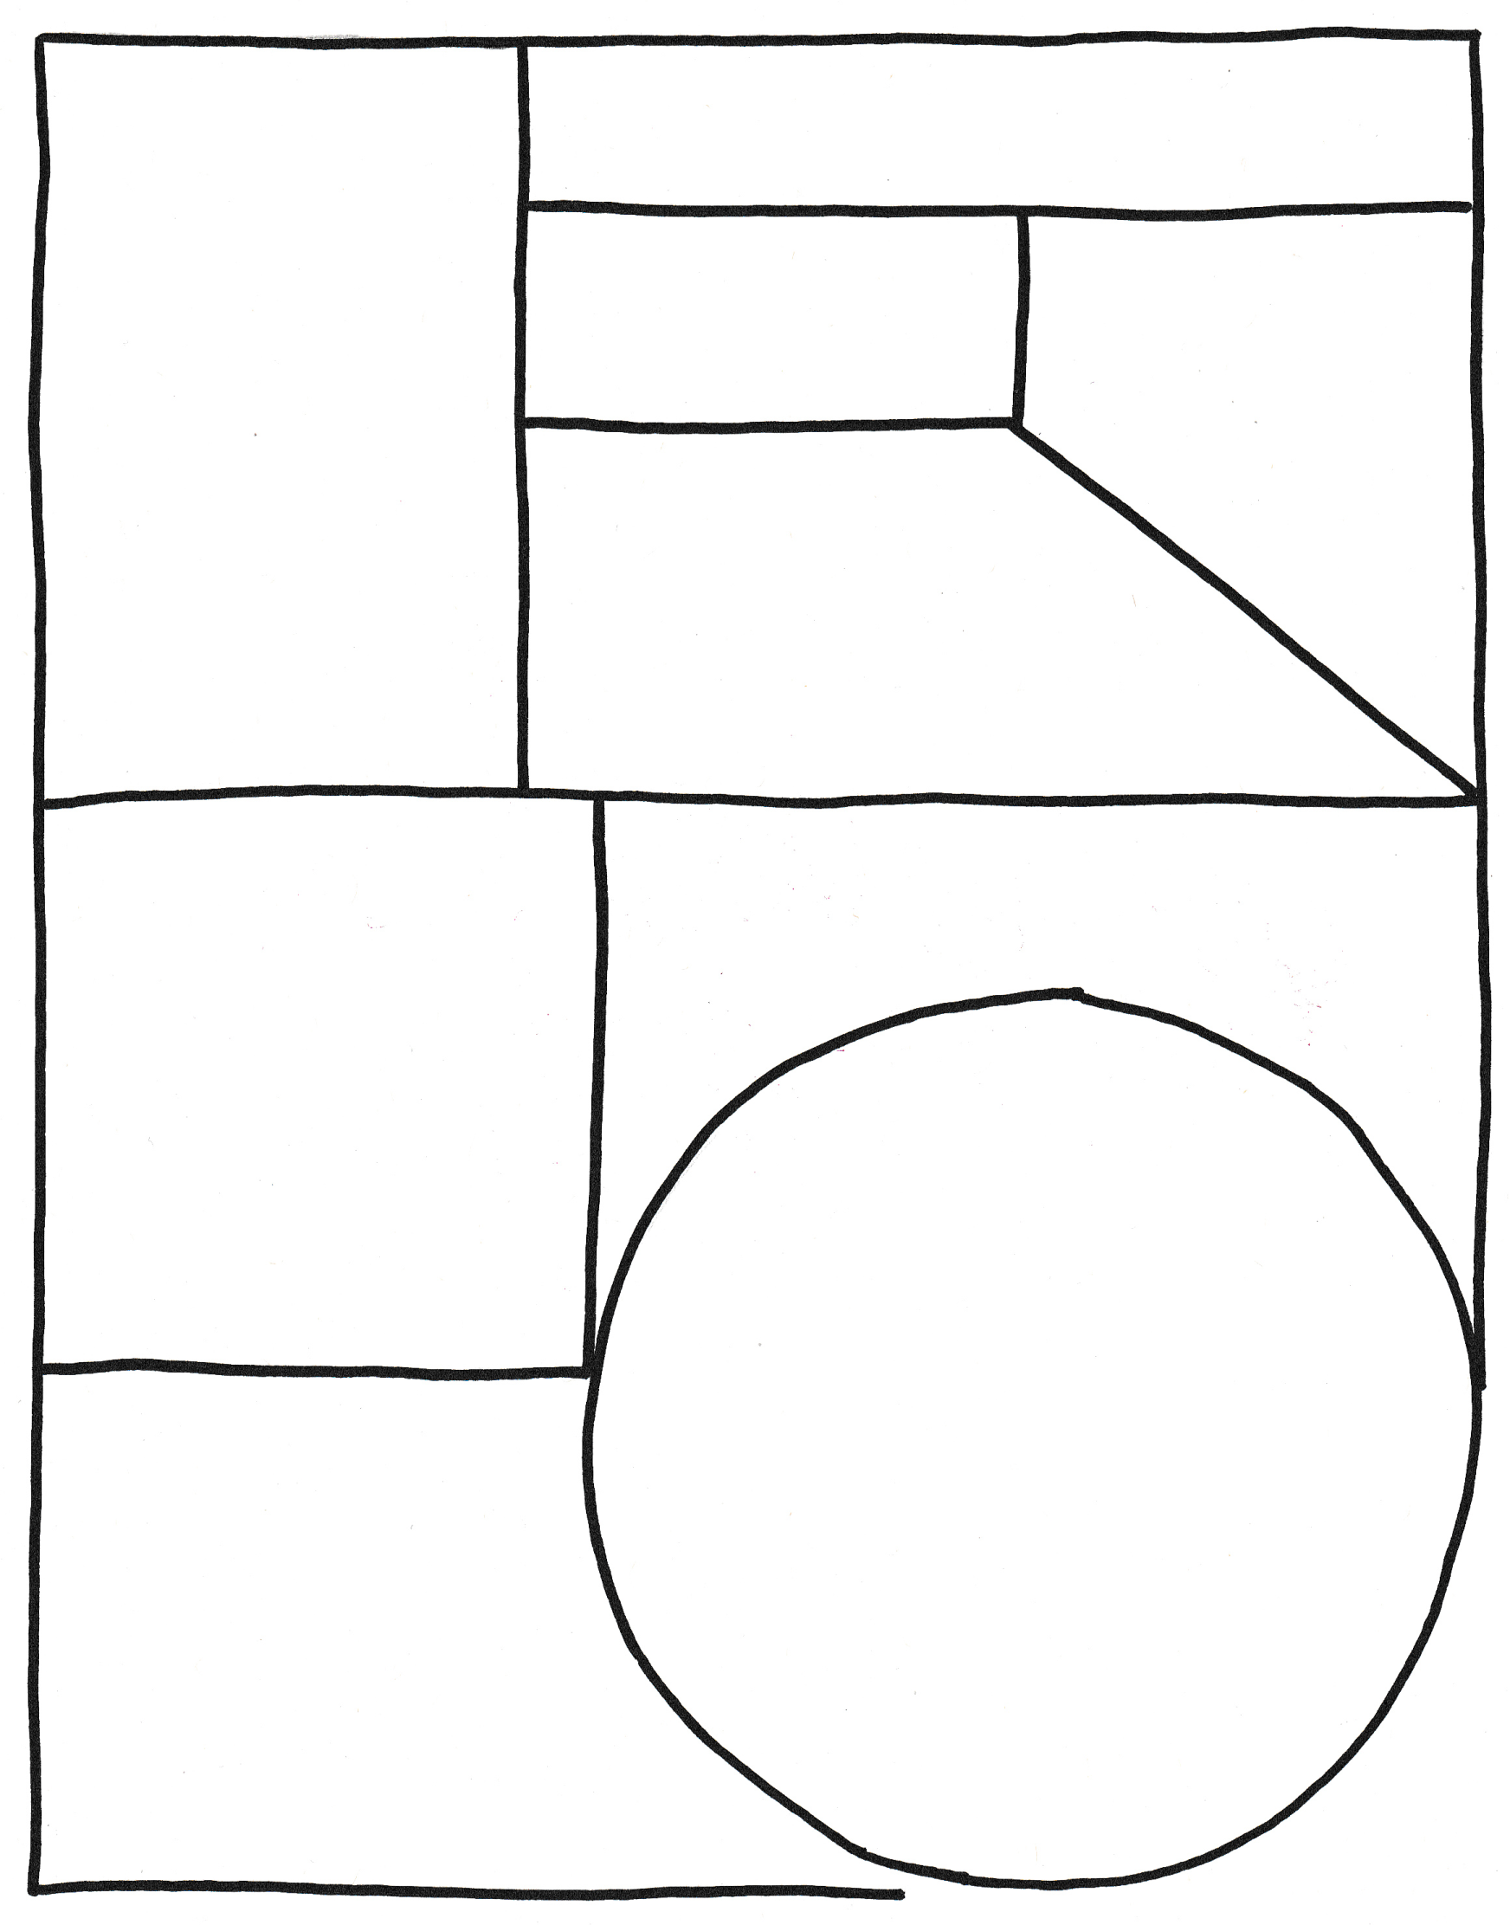
Full name
Portrait
My achievements
What makes me a good representative?
About me
About my electorate
What political party do I represent?
Member of Parliament
What is my title?
Keywords that describe me...

Teacher Resource

History of Voting

Students will investigate the history of voting and analyse significant events that have shaped Australia’s system of voting.

Civics and Citizenship – Year 5
The roles and responsibilities of electors and representatives in Australia’s democracy.

The key features of the Australian electoral process.

History – Year 6
Experiences of Australian democracy and citizenship, including the status and rights of Aboriginal and Torres Strait Islander Peoples, migrants, women, and children.
- Discuss the History of Voting story as a class and record the main points of the discussion.
- Who was allowed to vote in Australia in the 1800s?
- What does suffrage mean?
- Who were the suffragettes?
- When did women get the right to vote in Australia?
- When did all Indigenous people get the right to vote in federal elections?
- In which year did the voting age change from 21 to 18 years of age?
- Voting in Australia is not compulsory. True or false?
- Do you think the right to vote is important? Explain your answer.
- What was surprising about this story?



What is voting?

Before watching the BTN History of Voting story, ask students what they already know about voting. Use a mind map to record students’ responses.

- What is voting?
- Why is voting important?
- Who can vote in Australian federal elections?
- How old do you have to be in Australia to vote?
- Is voting compulsory?

Class discussion
Have you ever voted? Think of different situations where you have been able to have your vote. For example, in the classroom with hands-up voting, at home in family decisions or at clubs voting for new members.

How do you know there is an election coming up? There are a lot of signs an election is near, for example, news stories, posters on stobie poles, parents talking about it or letters in the mail. Discuss as a class.

Class glossary
Create your own classroom glossary about voting. Start by brainstorming words as a class using a mind map to record your responses. Add to your list of words by downloading the BTN History of Voting story transcript and highlighting all the words that relate to voting. Find definitions for each word. Consider using pictures and diagrams to illustrate meanings.

- vote  - election  - ballot box  - ballot paper  - candidate  - political party  - electoral roll  - secret ballot | - donkey vote  - poll  - formal vote  - informal vote  - preferential voting  - campaign  - nominate  - compulsory voting

Challenge students by asking them to use words from their class glossary to write their own sentences. Alternatively, students can make their own crossword puzzle or word find.

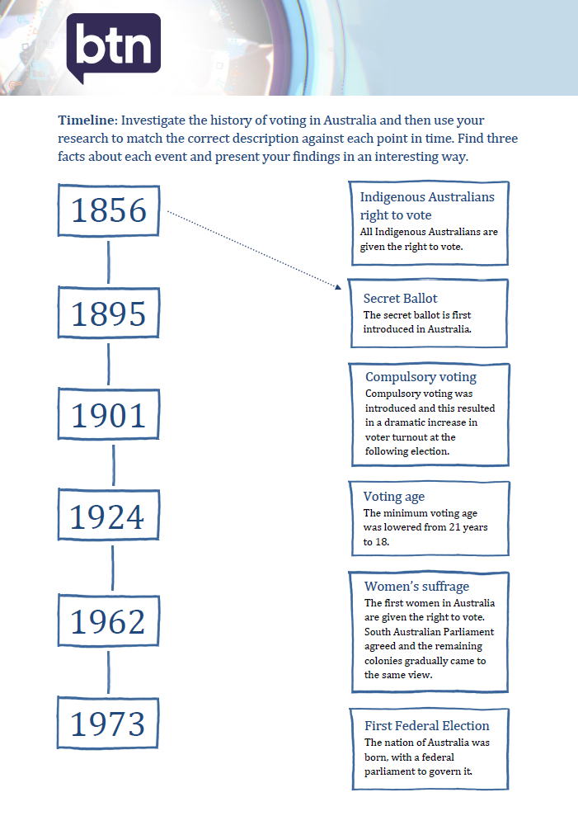
Timeline of voting
Research the history of voting in Australia. Download this template and use your research to help match the dates to key events in Australia’s history of voting.

Students will then respond to one or more of the following questions:
- Find three interesting facts about each significant event.
- Imagine what it was like not being able to vote because you are a woman or because you are Indigenous. Write a journal entry explaining your lack of rights and how it feels not being able to vote. Students will use their research findings to support their writing.
- How would you feel not being able to vote because of colour, race, gender or financial status? Was this fair? Was this democratic? Why do they think the right to vote has changed over time?
- Which dates on the timeline do you think are especially significant? Why?

Suffragette movement
Provide your students with the opportunity to act like an historian in the classroom. Students will develop an understanding of the suffragette movement and then present their findings in an interesting way.

Act like an historian
- What does suffrage mean? Find a dictionary meaning.
- Describe the suffragette movement.
- Imagine you are a suffragette living in the late 1800s. Write a persuasive letter to your local government, write a newspaper article or start a petition explaining why women should be able to vote.

Further investigation – Timeline
Students will find answers to the questions below and then create their own timeline on the suffragette movement.

Research questions
- When were women first given the right to vote in Australia? This may differ from state to state.
- When were indigenous Australian women given the right to vote?
- When were women first given the right to stand for federal parliament in Australia? This may differ from state to state.
- Who was the first woman elected as a member of parliament in Australia?
- Who was the first Australian female Prime Minister?

Can you find any other important events that have contributed to gender equality in Australia’s history? Include these in your timeline.

Whilst Australian women gained the right to vote in the late 1800s, many women around the world still do not have the right to vote. Ask students to find out where in the world women still do not have the vote. Students will highlight their findings on a world map.

Visual literacy
Below are two photographs depicting significant events in Australia’s history of voting. Look at the images below (alternatively find your own images using the internet) and then respond to the following questions:
- What is happening in the image?
- Where do you think it was taken?
- How do you think they might be feeling?
- Is there a message about democracy that comes across in the image? Explain.
- What question/s would you like to ask the people in the image?
- Create a caption for each image.

After you have responded to the above questions click on the link for each image to find out what is happening and compare to your responses.

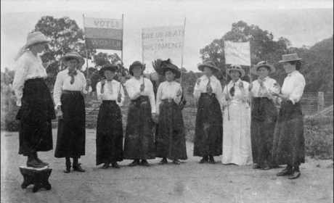

Source – State Library of WA (link to image)

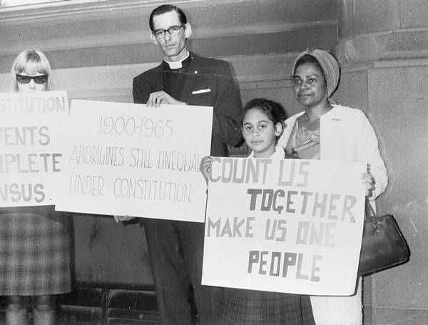

Source – National Museum Australia (link to image)

Secret Ballot
Choose a common classroom rule to vote on. Conduct an (open vote) with students on the classroom rule either for or against by putting up their hand. Now vote on the same classroom rule but students will vote using the secret ballot system.

Discussion questions:
- How does an open vote feel?
- How does a vote using the secret ballot system feel?
- Were there differences in the outcome of the votes?
- Did having no privacy influence your decision at all? How did it affect how you voted?
- How does it make you feel when others know what you want and feel?
- What are the possible reasons for people voting in a different way?

Ask students to share their responses in small groups and use either a plus, minus and interesting or SWOT (strengths, weakness, opportunities, threats) chart to display the information.

Students will learn more about how the secret ballot works and investigate why the secret ballot was introduced to Australia’s voting system.
- What is a secret ballot?
- Investigate the history of the secret ballot
- When was the secret ballot introduced in Australia?
- Why is the secret ballot important to Australia’s voting system?

Voting Age
In Australia it's compulsory to vote in a federal election when you turn 18, but even more importantly voting gives young people the opportunity to choose who represents them in parliament. It's estimated that approximately only one in two 18 year olds and that approximately two in three 19 year olds are enrolled to vote. That's a lot of young voices missing out on having a say in who runs their country.

Write a persuasive letter convincing 18 year olds to enrol and vote. Before writing your letter think about the following:
- Why do you think 18 year olds might not enrol to vote?
- Why is it important to vote?
- Why is voting an important right?
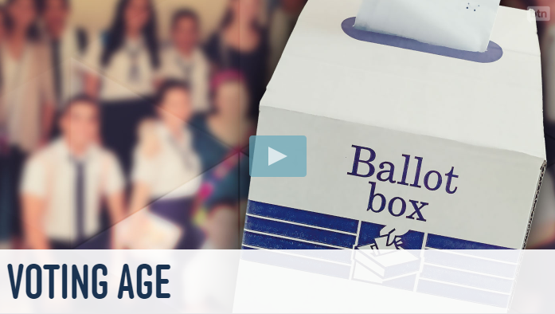
Do you think lowering the voting age from 18 to 16 would encourage more young people to enrol and vote in a federal election? Watch BTN’s Voting Age story to learn more about the debate.

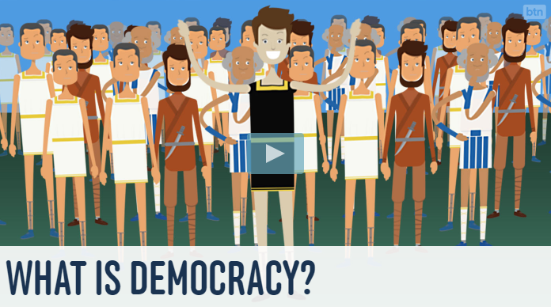
A lot of people in the world don’t have the right to vote. Do you think it is an important right to be able to vote in a federal election? Watch BTN’s What is Democracy? story to learn more about the origins of democracy and how it has influenced our rights and freedoms today.

Run your own election
Running an election for your class provides the opportunity for students to participate in the democratic process of choosing representatives for a range of purposes. Students will run their own election and investigate how the preferential voting system works.

Watch BTN’s Preferential Voting story to find out why people’s preferences matter on election day. Visit the Australian Electoral Commission’s Get Voting website. Get voting is everything you need to run a free and fair election for your class.

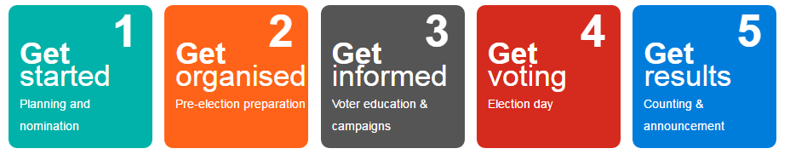

BTN – Preferential Voting
http://www.abc.net.au/BTN/story/s3835708.htm

BTN – Voting Age
http://www.abc.net.au/BTN/story/s4345701.htm

BTN – Youth Vote
http://www.abc.net.au/BTN/story/s3809181.htm

Australian Electoral Commission – Get Voting
http://education.aec.gov.au/getvoting/content/resources.html

Australian Electoral Commission – Australian Voting History in Action
http://www.aec.gov.au/About_AEC/25/theme1-voting-history.htm

Civics and Citizenship Education – Electoral events timeline
http://www.civicsandcitizenship.edu.au/cce/electoral_events_timeline_ls,9491.html

Timeline: Investigate the history of voting in Australia and then use your research to match the correct description against each point in time. Find three facts about each event and present your findings in an interesting way.



Indigenous Australians right to vote
All Indigenous Australians are given the right to vote.
1856



Secret Ballot
The secret ballot is first introduced in Australia.

1895


Compulsory voting
Compulsory voting was introduced and this resulted in a dramatic increase in voter turnout at the following election.

1901


Voting age
The minimum voting age was lowered from 21 years to 18.

1924


Women’s suffrage
The first women in Australia are given the right to vote. South Australian Parliament agreed and the remaining colonies gradually came to the same view.

1962
1973


First Federal Election
The nation of Australia was born, with a federal parliament to govern it.

