
EPISODE 19
21 July 2026

KEY LEARNING
Students will view a range of BTN stories and use comprehension skills to respond to a series of focus questions.

CURRICULUM
English – Year 4
Use comprehension strategies such as visualising, predicting, connecting, summarising, monitoring and questioning to build literal and inferred meaning, to expand topic knowledge and ideas, and evaluate texts.
English – Year 5
Use comprehension strategies such as visualising, predicting, connecting, summarising, monitoring and questioning to build literal and inferred meaning to evaluate information and ideas.

English – Year 6
Use comprehension strategies such as visualising, predicting, connecting, summarising, monitoring and questioning to build literal and inferred meaning, and to connect and compare content from a variety of sources.

  - Teacher Resource

Focus Questions
As a class, discuss the stories featured in the episode of BTN Classroom and record the main points of the discussion. Students will then respond to the following focus questions.

Telco Trouble
- What impact did the recent Telstra outage have?
- What happened to the Triple Zero emergency system?
- You should be able to call Triple Zero even if your network isn’t working. True or false?
- Name three facts you learnt watching the BTN story.
- What questions do you have about this story?

Bird Flu
- Summarise the BTN Bird Flu story in 2-3 sentences.
- Why is it difficult to stop bird flu from spreading?
- Bird flu can spread to mammals. True or false?
- What impact could bird flu have on the poultry industry and native species?
- If you notice a sick or dead bird, what should you do to protect yourself and stop the virus from spreading?

CSIRO Centenary
- In pairs, discuss the BTN story. Record the main points of the discussion and share them with another group.
- Name three inventions made by the CSIRO.
- Choose one of the inventions. How has it changed people’s lives?
- Is it important to invest in scientific research? Explain your answer.
- What was surprising about this story?

Check out the teacher resource on the Archives page.

Aboriginal Flag Anniversary
- What do the colours on the Aboriginal flag represent?
- In 1972, the flag became a famous symbol at which protest site in Canberra?
- Which Australian athlete sparked controversy at the 1994 Commonwealth Games by carrying both the Aboriginal and Australian flags during her victory lap?
- When did the Aboriginal flag become an official flag of Australia?
- What does the Aboriginal flag mean to you?

Check out the teacher resource on the Archives page.

Woodchopping
- Where in Tasmania does Kallie live?
- How did she get into competitive woodchopping?
- When did the world’s first woodchopping competition take place in Tasmania?
- Why is listening an important part of woodchopping?
- What question would you like to ask Kallie?

EPISODE 19
21 July 2026

KEY LEARNING
Students will explore the history of the CSIRO and its scientific breakthroughs that have improved people’s everyday lives.

CURRICULUM
Science – Years 5 & 6
Examine why advances in science are often the result of collaboration or build on the work of others.

Investigate how scientific knowledge is used by individuals and communities to identify problems, consider responses and make decisions.

Science – Year 7
Explain how new evidence or different perspectives can lead to changes in scientific knowledge.

Examine how proposed scientific responses to contemporary issues may impact on society and explore ethical, environmental, social and economic considerations.

  - Teacher Resource

CSIRO Centenary

Focus Questions
Discuss the BTN story as a class and record the main points of the discussion. Students will then respond to the following:
- In pairs, discuss the BTN story. Record the main points of the discussion and share them with another group.
- Name three inventions made by the CSIRO.
- Choose one of the inventions. How has it changed people’s lives?
- Is it important to invest in scientific research? Explain your answer.
- What was surprising about this story?

Activity: Class Discussion
After watching the BTN CSIRO Centenary story, hold a class discussion using the following discussion starters.
- What is the CSIRO and what does it do?
- What was one interesting invention or discovery you learned about in the BTN story? Why did it stand out to you?
- How has the CSIRO helped improve people’s everyday lives? Can you think of an example from the BTN story?
- If you were a scientist at the CSIRO, what problem would you like to solve and why?
- What questions do you have about the BTN story?


What is the CSIRO and what does it do?
What questions do you have about the BTN story?

Activity: KWLH Research
The KWLH organiser provides students with a framework to explore their knowledge on a topic and consider what they would like to know and learn.

What do I know? | What do I want to know? | What have I learnt? | How will I find out?

Research Inquiry questions
Students will collect and record information from a wide variety of sources. Students may develop their own question for inquiry or select one of the questions below.
- What is the CSIRO and why was it created?
- What are some of the most significant inventions or discoveries made by the CSIRO and why are they significant?
- How has the CSIRO helped improved life in Australia through science and technology?
- Which CSIRO invention do you think has had the biggest impact on the world? Explain your reasons.
- What kinds of scientists and researchers work at the CSIRO and what skills do they need?
- If you could work at the CSIRO, what problem would you want to investigate and how would you try to solve it?

Activity: CSIRO Inventions
Before watching BTN’s story about the CSIRO ask your students what they think the following things all have in common.

What do you think these four things all have in common?

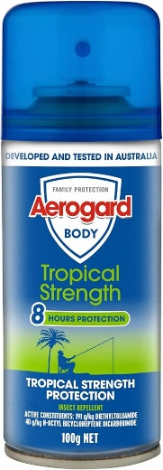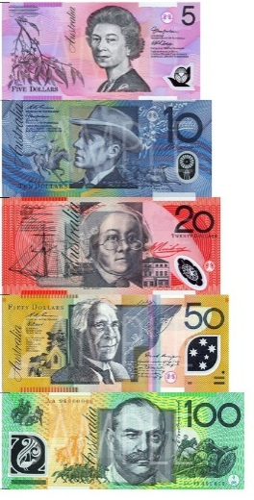

CSIRO Inventions
Explain to your students that these everyday items are Australian inventions that were created or improved by scientists at the CSIRO. Watch the BTN CSIRO Centenary story to learn more about the history of the CSIRO and its scientific breakthroughs that have improved people’s everyday lives.

Students will then investigate one item in more detail using the following questions to help guide their research.

Research: CSIRO Invention
- What is the invention?
- Who invented it?
- What inspired the invention?
- How does it work?
- What problem does it solve?
- What is it made from?
- What makes its design unique?
- How does it help people?
- How has it changed people’s everyday lives?
- What questions do you still have about it?
- What might life be like if it had never been invented?

Activity: Design your own invention
In small groups, students will design their own invention or make a modification to an invention (to improve the design or function of a product). Students will research the following and then share their research findings with the class or create a display in the classroom.

Research: Design your own invention
- What are some real-world problems that need solving? Think about problems you have seen, experienced or learned about. Include both big and small problems.
- Choose one problem from your list. Why is it important to solve?
- What is your invention? How will it help solve the problem?
- How does your invention work?
- What materials would you use to make your invention?
- What makes your invention different, creative or useful?
- What inspired your idea?
- Draw and label your invention. Give it a creative name.
- Prepare a short presentation explaining your invention and how it solves the problem. Present it to the class or wider school community.

Activity: Inventions by Kids
Check out these BTN stories featuring kids talking about their inventions which help solve real-world problems.

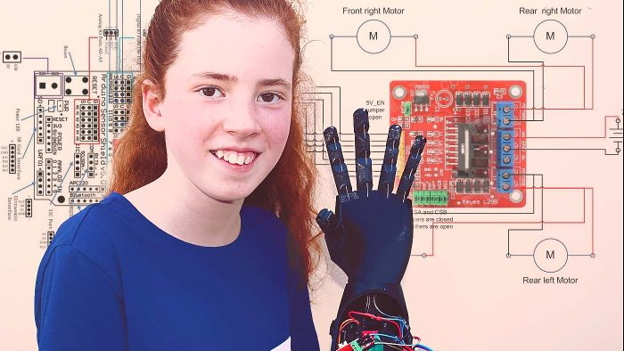  Bionic Arm Builder | 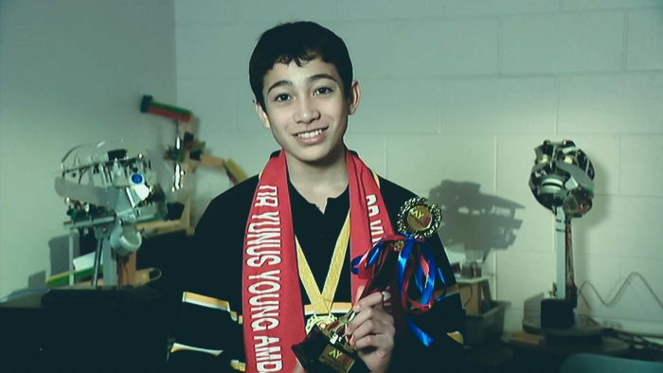  Young STEM Inventor
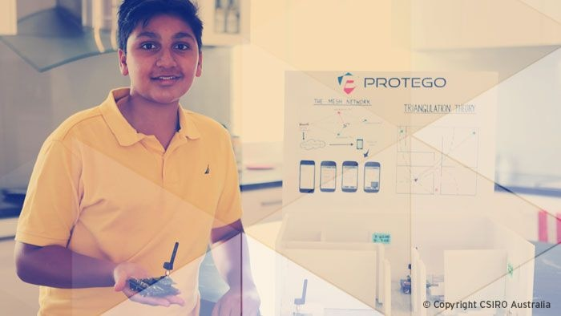  Aged Care App | 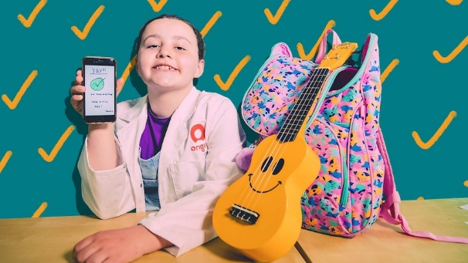  Little Big Idea Winner

Useful Websites
- CSIRO Inventions – CSIRO
- Our top 10 inventions – CSIRO
- 20 Australian inventions that changed the world – Australian Geographic
- Inventions that Shape History – TEDEd

EPISODE 19
21 July 2026

KEY LEARNING
Students will learn more about the history of the Aboriginal flag.

CURRICULUM
HASS – Year 3
Significant events, symbols and emblems that are important to Australia’s identity and diversity, and how they are celebrated, commemorated or recognised in Australia, including Australia Day, Anzac Day, NAIDOC Week, National Sorry Day, Easter, Christmas, and other religious and cultural festivals.

The ways First Nations Australians in different parts of Australia are interconnected with Country/Place.

HASS – Year 4
The diversity of First Nations Australians, their social organisation and their continuous connection to Country/Place.

HASS – Year 5 and 6
Develop appropriate questions to guide an inquiry about people, events, developments, places, systems and challenges.

Aboriginal and Torres Strait Islander people should be aware that this document may contain images and names of deceased persons.

  - Teacher Resource

Aboriginal Flag Anniversary

Focus Questions
Discuss the BTN story as a class and record the main points of the discussion. Students will then respond to the following:
- What do the colours on the Aboriginal flag represent?
- In 1972, the flag became a famous symbol at which protest site in Canberra?
- Which Australian athlete sparked controversy at the 1994 Commonwealth Games by carrying both the Aboriginal and Australian flags during her victory lap?
- When did the Aboriginal flag become an official flag of Australia?
- What does the Aboriginal flag mean to you?

Activity: Comprehension
After watching the BTN Aboriginal Flag Anniversary story students can answer one or more of the following questions:
- What are some keywords from the BTN story?
- What did you learn from the story? Write a summary.
- Why do you think BTN covered the story?

Activity: Class Discussion
Hold a class discussion after watching the BTN story using the following questions as a guide. Record the main points of the discussion on a mind map with ABORIGINAL FLAG at the centre.
- Who designed the Aboriginal flag?
- When and where was the flag first flown?

- What do the colours - black, red and yellow on the flag represent?
- Where can you see the Aboriginal flag in your community?
- What is the significance of the Aboriginal flag to you and/or to your school and community?

Did you know? The black section must always be at the top when the flag is flown. Why do you think that is?

Activity: Key Words
Students will brainstorm a list of key words that relate to the BTN Aboriginal Flag Anniversary story. Here are some words to get them started.
Activist
Land rights
Protest
Identity
Unite
Symbol
First Nations peoples
Culture

Ask students to write what they think is the meaning of each word (including unfamiliar words). They will swap definitions with a partner and ask them to add to or change the definition. Check these against the dictionary definition.

Activity: Aboriginal flag timeline
Students place the following key moments in the correct chronological order from 1 to 6. Write the numbers next to the events. Choose one of the events from the list below to investigate further.

Students use their research to answer these questions:
- What happened during this event?
- Why was this moment so important for the Aboriginal flag?
- Create a poster, write a short paragraph, or draw a picture explaining your chosen event.

The Australian Government officially proclaims the flag under the Flags Act 1953.

Harold Thomas designs the Aboriginal flag.
The Aboriginal flag is flown at Victoria Square, Adelaide.

The Commonwealth secures the copyright, making the flag free for public use.

The flag achieves national prominence at the Aboriginal Tent Embassy in Canberra.

Olympic athlete Cathy Freeman wore both the Australian and Aboriginal flags during her victory lap at the Commonwealth Games.

Activity: Aboriginal Flag Research
Discuss the information raised in the BTN Aboriginal Flag Anniversary story. What questions were raised in the discussion and what are the gaps in students’ knowledge? Students will develop their own question/s to research or choose one or more of the questions below.
Research Questions
- In what ways is the Aboriginal flag a symbol of cultural identity?
- What protocols should be followed when flying the Aboriginal flag?
- How does the Aboriginal flag tell a story without using words?
- In 1995, the Australian government made the Aboriginal flag an official flag of Australia. Why do you think official recognition is important for the people a flag represents?
- How do other flags around the world use colour to represent their people and geography?

BTN First Nations collection
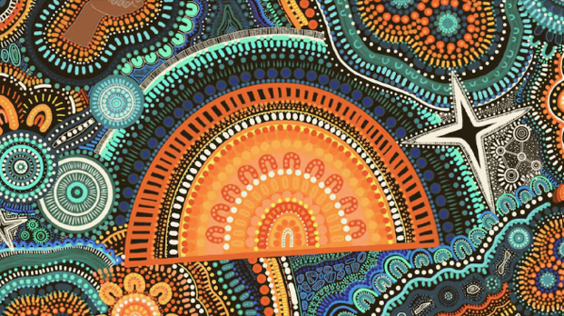
Visit BTN’s collection of stories which focus on First Nations. Look for BTN stories with the pencil icon to find supporting teacher resources all linked to the Australian Curriculum. BTN – First Nations Collection

Useful Websites
- Aboriginal Flag History – BTN
- Free the Flag – BTN
- Aboriginal and Torres Strait Islander flags – Australian Museum
- Moments of the Aboriginal and Torres Strait Islander flags – Australian Government
- First Nations Stories – BTN

  - Teacher Resource

BTN Transcript: Episode 19- 21/7/2026

Yaama, I'm Jack Evans and you're watching BTN. I hope you had an awesome holiday. Let's see what's coming up. We find out about the fight against bird flu, say happy birthday to the CSIRO and meet a champion chopper from Burnie.

Telco Trouble

Reporter: Justina Ward

INTRO: But first today, Telstra is being investigated over a nationwide outage, which left thousands of Australians unable to make calls or access the internet. Justina found out why that's a really serious problem.

OUTBACK JUSTINA: I've broken down.
PARENTS: We've just had a baby.
PHONE: Can you repeat that?
MOUNTAIN JUSTINA: I said I’m stuck on a mountain.
ADVERT JUSTINA: Phones. We need them for all sorts of reasons.
MOUNTAIN JUSTINA: How did you get up here?
So, if you want to be able to do pretty much anything.
COUCH JUSTINA: Hey, you want to come over?
ADVERT JUSTINA: You should probably get one of these. A phone.
OUTBACK JUSTINA: Did your car break down too?
Phones. Now one of life's necessities. Yeah. We recently got a big reminder of just how important phones are when Telstra's network stopped working.
PERSON: Couldn't get my texts.
PERSON: Couldn't make any calls.
PERSON: Made you realise how much of an impact it sort of has.
Businesses lost money.

PERSON: Could not get any job.
Even trains shut down.
MAN (OVER LOUD SPEAKER): Due to the network outage, services and trains will not be departing from Southern Cross.
PERSON: My first response was to laugh that a small outage would down the entire regional network for the state.
And with thousands of Aussies unable to make calls or access the internet, more than 600 Triple Zero calls couldn't get through.
Anika Wells, COMMUNICATIONS MINISTER: The 000 custodian has advised that some callers were unable to connect.
Michael Ackland, TELSTRA CFO: We conduct welfare checks when any call to 000 fails.
Telstra thinks it happened because of a software bug that affected its network clocks. It's also trying to get to the bottom of the more serious problem. Why didn’t Triple 0 work? You see, you're supposed to be able to call Triple 0, even if your network isn’t working. In fact, you can even call it without a sim card. Your phone just picks up whatever phone network is available at the time, but for some reason this didn't happen.
Vicki Brady, TELSTRA CEO: We have let our customers and Australians down. And for that, I am deeply sorry. We will conduct very thorough investigations, and one of our focus areas will be, what are the lessons out of this?
Except some people reckon we should have already learnt those lessons because this happened last year.
News reporter: New blow to Optus, with yet another triple 0 outage.
News reporter: The telco is blaming a faulty mobile tower.
News reporter: Consumer confidence in our telcos plummets.
The Optus outage left hundreds of people unable to call Triple Zero and two people died.
Stephen Rue, Optus CEO: What has happened is completely unacceptable. We have let you down.
After that, the government created a Triple 0 Custodian to oversee the emergency network…
CALLCENTRE: Ambulance Emergency. What town or suburb?

…and new rules making phone companies responsible for keeping it available.
CALLCENTRE: Got a car responding now for you.
Anika Wells, COMMUNICATIONS MINISTER: And now that Telstra has resolved its outage. It's time for Telstra to face the music.
Yeah, Telstra is under a number of investigations and may have to pay fines, compensation to those who were affected. But some experts reckon we need a backup plan.
Mark Gregory, RMIT University associate professor: Our networks are not secure, they're not resilient, they're not reliable, uh, and we really need the legislation to be rewritten.
Some are calling for the federal government to introduce domestic mobile roaming which makes phones automatically connect to the strongest mobile network, no matter which company you pay your bills to.
Carol Bennett, ACCAN CEO: International tourists that come to Australia don't have this problem because they can actually mobile roam. Whereas Australians can't often do that.
In the meantime, experts say it’s important to know what to do if this thing stops working.

MOUNTAIN JUSTINA: Hello?
If it's an emergency, always call Triple 0 because it might still connect through another network. But if it doesn't, try Wi-Fi calling instead or find a payphone. Otherwise, ask someone nearby for help.
MOUNTAIN JUSTINA: So, can I just use your phone.
JUSTINA: Oh yeah, sure.

Did you know?

Did you know you can also text emergency services? The number is 106, and it's to make sure people who are deaf or have hearing or speech problems can access help if they need it.

News Quiz

There’s been more fighting in the Middle East after a ceasefire between the US and Iran broke down over the holidays. It means ships can’t travel through the Strait of Hormuz, which is a narrow shipping lane that provides access to which body of water? Is it the Red Sea, the Persian Gulf or the Gulf of America? It’s the Persian Gulf. Seven oil-producing countries have ports there and right now they can’t get their oil out. The fighting started again when Iran attacked a ship that was trying to go through the Strait without their permission and since then it’s escalated.

People all around the world have paid tribute to New Zealand actor Sam Neill who died recently at the age of 78. He starred in many big and small movies over his long career but is probably best known for his role as Dr Alan Grant in Jurassic Park. Do you know when the first movie came out? Was it 2008, 1998 or 1993? It was 1993.
Say again. We have a T-Rex.

POLITICIAN: And he's now been handed a red card by the 400 dodgy referees behind him.

Meanwhile there was laughter and tears in the UK’s parliament as the Prime Minister, Keir Starmer took part in his last question time.
KEIR STARMER: I will give my wholehearted support to my successor.
Mr Starmer decided to step down because he wasn’t very popular, and has been replaced by Andy Burnham, who was the Mayor of Greater Manchester before being elected to parliament last month. How many prime ministers has the UK had in the past ten years? 3, 5 or 7? It’s 7 in ten years, which is quite the turn-around.

And can you name this iconic elephant seal that’s been causing chaos and winning hearts during his recent stay in Tasmania? It’s Neil the Seal.
PERSON: We all love him, and he's the best. He's naughty. He knocks down stuff. And I like doing that too.
Neil was born in Tassie in 2020, and he comes back twice a year to moult and rest. And while he’s got lots of fans in Tassie and around the world, he’s also a bit of a problem because he’s very big and potentially dangerous, which is why he had 24-hour security around him during his stay.
PERSON: He causes, uh, drama. A lot of drama.

Bird Flu

Reporter: Saskia Mortarotti

INTRO: Now to some bad news that we got over the holidays. A strain of bird-flu which has devastated species all over the world has finally arrived in Australia. Sas found out more.

SASKIA MORTAROTTI, REPORTER: Here in Australia, we have a lot of birds. From our quirky cockatoos to our cutie kookaburras. But our birds are in a bit of trouble at the moment, because of a thing called bird flu. Bird flu, or avian influenza, is a virus. It's similar to the flu virus that humans commonly catch, but it originated in birds, and there are lots of different strains. But the one that has a lot of people worried right now is called H5N1. A global outbreak of it began in 2021 and has resulted in millions of birds dying or being culled.
DOUG CORWIN, DUCK FARM OWNER: I was tending to a barn. One day they were beautiful, like this, and the next day I saw multiple dead ones all over the place.
BORIS BELCHEV, RANGER: I was shocked. What's going on here? Why? Where are all the birds?
H5N1 spreads extremely quickly and is considered the deadliest strain of bird flu. It can also spread to other mammals, such as foxes, cows, dogs, cats, and seals. It can also be caught by humans who have come into contact with sick animals, and because, well, birds can fly, it's really difficult to stop from spreading, and by the start of this year, it had been found in every continent except Australia. And over the holidays, the news everybody had been dreading came.
JULIE COLLINS, MINISTER FOR AGRICULTURE, FISHERIES AND FORESTRY: The Western Australian Department of Primary Industries and Regional Development is investigating a suspected detection of avian influenza or bird flu.
This seabird, found on a remote beach in WA, was the first H5 bird flu case confirmed in Australia. Since then, there have been 16 more. 9 in Western Australia, 5 in South Australia, and 2 in New South Wales. It's got a lot of people worried. Including the poultry industry.
PHILLIP HANS, CHICKEN SELLER: Devastating if it gets into our flocks.
It could also be a big threat to our native species.
DAVID PATON, ECOLOGIST: If it gets into the black swan populations, then it could decimate those populations.
FIONA FRASER, THREATENED SPECIES COMMISSIONER: The Tasmanian Devil, as a scavenger, is susceptible.
At the moment, there's no specific cure for H5N1, but authorities here have spent the past few years getting ready for it, and they're putting in measures to try and stop its spread. There are also scientists around the world working on vaccines. Experts say the risk of bird flu for humans remains low. While bird flu is easy for birds to catch, it's much more difficult for humans to get it, and most of the people who've been sick had spent a lot of time around sick birds. But the government is advising that if you do notice a sick or dead bird or other animal, not to touch them or get too close.
EMILY BOURKE, SA ENVIRONMENT MINISTER: Birds that are discoloured, behaving in odd ways. It might be their movements, they might look drowsy, wobbly.
You can help by recording the location of where you saw the animal and by reporting what you saw to the Emergency Animal Disease Hotline. It's also important that we keep our pets safe. By keeping them away from any wild birds and by doing regular hygienic things like cleaning their food and water bowls. We don't know how badly this strain of bird flu is going to affect Australia, but it's being taken seriously.
DR SKYE FRUEAN, SA CHIEF VETERINARY OFFICER: Based on what we've seen overseas, we could expect further spread. That's what we've been preparing for. Preparing for the worst, hoping for the best.
CSIRO Centenary

Reporter: Tatenda Chibika

INTRO: Recently a very important Australian organisation celebrated a very big birthday. The CSIRO turned 100. Tatenda found out more about it and how its scientists have helped to change the world.
Tatenda Chibika, Reporter: What do these things have in common?
Long wear contact lenses, fast Wi-Fi, Aerogard, polymer banknotes, and Twisties?
Kushi: They're all really good?
Yeah, and they're all created with the help of the CSIRO?
Kushi: Hmm.
Tatenda: That stands for the Commonwealth Scientific and Industrial Research Organisation.
As the name suggests, it's a government-funded organisation that's dedicated to science and research. Its story actually starts way back in 1916 when Prime Minister Billy Hughes created a temporary science council to tackle some of the problems facing Australian industry, particularly farming. It meant science experts from around the country could work together right here in Melbourne.
Its very first project was investing 250 pounds into research around ways to control the prickly pear, an invasive weed that was running rampant in parts of New South Wales and Queensland.
In 1926, the government set up a new council for Scientific and Industrial Research. It got more funding, more scientists and new laboratories where they could carry out their own research.
In 1949, the CSIR got an O. It was now an independent organisation, government funded, but able to make its own decisions. And it kept researching, developing and inventing.

VOICEOVER: And it can turn, and tilt, to scan the entire sky.
We got famous products like the ones I mentioned earlier, an insect repellent that protected troops during the war, and even the Queen. Banknotes that were more durable and harder to counterfeit…

VOICEOVER: This Australian technology is a world first.

…and the Wireless technology that the whole world uses every day.
Tatenda, Reporter: They didn't actually invent Twisties, but the CSIRO did help their creator work out how to make them.
Today, the CSIRO has sites across the country as well as overseas in France and the US.
Elanor Huntington, Deputy Chief Executive of CSIRO: The CSIRO is an organisation of about 5,000 people, including about 4,000 amazing, talented and dedicated scientists.
So, some of us are good at bugs, some of us are good at birds, some of us are good at rocks, some of us are good at computers, some of us are good at water or the ocean or even space or robots. Elanor says those scientists are still working on solving some of Australia's big problems. For example, it's the CSIRO which has been leading Australia's response to Bird Flu.
Elanor Huntington, Deputy Chief Executive of CSIRO: We are the only people in Australia who are qualified to say definitely, yes, this was this particular type of bird flu.
But of course all of that science isn't cheap. And some say the CSIRO's funding hasn't kept up with the cost of research. It recently announced hundreds of job cuts on top of more than 800 that have been lost in the past couple of years.
Elanor Huntington, CSIRO Deputy Chief Executive: Every now and then, just like with, like, a sporting team or a music band or a business, we need to step back and understand what's the most important thing that we should be doing for Australia right now.
But Elanor says the CSIRO will keep doing what it's done for one hundred years and hopefully inspire the next generation of scientists.
Elanor Huntington, CSIRO Deputy Chief Executive: Science is a way of understanding the world around us. You play sport, you do art, you play music, you eat food, all of that, you can do better if you understand how the world works around you.

Quiz

In 1964 two CSIRO researchers coined the word "petrichor" which describes what distinctive smell? Is it freshly cut grass, rain on dry dirt or mouldy rocks? Petrichor is the earthy smell of rain on dry dirt and rocks.

Aboriginal Flag Anniversary

Reporter: Saskia Mortarotti

INTRO: Now for another big Aussie Birthday. During the Holidays the Aboriginal Flag celebrated 55 years since it was first flown. Sas found out more about the flag, what it represents and why it was created.

For 55 years, the Aboriginal flag has been a symbol that has united Australia's Aboriginal people. Whether it's on famous landmarks or famous sets of teeth.

REPORTER: This is where the Aboriginal flag was first flown, here in Tarntanyangga, or Victoria Square in Adelaide, on the 12th of July 1971 as a part of a land rights rally.

And it was thanks to Luritja artist and activist Harold Thomas. In 1970, Harold Thomas had just become the first Aboriginal person to graduate from an Australian art school after studying at the South Australian School of Art and started working a job as a survey artist at the South Australian Museum. It was a time of change, of political activism and symbolic breakthroughs as Indigenous people united to fight for the rights that they'd been denied. Harold Thomas wanted to make something that would represent all of Australia's First Nations people during these rallies. And this is his design. The black represents the Aboriginal people. The yellow represents the sun, the giver of life, and the red represents the earth, and the spiritual connection First Nations people have to the land.
HAROLD THOMAS, ARTIST: So, I lived amongst the redness of the earth. It's so powerful, so as a child, it was part of my identity.
I'm here at a special facility for the South Australian Museum, and it's here where they keep this. It's a piece of the original Aboriginal flag. It's in the shape of a circle and that's because it was cut out of the original flag to make space for the sun to be in the middle. Unfortunately, we don't know what happened to the original flag.

A year after it was first flown, Gumbaynggirr activist Gary Foley took the flag to Canberra, where it was flown at the Aboriginal Tent Embassy, which was set up on the lawns of Parliament House as a meeting place for activists.

In the years that followed, the Aboriginal flag did what it was intended to do: unite Australia's Aboriginal people. It was used during protests as well as during times of celebration. Soon enough, it became internationally known.

Sporting legend Cathy Freeman caused a bit of controversy at the 1994 Commonwealth Games when she wore both the Australian and Aboriginal flag during her victory lap. It was technically against the rules, and the Aboriginal flag wasn't an official flag of Australia. But, Paul Keating, Australia's Prime Minister at the time, sent a letter of support to Cathy Freeman, and the next year he made it an official flag along with the Torres Strait Islander flag, which had been designed 3 years earlier by Torres Strait Islander man Bernard Namok. In 2000, Cathy Freeman carried both flags again and was cheered on by the whole country.

Today, the Aboriginal flag is flown in, well, lots of places. Schools, government buildings, businesses, organisations, and the Sydney Harbour Bridge. Yeah, it's everywhere, and it continues to be an important symbol of unity, pride, identity, and resilience.

Sport

The FIFA World Cup has wrapped up with a huge, nail-biting, exciting, all of the adjectives match between the reigning world champions, Argentina and European champions Spain. After a furiously tense 90-minutes and some pretty close encounters from Spain, neither side could find the net sending the match into stoppage time. That's when the heat really turned up.
COMMENTATOR: Enzo Fernandez is walking.
Yeah, with a player down, Argentina were on the back foot, but Spain didn't let up and sealed their second world cup title with this 106th minute goal from Ferran Torres.
COMMENTATOR: The champions of the world are Spain.
Now, to the Belgian Grand Prix where it didn't take long for things to get hairy.
COMMENTATOR: And Russell and Lewis Hamilton make contact!
Yeah, this tap from Ferrari's Lewis Hamilton ended Mercedes' George Russell's race on the first lap. Aussie Oscar Piastri also had a high-speed bingle with Ferrari's Charles Leclerc which damaged his car and sent him down the grid eventually crossing the line in fifth. But the star of the weekend was Italian teenage sensation Kimi Antonelli from Mercedes taking home his sixth win of the season and rocketing him further into the lead of the championship.

Woodchopping

Rookie Reporter: Kallie

INTRO: Finally, today we're going to Burnie in Tasmania to meet a winner of the ABC's Takeover competition. It asked kids in regional areas around the country to share stories about things that are important to them and Kallie is going to tell us about her passion for woodchopping.
I live by the coast in northern Tassie, in the beautiful town of Burnie. In winter, it gets cold. You’ll find me warming up by the fireplace or outside collecting wood. We’ve got heaps of wood, thanks in part to my training. I’m a chopper. I compete in woodchopping events all over Tassie.

In the underhand chop discipline and the Jack and Jill saw with dad. I come from a long line of woodchoppers. Dad and Pop competed 20 years ago. My great grandad was also a chopper and supplied logs to sawmills and my other great grandad chopped railway sleepers.

Forestry has been such a big part of Tasmania for over a century. Did you know the world’s first wood chopping comp took place near here back in the late 1800s? We’ve even got the Axeman’s Hall of Fame Museum. I want to be great like them.

When I’m not chopping wood, I love chilling in my room listening to Aussie music from the 80s on my record player. My favourite band ever is Icehouse. I saw them live a few years back. They were awesome. Lead singer Iva Davies even signed my jumper. I listen to the words and let the music take me away. Listening is an important part of wood chopping too. You can tell if you’re chopping well by the sound the wood makes. You’re looking for that snap.

This year, it’s mandatory for all choppers to wear feet and leg guards. Better to break a toe than to chop it off, I say. Choosing the right axe is an art in itself. These are for softwood and these chop hardwood. This is my favourite axe. I call him Neville. He chops like a dream. Chopping is one of those sports that’s very family run, so it’s hard to get other people into it, especially ladies. But I reckon everyone should pick it up. I’m in it for life. Now stand back and let me chop.

Closer

Well, That's all we have for this week, but we'll be back soon. In the meantime, you can keep up to date with Newsbreak every weeknight and you can tune in to BTN Live on Friday if you've got a question for us. Until then, have a great week, and I'll see you next time. Bye.

