Episode 2
19th February 2019



Refugee Medivac Vote
- Briefly summarise the BTN Refugee Medivac Vote story.
- Who is Australia’s current Prime Minister?
- Where is Nauru and Manus Island? Locate using Google Maps.
- Why have there been protests about offshore detention?
- Who is the current Member for Wentworth?
- What law was recently put forward to help asylum seekers and refugees on Nauru and Manus Island?
- When voting for this new law, the Government lost the vote. True or false?
- To form government, you need more than half of the seats in the ________ house. Complete this sentence.
- What similarity was made between Prime Minsters Stanley Bruce and Scott Morrison in the BTN story?
- What did you learn watching the BTN story?

Insect Extinction
- In pairs, discuss the Insect Extinction story and record the main points of the discussion.
- How many different insect species are there in the world?
- A study has found that over the past decade the world’s insect populations have reduced by
  - 1.4%
  - 14%
  - 41%
- Why are our insect populations declining? Give one reason.
- What do you call someone who studies insects?
- Why are insects so important to our ecosystem? Give an example of one of their important roles.
- What would happen if insects were removed from the food web?
- How can people help care for insects?
- What do you understand more clearly since watching the BTN story?
- Illustrate an aspect of the Insect Extinction story.
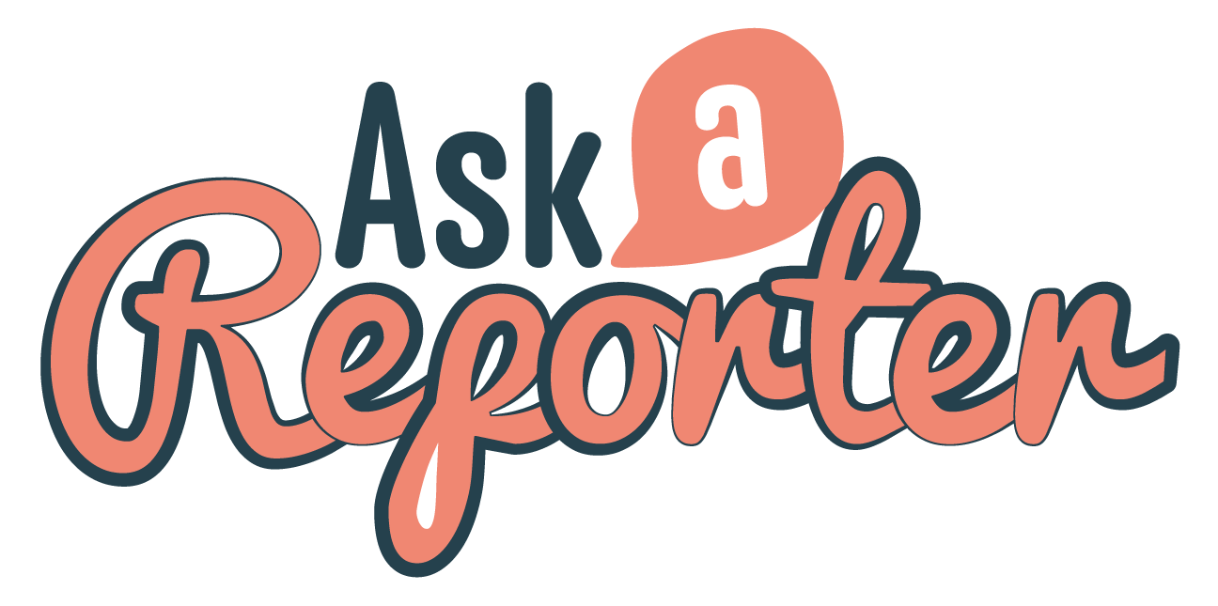
Check out the Insect Extinction resource on the Teachers page. Get your class involved in BTN’s Ask A Reporter! This week’s topic is Insect Extinction.

Mother Language Day
- How many languages can you say ‘hello’ in? Share as a class.
- How many languages and dialects are spoken around the world?
- What language is most commonly spoken around the world?
  - Spanish
  - Mandarin
  - English
- How many people around the world speak Mandarin?
- What Indigenous language of Scotland can Martin’s sister speak?
- How many of the world’s languages are endangered?
- What Indigenous language belongs to the traditional owners of the area around Adelaide?
- Why have so many Indigenous languages been forgotten in Australia?
- What do you understand more clearly since watching the BTN story?
- What’s your mother language? Write a list of all the languages students speak in your class.

Barefoot to Boots
- Retell the BTN Barefoot to Boots story using your own words.
- Where is Kenya? Find using Google Maps.
- Why did Conrad go to Kenya?
- Why did the young refugees leave their home country of South Sudan?
- Who helped start the organisation Barefoot to Boots?
- How does Barefoot to Boots help kids?
- What did Conrad learn about school in Kenya?
- What do some of the kids that Conrad met want to do when they grow up?
- What did you learn watching the BTN story?
- How did this story make you feel? Discuss in pairs.

Junior Beekeepers
- What do you know about bees? Discuss in pairs before watching the BTN story.
- What do the kids in the junior beekeeping club learn about?
- Bees can hear each other even if they’re not near each other. True or false?
- What do bees do after they have eaten pollen?
- Bees go from plant to plant collecting _________. Complete this sentence.
- How do bees help plants produce seeds and fruit?
- How many crop species do bees pollinate?
- What is another name for a beekeeper?
- Why are the kids in the BTN story raising money?
- What was surprising about this story?

Check out the Junior Beekeepers resource on the Teachers page.

Teacher Resource
Episode 2
19th February 2019

Insect Extinction

Students will investigate the importance of insects to the ecosystem.


Science – Year 5
Living things have structural features and adaptations that help them to survive in their environment.

Science – Year 6
The growth and survival of living things are affected by physical conditions of their environment.

Science – Year 7
Classification helps organise the diverse group of organisms.

Interactions between organisms, including the effects of human activities can be represented by food chains and food webs.

- In pairs, discuss the Insect Extinction story and record the main points of the discussion.
- How many different insect species are there in the world?
- A study has found that over the past decade the world’s insect populations have reduced by
  - 1.4%
  - 14%
  - 41%
- Why are our insect populations declining? Give one reason.
- What do you call someone who studies insects?
- Why are insects so important to our ecosystem? Give an example of one of their important roles.
- What would happen if insects were removed from the food web?
- How can people help care for insects?
- What do you understand more clearly since watching the BTN story?
- Illustrate an aspect of the Insect Extinction story.


What do you see, think and wonder?
After watching the BTN Insect Extinction story, students will respond to the following questions:

- What did you SEE in this video?
- What do you THINK about what you saw in this video?
- What did you LEARN from this story?
- What was SURPRISING about this story?
- Why are insects important?

Students will then think of a question they would like to ask the entomologist featured in the story. Students can leave a message in the comments section on the BTN Insect Extinction story page.

KWLH
Discuss the BTN Insect Extinction story as a class. What questions were raised in the discussion and what are the gaps in their knowledge? The following KWLH organiser provides students with a framework to explore their knowledge on this topic and consider what they would like to know and learn.
What do I know? | What do I want to know? | What have I learnt? | How will I find out?

Topics of inquiry
Students will start to think like scientists and develop their own question/s for inquiry, collecting and recording information from a wide variety of sources. Students may develop their own question for inquiry or select one or more of the questions below.

- What makes an insect an insect? Find a definition for insect and then compare your definition with that of your classmates.
- What are some of the main threats to the survival of insects? Choose one insect and research the threats to its survival.
- Why should we protect insects? Write a persuasive piece of writing explaining your reasons.
- What happens when an insect becomes extinct? If one species in the food chain becomes extinct how would it affect the rest of the chain? Choose an insect species and explore its role in the food chain.
- Why are insects important? Think of creative ways to raise awareness about the issues raised in the BTN Insect Extinction story.
- What might happen if we don’t look after our insects? What would the populations of insect species look like in 30 years’ time? Make some predictions.

Are your students curious about insects? Choose one question about insects that you would like answered as a class. Send your question into The Conversation: Curious Kids for an expert answer. For example, Do butterflies remember being caterpillars? Or How do moths eat our clothes?.

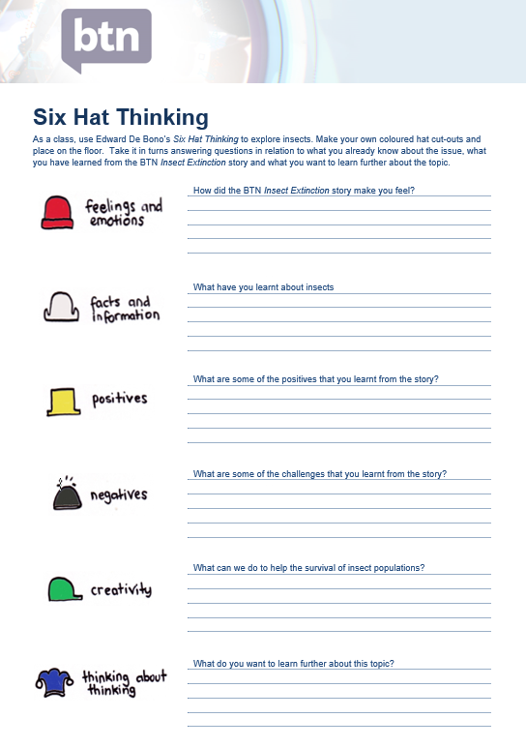
Six Hat Thinking
As a class, use Edward De Bono’s Six Hat Thinking to explore insects. Make your own coloured hat cut-outs and place on the floor. Students will take it in turns answering questions in relation to what they already know about the issue, what they have learned from the BTN Insect Extinction story and what they want to learn further about the topic.

Print this worksheet (featured at the end of this activity) for students to respond to a range of questions about insects.

Reflection
After this activity, ask students to reflect on what they have learnt. Students can include details about how their thinking on this issue has changed and why they think we should act.

Investigation
Provide students with the opportunity to think and behave like scientists. In this activity students will be given the mission to explore a natural habitat in their local area, identify insects in their habitat and document what they find. Use the following as a guide. Students may work individually or in small groups.

  Plan | Students will plan a visit to a local nature reserve or their own school yard to explore and identify insects. Students will need to write a list of tools they may need for the investigation, for example: pen and paper for taking notes, camera and magnifying glass. Students will predict insects they might see and find. Students will think about what an entomologist would need on an investigation.
  Explore | Students will visit the habitat and carry out an exploration of the area. Students will choose a spot in the environment to investigate. Consider exploring the habitat from different angles, closeup or far away. Look and listen for evidence that insects live in the area.
Collect | Students will choose their favourite insect to explore in detail. Students will collect as much data as they can about that insect and record what they find. Students may write notes and sketch what they see to help in their investigation. Students may want to record what they see with a stills or video camera.
Share | Students will return to the classroom and share/compare their findings.
Analyse | Students will analyse their findings and write a short summary of their investigation. Students will respond to the following questions:  - Did you find any insects during your investigation? If yes, identify and describe what you found. If you didn’t see any insects did you find any evidence that insects live in the area?  - How could you help protect this habitat?
Research | Students will research an insect, and respond to the following:  - What does the insect look like? Describe its physical characteristics.  - What is its classification?  - What is the life cycle of the insect?  - What role does the insect play in the ecosystem?  - Why is this insect important?
Reflect | Students will reflect on the investigation by responding to one or more of the following questions:  - What did you enjoy about this investigation?  - What did you find surprising?  - What would you do differently next time?

Create a new insect species
Students will use their imagination and create new insect species. Students will imagine they have discovered a new species of insect which has never been seen before. Use the following as a guide for this activity:
- Illustrate the new insect using only a black felt-tip pen on a piece of A4 art paper – include as much detail as you can.
- Give the insect a common and scientific name.
- Describe what the insect looks like – what are some of its physical characteristics?
- Describe its habitat and how it behaves in its habitat.
- Does it have any interesting or unique features? For example. any adaptations.


Australian Museum – Insects
https://australianmuseum.net.au/learn/animals/insects/

ABC Education – Mini Beasts
http://education.abc.net.au/home#!/topic/495556/minibeasts

ABC News – Insect population and species decline a `wake-up call’, scientists say
https://www.abc.net.au/news/science/2019-02-12/insect-species-in-decline-and-facing-extinction/10804094
Royal Entomological Society - Why are insects important?
https://www.youtube.com/watch?v=KgZ_YdKPMdM
ABC Education - Minibeast games
http://education.abc.net.au/home#!/media/2806409/minibeast-games

Royal Entomological Society - Why are insects important?
https://www.youtube.com/watch?v=KgZ_YdKPMdM

Six Hat Thinking
As a class, use Edward De Bono’s Six Hat Thinking to explore insects. Make your own coloured hat cut-outs and place on the floor. Take it in turns answering questions in relation to what you already know about the issue, what you have learned from the BTN Insect Extinction story and what you want to learn further about the topic.

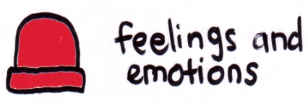
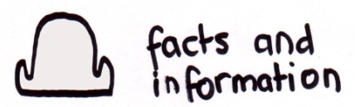
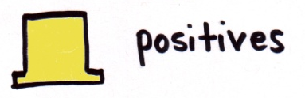
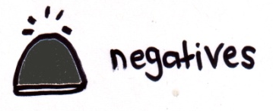
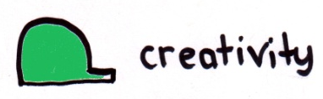
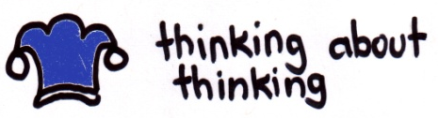
How did the BTN Insect Extinction story make you feel?

What have you learnt about insects?

What are some of the positives that you learnt from the story?

What are some of the challenges that you learnt from the story?

What can we do to help the survival of insect populations?
What do you want to learn further about this topic?

Teacher Resource
Episode 2
19th February 2019

Junior Beekeeping
Students will explore the features of the honey bee, including habitat and unique features.

Science – Year 5
Living things have structural features and adaptations that help them to survive in their environment.

Science – Year 6
The growth and survival of living things are affected by physical conditions of their environment.

Science – Year 7
Classification helps organise the diverse group of organisms.

- What do you know about bees? Discuss in pairs before watching the BTN story.
- What do the kids in the junior beekeeping club learn about?
- Bees can hear each other even if they’re not near each other. True or false?
- What do bees do after they have eaten pollen?
- Bees go from plant to plant collecting _________. Complete this sentence.
- How do bees help plants produce seeds and fruit?
- How many crop species do bees pollinate?
- What is another name for a beekeeper?
- Why are the kids in the BTN story raising money?
- What was surprising about this story?

What do you see, think and wonder?
After watching the BTN Junior Beekeeping story, respond to the following questions:

- What did you SEE in this video?
- What do you THINK about what you saw in this video?
- What did you LEARN from this story?
- What was SURPRISING about this story?

Class Discussion
Discuss the BTN Junior Beekeeping story as a class. Record what students know and would like to know on the KWHL chart below. Use the following questions to help guide discussion:
- Why do bees make honey?
- Why do bees pollinate flowers?
- What makes the nectar change into honey?
- What parts of the bee are involved in pollination?
- What jobs do different bees have in the colony?
- What is a hive?
- What happens inside a hive?
- How do honey bees communicate?
- Why is it important for bees to communicate?
- Why are bees important?
- Does all honey look and taste the same?
The following KWLH organiser provides students with a framework to explore their knowledge on this topic and consider what they would like to know and learn.
What do I know? | What do I want to know? | What have I learnt? | How will I find out?

Glossary of key terms
Students will create a classroom glossary about honey bees. Students will start by brainstorming words as a class using a mind map to record their responses. Add to your class list of words by downloading the BTN Junior Beekeeping story transcript and highlighting all the words that relate to bees and honey.

colony | drone bee | apiarist
hive | nectar | pollinate
beekeeper | queen bee | worker bee

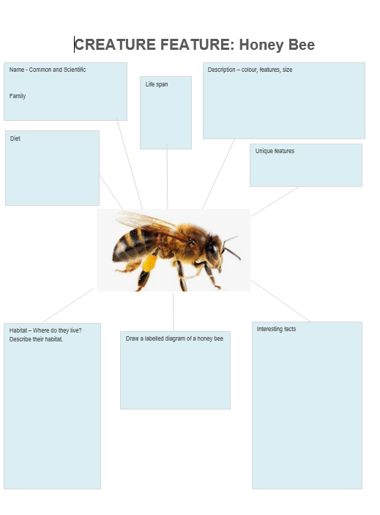
Creature Feature – Honey Bee
Students will research and write a Creature Feature about the honey bee. Encourage students to use a range of sources to find their information.

Students will research the following for their project:
- Common and scientific name
- Appearance - what are some of their physical characteristics?
- Habitat - where do bees live? Describe their habitat.
- Threats - what are some of the threats to bees?
- Interesting features or facts.
- Labelled diagram of the honey bee.

Students can use the Creature Feature worksheet (at the end of this activity) to record their findings.

Bee Quiz

- What do bees collect from flowers to make honey?
  - Pollen
  - Stalk
  - Nectar
Answer: Nectar

- Only the female bees leave the hive to collect nectar.
  - True
  - False
Answer: True.

- What happens to the nectar once it’s in the bee’s stomach?
- It makes them sick
- The nectar stops them from flying
- It mixes with the enzymes and proteins in its stomach
Answer: It mixes with the enzymes and proteins in its stomach

- How do beekeepers avoid getting stung when collecting honey?
  - Using smoke to calm them
  - Throwing water on the hive
  - Making a lot of noise to scare them away
Answer: Using smoke to calm them down

- Honey can be described as bee vomit.
  - True
  - False
Answer: True. The bee regurgitates the nectar into another bee’s mouth.

- How many eyes does a bee have?
  - 2
  - 4
  - 5
Answer: 5. Two large compound eyes and 3 smaller simple eyes.

Bee Friendly Garden

Establish a BEE FRIENDLY GARDEN in your school
- Research the habitat of honey bees.
- Explore your school garden. Do you notice any bees? Record your observations.
- Design a honey bee garden for your school. Include a map, special features and make a list of the top 10 honey bee attracting plants.

Bee Videos
Here are some videos to help students learn more about bees.

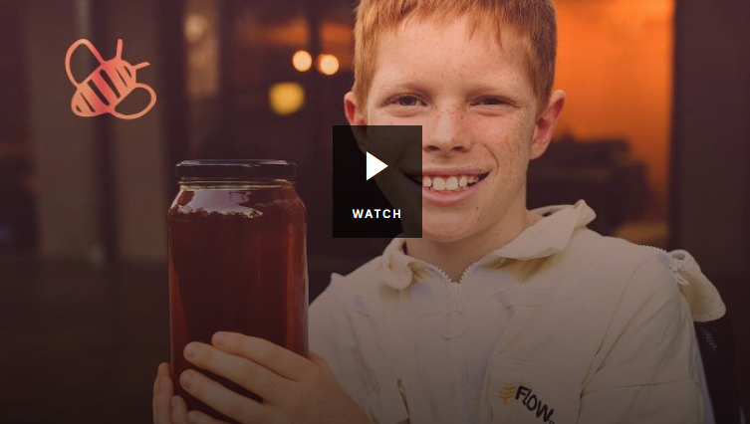
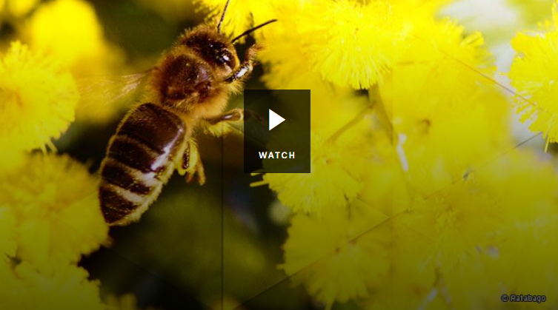

BTN Backyard Bees BTN Bee Business

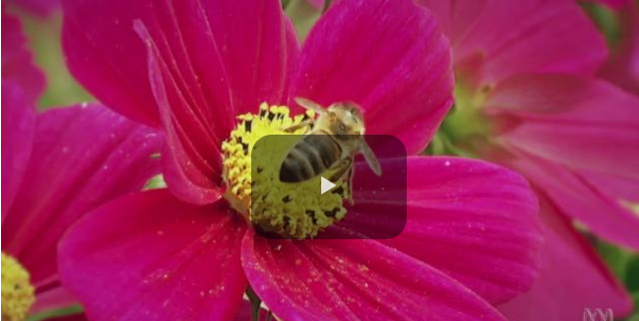
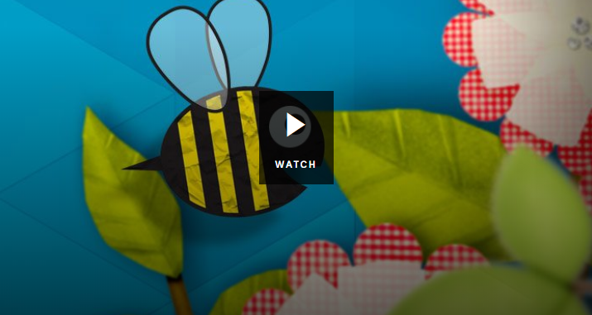

Why do bees boogie? BTN Bee Problems

BTN Newsbreak – Bee kids
http://www.abc.net.au/btn/newsbreak/bee-kids/10798910
BTN – Backyard Bees
http://www.abc.net.au/btn/classroom/backyard-bees/10536114
ABC Education – Why do bees boogie?
http://education.abc.net.au/home#!/media/2188279/why-do-bees-boogie
ABC Education – Meet the honey bee
http://education.abc.net.au/home#!/digibook/2748838/bee-heroes
Australian Museum – Honey Bee
https://australianmuseum.net.au/learn/animals/insects/honey-bee/

CREATURE FEATURE: Honey Bee
Name - Common and Scientific

Family

Description – colour, features, size

Life span

Diet

Unique features

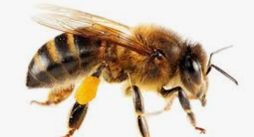

Draw a labelled diagram of a honey bee

Habitat – Where do they live? Describe their habitat.
Interesting facts

BTN Transcript: Episode 2 – 19/2/19

Hey everyone. Amelia here with another episode of BTN. Let's check out what’s on today’s show.

- We'll learn why insects are so important and why they're in trouble.
- We'll find out why Martin is speaking Gaelic
- And we'll follow a young Aussie on his journey to a Kenyan refugee camp.

Refugee Medivac Vote
Reporter: Jack Evans

INTRO: All those stories coming up soon. But first we're going to have a look at a political story that was really big in the news last week. A controversial law was passed in Aussie Parliament that affects people in offshore detention centres. But it was the way it was passed that was really unusual. Take a look.

This is Stanley Bruce, 8th Prime Minister of Australia. Born in 1883 and sometimes known as "spats" because of his famously stylish dress sense. Also, he’s a big fan of shovels. This is Scott Morrison, 30th Prime Minister of Australia. Born in 1968 and sometimes known as "ScoMo" because, well, it sounds like his name. Not sure if he is a big fan shovels. But these two Prime Ministers do share something else in common.
But we'll get back to that, first let’s back up a bit. Whoa whoa, too far, colour please. Nope keep going. Here we are. Last year, this guy was PM remember? But he got kicked out and left politics. So, there was an election to replace him in his home seat of Wentworth. And for the first time in, well ever, Wentworth chose someone who wasn't a member of the Liberal Party. Her name is Kerryn Phelps and while she agrees with the government on some things there was an issue she wanted to change. And that was the way people are treated in Australia's offshore detention centres on Nauru and Manus Island.
That's where people are sent if they try to get to Australia by boat without permission. The government says it's a way of discouraging asylum seekers from risking their lives trying to get to Australia by sea and it says it's worked. But it's been controversial. Some reckon people in offshore detention don't have access to proper medical facilities and some asylum seekers have died.
Last week Kerryn Phelps put forward a new law which would make it easier for people who are already on Nauru and Manus Island to be taken to Australia for medical treatment if they needed it. But the government didn't support it. It said the law would put Australia's security at risk and encourage more asylum seekers to come to Australia. So, it voted against it. But the government lost the vote. Now that might not sound like such a big deal, but it is.
You see in theory governments should always win votes like this one. That's because to form government you need more than half of the seats in the lower house. Or you need enough support from independents and minor parties to pass your laws. Except, last week, for the first time in a really long time that didn't happen. Aussie governments have only lost votes like this twice in the past 90 years. Once in 1941 and once in 1929 when this guy was Prime Minister. See, told you we'd get back to him. And that's why a lot people last week were comparing Stanley Bruce to the current PM. When it happened to Bruce's Government they called an election, which he lost. But this Prime Minister says that won't happen this time around. He's not calling an early election. But he's also not happy about the new law.
SCOTT MORRISON, PRIME MINISTER: It's not my law. I think it's a foolish law, um it's a foolish law and it's not one that I support.
The government reckons it'll lead to heaps of people arriving in Australia by boat. But others say that won't happen.
BILL SHORTEN, OPPOSITION LEADER: I do not accept that you either have strong borders or you have humane treatment.
It's already become a big debate in Australia and many reckon that as we get closer to the election it'll only get bigger.
This Week in News

Massive bushfires have destroyed homes and burnt tens of thousands of hectares in New South Wales. Three of the worst fires were at Tinga, Tabulam and Wallangarra in the state's north.
Hundreds of fire fighters have spent the weekend trying to control the fires. Some cooler weather on Sunday helped to calm things down but authorities have told locals to stay alert.

Students in 30 towns and cities across the UK have skipped school today to protest against climate change. It’s similar to the protests that happened in Australia late last year for the same reason.
KID 1: I want to be the voice of the generation I think just sitting down doing nothing isn't going to help.
KID 2: Because nearly 200 species are coming extinct in a day.
The campaign has been inspired by 15-year-old Swedish student Greta Thunberg, who starting missing lessons every Friday to protest outside the Swedish parliament.

Finally, can you own a dance move? That's the big question being asked in a court in the US, where the creators of Fortnite are defending their use of some pretty famous dance moves.
Rapper 2 Milly, says Fortnite copied a move that he made famous, called "the Milly Rock". His lawyers say the game also ripped off The Floss, The fresh Carlton dance and The boneless.
They reckon those very moves are what’s helped the game become so popular. However, Fortnite’s creators argue individual dance moves aren't owned by anyone. And here I was trying to make the Amelia Rock happen.
Insect Extinction
Reporter: Amelia Moseley

INTRO: OK, now how do you feel about insects? I have to admit I wasn’t always such a massive fan, but this next story kinda changed my mind. It’s about a new study's that’s found insects are in big trouble and that could affect all of us. Take a look.
They're sometimes seen as creepy and often crawly, or jumpy, or wriggly, or fly-y?
Actually, there are lots of different ways to describe insects because there are 30 million different insect species in the world and they're just the ones we know about. In fact, if you put all the insects together into one big, creepy crawly, wriggling mass they'd outweigh all of humanity at least 17 times over.
AMELIA, REPORTER: Now, hearing all that, who could blame you for thinking "hey, insects are doing just fine". But scientists say that's not the case. They're actually disappearing at a worrying rate.
A new study has found that over the past decade the world's insect populations have reduced by 41 per cent. That includes around 46 per cent of bee populations, 49 per cent of beetles, 50 per cent of crickets and grasshoppers and 53 per cent of butterflies and moths.
So why are some insects dying out? Well, the finger is pointing mostly towards us humans. Scientists say habitat loss from deforestation, pollution and pesticides and climate change are some of the biggest factors. The study predicted a pretty sad future too where more than 40 per cent of all insect species could go extinct over the next few decades.
AMELIA, REPORTER: Hey Ben.
BEN PARSLOW, ENTOMOLOGIST: How you doing Amelia? Great to see you.

AMELIA, REPORTER: Great to see you. This is amazing.

BEN PARSLOW, ENTOMOLOGIST: Yeah, it’s a fantastic place. Well, I think we should get cracking and go catch some bugs. I brought you along a net.

AMELIA, REPORTER: Awesome, let’s do it!

Ben is an entomologist; that's a scientist that studies insects.
BEN PARSLOW, ENTOMOLOGIST: So I've always loved bugs, ever since I was a pup. All I've ever wanted to be is a bug scientist. So check this out Amelia. I caught a fly in the grass here.
He says even the tiniest, most irritating insects are more important than they appear.
BEN PARSLOW, ENTOMOLOGIST: They pollinate plants, they help to recycle material in the environment - not just plant material, but animal material. They also play an important role in food webs because not only do they consume things like plants, but they are actually food sources for animals further up the food chain.
AMELIA, REPORTER Ben what would the world be like without insects?
BEN PARSLOW, ENTOMOLOGIST: I think we wouldn't have a world without insects. Once we remove that chain from this kind of food web everything collapses around it, we'd pretty much have waste piling up everywhere - this is animal waste and plant waste, we wouldn't have any food to eat. So, it's pretty scary idea to think about a world without insects.
Ben says that's why it's so important to take care of our environment and to keep a close eye on how insects are going.
AMELIA, REPORTER: Hey, I got something.
BEN PARSLOW, ENTOMOLOGIST: Let’s have a look. So this is a male velvet ant. This is a really good catch.
AMELIA, REPORTER: What can I do and what can the kids of Australia do to help insects?
BEN PARSLOW, ENTOMOLOGIST: Some easy things you can do around the home is reduce your reliance on insecticides, spraying them in and around the house. And as far as habitat loss to actually provide by planting native plants in your backyard which provides food sources, but also kind of habitat.
While we go work on that, scientists like Ben will keep spreading the word that without insects - both pretty (awww.) and creepy (ewww.) - our world just wouldn't be the same.
Quiz

Which of these isn’t an insect?
A millipede
A huntsman spider
A tick

The answer is, it's all of the above because none of them are insects. Spiders and ticks are arachnids and millipedes and centipedes are arthropods. You can remember by counting their legs - insects have six.
Ask a Reporter

And if you want to know more about that story you can ask all of your burning questions about insects next Friday on Ask A Reporter. Jump on the website for more details.

Mother Language Day
Reporter: Martin Dougan

INTRO: Now from endangered insects to endangered languages. Did you know that every two weeks one of the world's languages disappears? That's one of the reasons why UNESCO set up International Mother Language Day which is on the 21st of February. It's about celebrating the languages of the world and encouraging us to protect them. Let's find out more.

As you just heard, there are many ways to say hello.
MARTIN, REPORTER: Awrite Ach I thought I'd give it a go. Awrite is a word that Scottish people use to greet their friends and family I'm not too sure if it’s an official way to say hello, but I think it's cool anyway.

Did you know there are more than 6,500 languages spoken around the world? Doesn't that just blow your mind? Of course, some languages are more common than others.

STUDENT: Does anyone know what this guy just said?
The most commonly spoken language in the world is Mandarin, with nearly 1 billion speakers. Whaaatttt? Second on the list is Espanol, or Spanish with roughly 390 million speakers and English comes in a close third with about 365 million speakers.

But there are a whole lot of languages that aren't nearly as common, for example, my younger sister can speak Gaelic, which is one of the indigenous languages of Scotland, which of course is my homeland. It’s thought there are around 60,000 people who can speak it. Funnily enough to say hello, it’s the same in English but to say good afternoon in Gaelic, it’s matin vah.
Many people think language is a really important part of culture, but there are many languages around the world that are in danger of being forgotten. In fact, 43% of the world's languages are endangered and every two weeks one of them disappears.
These kids are working hard to preserve one of Australia's endangered languages. It's called Kaurna and it belongs to the traditional owners of the area around Adelaide. It's one of more than 250 remaining Australian Indigenous languages. There used to be more than 400 but after colonisation many people were forced to stop speaking their native tongue and many were forgotten. By the 1980s, Kaurna had all but disappeared. But researchers and Kaurna people have worked hard to bring it back and now it's being taught in schools like this one.
KID 1: It's been here for like a long time, and also because it’s like, it’s my language as well.
KID 2: I think that it’s important that I speak this language because, it just regains a bunch of years back, and one little word can mean a lot to our ancestors.
KID 3: When I look back to see when it was almost extinct, I was shocked but also excited that they started to bring it back.
And right around Australia and the world, there are other people like these guys working hard to make sure that languages survive. Happy International Mother Language Day.

Did You Know?

Did you know not all languages are spoken? There are around 130 different sign languages around the world. And Auslan, which is Australian sign language, is the mother language of thousands of people.
Barefoot to Boots
Rookie Reporter: Conrad

INTRO: Next up to Kenya. A young Aussie called Conrad is about to take you to a place called Kakuma where he met some kids living in a refugee camp and found out more about their lives including their shared love of soccer. Check it out.

CONRAD: Hi BTN, my name's Conrad and I’m here to tell you about my trip to north western Kenya with my dad.
That's him right there with some locals. But this isn't a family holiday; we went to Africa for a way better reason. To meet young refugees who had to leave their home country because of war. You see, my dad helped to start an organisation called Barefoot to Boots. It was created by professional soccer player and former refugee, Awer Mabil, and his brother. They grew up in this very refugee camp. At first, Barefoot to Boots was about bringing soccer gear to kids here. They're just as crazy about the sport as I am.
RACHEL: I like football.
CONRAD: What team do you support?
RACHEL: What team do I support? I support Chelsea.
CONRAD: Ah, wrong team - Manchester United is the way.
But then it grew into providing all sorts of stuff like books and computers and medical equipment. This time I came along to help out and to learn more about what it's like to be a kid here. So, I went to check out the school which was set up by famous actor Angelina Jolie.
ANJELINA JOLIE SCHOOL: He is the youngest visitor ever to visit us.
I was told that older kids go to school from 7.30am until 12pm and there are more than a hundred kids per class with just one teacher. I also learnt that far fewer girls get to finish their education, which is something lots of people want to change. While we were there, we handed out more than 500 maths sets and donated to the school and, as you can see, they were pretty excited about it.
CONRAD: Take great care and much love from Australia.
CONRAD: It was a real eye opener seeing the differences from the luxuries that we have in Australia that they don't have and how we don't have to experience war and they do and it's not because of how they were born. It's just luck. They were unlucky and we were lucky.
I talked to some of the kids about what they want to be when they grow up.
KID 1: I would like to build my own hospital and then I go back to my home country, that is South Sudan, and then I make a hospital and an orphanage too.
KID 2: I would like to be a surgeon.
KID 3: When I finish my studies, I would like to be a pilot so that I can be flying my people from different places.
It's been an amazing trip. I've met people who I'll never forget and I'm glad I got to share their stories with you.
CONRAD: Fulfill your dreams. In Australia, we're all thinking of you, we're all supporting you and hoping you can fulfill your dreams to the best of your ability and do what you want in life. Whether that is to become a footballer or have your dream job. So, thank you.

Sport

The Canberra Capitols have claimed a record 8th WNBL championship after thrashing the Adelaide Lightning 93-73 in front of a sold-out crowd in Canberra on Saturday.
It's a pretty big turn-around for the team. This time last year the Capitols were 6th on the ladder after losing 13 games in the season.

Ben Simmons has made history and he did it in style. He became the first Australian to play in an NBA all-star game which pits the best players in the world against each other.
The game is the main event for All Star Weekend but there were a bunch of fun things going on like the Slam Dunk contest.

And finally, check out the speed on this kid. Nicknamed Blaze the Great, this 7-year-old can already run a hundred metres in 13.48 seconds that’s 3 and a half seconds away from the high school world record and four away from the world record.
So it's no wonder people are already comparing him to sprinting superstar, Usain Bolt. Watch this space.
Junior Beekeepers
Reporter: Jack Evans

INTRO: Finally, today to Tasmania where some local kids are buzzing with enthusiasm for their sweet hobby, beekeeping. Sorry, you're about to hear a whole lot of bee puns.
If you think these guys are getting dressed to, I don't know, go explore an unknown planet that could potentially be home to giant, vicious, peculiar and terrifying creatures. Well you'd be wrong, trust me I asked. They're actually gearing up to take on something much smaller and much less scary, although they can give you a nasty sting - hence the suits. Yup, I'm talking about bees. There's a real buzz happening here in Richmond, Tasmania which is home to a junior beekeeping club. That's a bit unusual, in fact these guys think they may be the only junior beekeeping club in Australia. And, as you can imagine, they're here to learn everything bee related.
ANITA LONG, COORDINATOR: We like to teach the children virtually from the life cycle of the bee right through to the pollination and then onto the honey and all the steps in between.
There's things like bee safety; how to open the hive; collecting the frames and how to extract that sweet, sweet sticky honey. Along the way they learn some pretty cool bee facts, like how they communicate.
KID 1: I love that they can all hear each other even if they're not near each other they can still hear each other by just doing like a dance.
And how they make that yummy sticky stuff.
KID 2: To make it they actually eat the pollen, then throw it up. Then another bee eats it and throws it up through the hives. They all work together to make it.
Wait a second, honey is bee vomit? Ugh, gross. But beekeeping isn't just about the honey. Bees are actually really important for another reason. You see as bees go from plant to plant, collecting nectar they also spread pollen, which helps plants produce seeds and fruit. In fact, bees pollinate around 70 crop species which feed around 90 percent of the world. So, we can thank bees for all these tasty foods too. Thank you, bees.
KID 3: They're good for the environment and they help us stay alive.
Organisers hope the program will get these guys buzzed about beekeeping. Because they reckon Australia needs more young bee enthusiasts to keep the honey business going strong.
LINDSAY BOURKE, BEEKEEPER: The average age of beekeepers in Australia is four years older than the average farmer so we're an ageing workforce. We need more young people coming through to replace us eventually.
Some of these young apiarists, that means beekeepers by the way, think doing this for a living would be pretty sweet.
KID 4: Beekeeping will always be in my future either as a hobby or a job.
But for now, the next step for the team is raising money to fly to Slovakia in Europe. Where they're hoping to become the first Aussie's to take part in an international beekeeping competition. Pretty sweet, right?
Closer

Mmm, even now that I know it's bee vomit, it’s still delicious. Well, that's all we have for you today.
But, as always, there are heaps of other sweet stories on our website. And you check out Newsbreak on TV or on YouTube. As for me, I'm going to make some toast. See you next week.

