EPISODE 17
20th June 2023

KEY LEARNING
Students will view a range of BTN stories and use comprehension skills to respond to a series of focus questions.

CURRICULUM
English – Year 4
Use comprehension strategies to build literal and inferred meaning to expand content knowledge, integrating and linking ideas and analysing and evaluating texts.

English – Year 5
Use comprehension strategies to analyse information, integrating and linking ideas from a variety of print and digital sources.

English – Year 6
Use comprehension strategies to interpret and analyse information and ideas, comparing content from a variety of textual sources including media and digital texts.

English – Year 7
Use comprehension strategies to interpret, analyse and synthesise ideas and information, critiquing ideas and issues from a variety of textual sources.
  - Teacher Resource

Focus Questions
As a class, discuss the stories featured in the episode of BTN Classroom and record the main points of the discussion. Students will then respond to the following focus questions.

Torres Strait Climate Case
- What was the main point of the BTN story?
- Where are the Torres Strait Islands located? Find on a map.
- Why are Uncle Pabai Pabai and Uncle Paul Kabai suing the federal government?
- What is happening to the sea levels in the Torres Strait?
- What severe weather is happening in the Torres Strait?

Flu Season Concerns
- How many Aussies have already had the flu in 2023?
- Why have there been more cases of the flu than normal? Give one reason.
- What system helps fight infections and diseases?
  - Immune
  - Respiratory
  - Circulatory
- What are health experts encouraging people to do to help reduce the risk of getting the flu?
- What questions do you have about the BTN story?

Fashion Waste Scheme
- How many tonnes of clothes end up in landfill each year in Australia?
- What is fast fashion?
- What percentage of global carbon emissions does the fashion industry create?
- Where do a lot of fashion brands make their clothes to cut production costs?
- What is the new scheme started by the Australian Fashion Council called?
  - Seamless
  - Sewmore
  - Stitchless
- What can we do to reduce fashion waste?

Check out the teacher resource on the Archives page.

Refugee Week 2023
- Why did Fatima and Fariba leave Afghanistan?
- How many people around the world are refugees?
- When did the United Nations decide to set up an organisation devoted to taking care of refugees?
- What is the Refugee Convention?
- How many countries have signed the Refugee Convention?
- What do Fatima and Fariba like about living in Australia?

Check out the teacher resource on the Archives page.

Cattle Club
- What breed of cows do the kids in the story raise?
  - Angus
  - Dexter
  - Jersey
- Why did the school start a cattle club?
- What do the cows look like? Describe.
- What do the kids do at Cattle Club?
- What is another word for agriculture?

EPISODE 17
20th June 2023

KEY LEARNING
Students will explore the issue of fashion waste and its impact on the environment.

CURRICULUM
Science – Year 5-6
Scientific knowledge is used to solve problems and inform personal and community decisions.

Science – Year 7
Solutions to contemporary issues that are found using science and technology, may impact on other areas of society and may involve ethical considerations.

Design and Technologies – Years 5 & 6
Select appropriate materials, components, tools, equipment and techniques and apply safe procedures to make designed solutions.

Examine how people in design and technologies occupations address competing considerations, including sustainability in the design of products, services, and environments for current and future use.

Design and Technologies – Years 7 & 8
Select and justify choices of materials, components, tools, equipment and techniques to effectively and safely make designed solutions.

Investigate the ways in which products, services and environments evolve locally, regionally and globally and how competing factors including social, ethical and sustainability considerations are prioritised in the development of technologies and designed solutions for preferred futures.

  - Teacher Resource

Fashion Waste Scheme

Focus Questions
Discuss the BTN story as a class and record the main points of the discussion. Students will then respond to the following:
- How many tonnes of clothes end up in landfill each year in Australia?
- What is fast fashion?
- What percentage of global carbon emissions does the fashion industry create?
- Where do a lot of fashion brands make their clothes to cut production costs?
- What is the new scheme started by the Australian Fashion Council called?
  - Seamless
  - Sewmore
  - Stitchless
- What can we do to reduce fashion waste?

Activity: Class Discussion
Engage students in a class discussion to explore their prior knowledge about fashion waste. Introduce key concepts and explain the environmental impact of the fashion industry. Use the following questions to help guide discussions about the topic:
- Have you ever heard the term "fashion waste" before? If so, what do you understand it to mean?
- Can you give some examples of fashion waste in your own words?
- Do you have any personal experiences related to fashion waste?
- What do you think happens to clothes that are thrown away or no longer used?
- Can you think of any ways that fashion waste could be reduced or minimised?
- How do you think fashion waste impacts the environment?

Activity: Glossary
Students will brainstorm a list of key words that relate to the BTN Fashion Waste Scheme story. Below are some words to get students started.

FAST FASHION | SUSTAINABLE FASHION | UPCYCLING
RECYCLED | LANDFILL | ENVIRONMENTAL IMPACT

Ask students to write what they think is the meaning of each word (including unfamiliar words). They will swap definitions with a partner and ask them to add to or change the definition. Check these against the dictionary definition.

Further activities for students:
- Students will add to their glossary by downloading the transcript for the BTN Fashion Waste Scheme story and highlight all the words that relate to the topic.
- What other words relate to this issue? Students will choose additional keywords and concepts to add to their class glossary that are tricky. For example: mass production, trends, exploitation of underpaid workers, fashion footprint, greenwashing, and overconsumption.
- What is slow fashion? Find a definition and then explain in your own words.
- What is the difference between upcycling and recycling?
- How did this story make you feel? Make a list of words that describe how you felt after watching the BTN story.

Activity: Fashion Waste Research
After watching and discussing the BTN story, what questions do students have? The KWLH organiser provides students with a framework to explore their knowledge on the issue and consider what they would like to know and learn.

What do I know? | What do I want to know? | What have I learnt? | How will I find out?

Questions to research
Students will develop their own question/s to research about the issues raised in the BTN Fashion Waste Scheme story. Students will collect and record information from a wide variety of sources. Students may develop their own question for inquiry or select one of the questions below.

- What is fast fashion? Why is it a problem?
- What are the negative impacts of fast fashion? Investigate and explain the impact of fast fashion on people and the environment.
- What natural resources are used to make clothing?
- Create a timeline highlighting key events in the history of the garment industry. Include a title, date, and description for each event. Compare the methods used to make clothing before and after the Industrial Revolution.
- What is slow fashion? Investigate what the 5 R’s of fashion are and give a short description for each term.
- What is sustainable fashion? Find a sustainable fashion brand. Describe what they are doing to be innovative and sustainable.
- What is greenwashing? Find a real life example in the fashion industry to help explain the concept. Watch this BTN Greenwashing story to learn more.
- What are some ways to decrease the environmental impact of your fashion?

Activity: Visual Literacy
Below is a range of photos that relate to fast fashion and fashion waste. Encourage students to provide detailed and thoughtful responses based on their analysis of the photos. This exercise will help them deepen their understanding of fast fashion and think about the impact it has on the environment and people.

Students will analyse one or more of the images and then respond to the following questions:
- Describe what you see in the image. What objects or elements stand out to you the most?
- How does this photo represent the concept of fast fashion?
- How does this photo make you feel? Is it a positive or a negative feeling? Why?
- What question/s would you like to ask about the image?
- Create a caption for each image.
- Does this photo make you view the fashion industry or how you consume clothes differently? Why or why not?

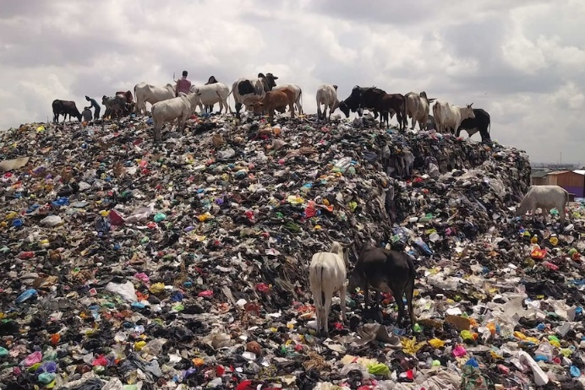  Link to image | 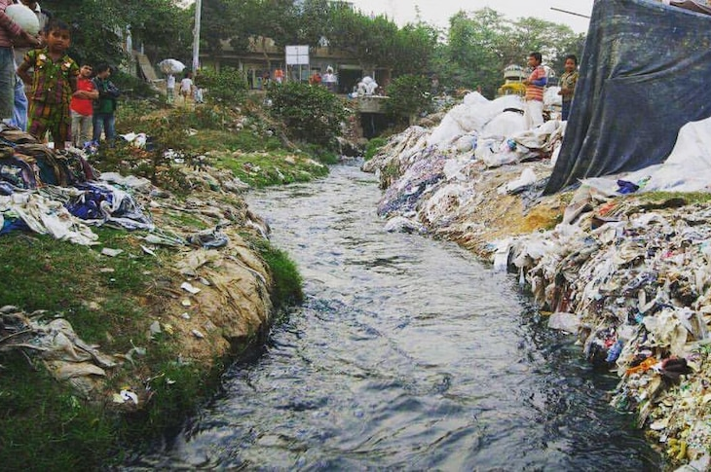  Link to image
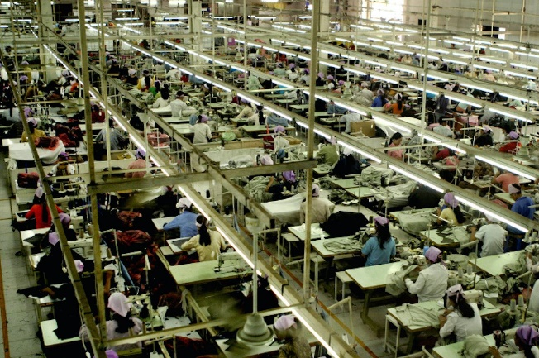  Link to image | 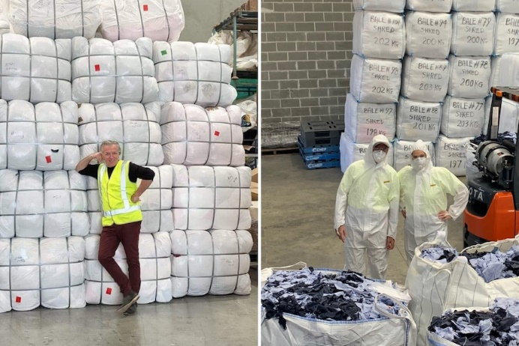  Link to image

Activity: TEDEd video
Consider the classic white t-shirt. Annually, we sell and buy 2 billion t-shirts globally, making it one of the most common garments in the world. But how and where is the average t-shirt made, and what’s its environmental impact?

As a class, watch this TEDEd video to learn more about the life cycle of a t-shirt. Students will then respond to one or more of the following questions.
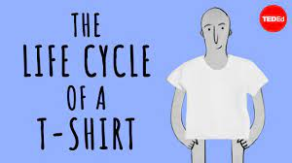
- How many t-shirts are made and sold each year globally?
- Where is cotton grown? Locate and highlight on a world map.
- How many litres of water is needed to produce enough cotton for one t-shirt?
- What negative impact does growing cotton have on the environment?
- How is organic cotton different to non-organic cotton?
TEDEd – The life cycle of a t-shirt

- List all the countries that may be involved in creating a t-shirt.

Activity: Where is my t-shirt made?
After watching the TedEd video students will choose one of their own t-shirts and investigate where it is made, what it is made from and who made it. Student will investigate where their clothes go when they throw them out and how they can reduce their impact on the environment.

Where is my t-shirt made? | Locate the ‘Made In’ label on one of your own t-shirts. Identify where your t-shirt is made. With your classmates locate and highlight each of the countries on a world map. What do you notice? Which countries are most popular for making your t-shirts?
What is my t-shirt made from? | Examine your t-shirt. Without looking at the labels what do you think it is made from? After you have made a prediction, examine the labels. Find out the following:  - What materials are used to make the t-shirt?  - Where do the materials come from?  - Where is the t-shirt made?  - Is the t-shirt and the materials used to make the t-shirt made in the same country?  - What else do you want to learn about your t-shirt? Investigate and record your findings.  Compare your findings with your classmates.
Who made my t-shirt? | Find out the brand of your t-shirt and conduct further investigation. Use the following to guide your investigation:  - What is the brand of your t-shirt? Does the company use sustainable materials? Explain.  - Who made your t-shirt? Find out more about the person who made your t-shirt. Consider contacting the brand to ask them who made your t-shirt.
How can I curb my t-shirt consumption? | Think of all the t-shirts you’ve owned in your life and then respond to the following questions:  - How many t-shirts do you own?  - What’s your favourite t-shirt?  - What do you do with t-shirts you no longer want? Find out what happens to your clothes when you throw them away.  - What can you do with your old t-shirt to avoid it going to landfill? Brainstorm ways you can upcycle your t-shirts. Use the internet to find out what other people are doing to upcycle their t-shirts.

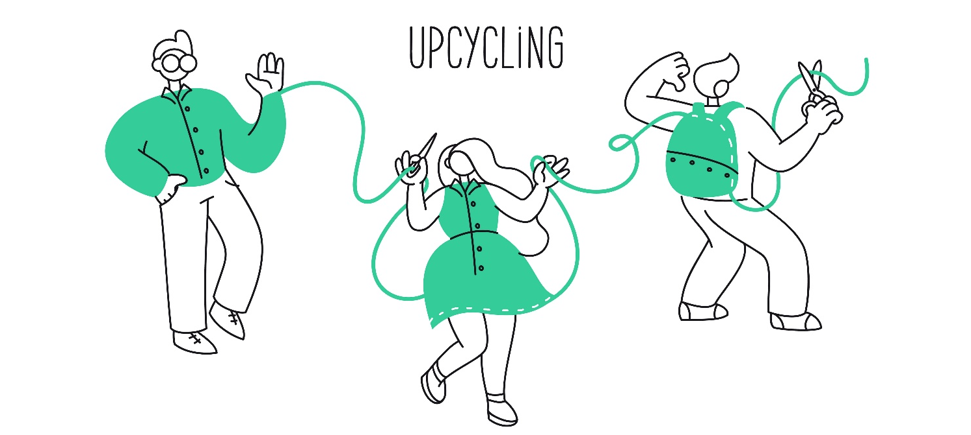

Useful Websites
- Big W and David Jones pledge cash to tackle waste, as rest of fashion industry told to follow – ABC News
- Seamless Scheme – Australian Fashion Council
- Fashion Waste – Newsbreak
- Fast Fashion – BTN
- Fashion Waste – BTN
- Why is fashion a BIG problem for the environment? – Newsround
- Sustainable fashion: How to be fashionable without harming the planet – Newsround

EPISODE 17
20th June 2023

KEY LEARNING
Students will develop an understanding of who is a refugee and why people become refugees. They will also explore the theme for Refugee Week 2023.

CURRICULUM
History – Year 3
Causes and effects of changes to the local community, and how people who may be from diverse backgrounds have contributed to these changes.

History – Year 6
The motivation of people migrating to Australia since Federation and throughout the 20th century, their stories and effects on Australian society, including migrants from the Asia region.

Civics and Citizenship – Year 4
Diversity of cultural, religious and/or social groups to which they and others in the community belong, and their importance to identity.

Civics and Citizenship – Year 7
How values based on freedom, respect, fairness and equality of opportunity can support social cohesion and democracy within Australian society.

  - Teacher Resource

Refugee Week 2023

Focus Questions
Discuss the BTN story as a class and record the main points of the discussion. Students will then respond to the following:
- Why did Fatima and Fariba leave Afghanistan?
- How many people around the world are refugees?
- When did the United Nations decide to set up an organisation devoted to taking care of refugees?
- What is the Refugee Convention?
- How many countries have signed the Refugee Convention?
- What do Fatima and Fariba like about living in Australia?

Before exploring this topic with your class, think about the students with refugee experience at your school and the sensitivities you will need.

Activity: See, think and wonder?
After watching the BTN Refugee Week 2023 story students will respond to the following:
- What did you SEE in this story?
- What did this story make you WONDER?
- How did this story make you FEEL?
- Think of three questions you have about the BTN story.

Activity: Note Taking
Students will practise their note-taking skills while watching the BTN Refugee Week 2023 story. After watching the story, ask students to reflect on and organise the information into three categories. What information in the story was...?
- Positive
- Negative or
- Interesting

Activity: Who is a refugee?
Working in pairs or small groups, students discuss the BTN Refugee Week 2023 story using the following questions as a guide. Watch the UNHCR Who is a refugee animation
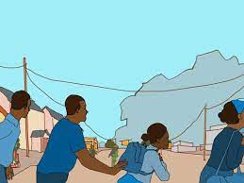
- Who is a refugee? How do they differ from asylum seekers and migrants?
- Why do people become refugees?
- Where do refugees come from? Look on a world map to find these countries.
- What challenges do refugees face when they leave their home country?
- How can we show empathy and support to refugees in our community?

Activity: Refugees Research
After watching and discussing the BTN Refugee Week 2023 story, what questions do students have and what are the gaps in their knowledge? The following KWLH organiser provides students with a framework to explore their knowledge on this topic and consider what they would like to know and learn.

What do I know? | What do I want to know? | What have I learnt? | How will I find out?

Students will develop their own question/s to research or choose one or more of the questions below. Encourage students to collect and record information from a wide variety of sources and present the information they find in an interesting way.

- How do refugees find safety and support in a new country?
- Which countries around the world resettle refugees and people in humanitarian need each year? What proportion does Australia accept? Display the information in a table.
- What are some misconceptions or stereotypes about refugees?
- How does the process of resettlement work for refugees?
- Choose a well-known person who came to Australia as a refugee. Create a biography about them that tells their journey.
- How can individuals and communities promote empathy and understanding towards refugees?
- Approximately how many refugees are there in the world? What is the role of the United Nations High Commissioner for Refugees (UNHCR) and how does it relate to Australia?

Activity: BTN Refugee stories
As a class watch one or more of the following BTN stories to learn more about the experiences of refugees. After watching any one of the BTN videos ask students to respond to the discussion questions (to find the teacher resources go to the related BTN Classroom Episode and download the Episode Package).

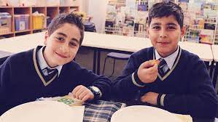  Syrian Refugee Family | 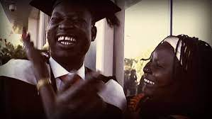  Refugee Journey | 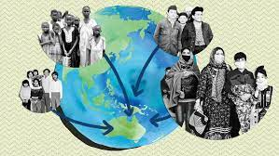  Refugees in Australia
Refugee Week 2019 | 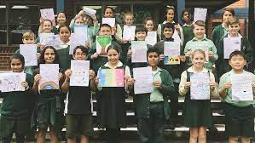  Letters to Refugees | 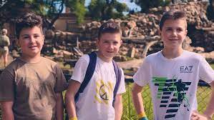  Journey from Ukraine

Activity: Syrian Journey – Choose your own escape
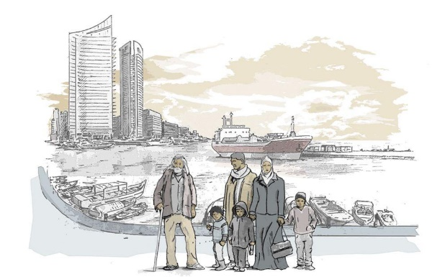
This interactive allows students to immerse themselves in the experience of being a Syrian Refugee. They can choose their own escape route from war-torn Syria to a safer place in Europe and face many challenges and tough choices on the way.
Syrian journey – Choose your own escape

Activity: 2023 Refugee Week
The theme for Refugee Week 2023 is Finding Freedom. Discuss as a class and record your student’s responses. Below are some questions to guide discussion.
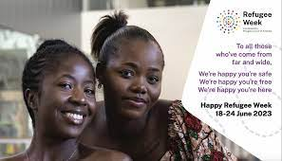
  - What does it mean to be free?
  - Why do you think the Refugee Council of Australia chose this theme?
  - How can we encourage Australians to improve our nation’s welcome for refugees? Share your ideas as a class.
  - Think of reasons why it takes courage to be a refugee. Think of reasons why it takes courage to speak out against injustice.
  - Students will design and create a poster to reflect the theme for Refugee Week 2023 and hold an art exhibition to present their artworks. The exhibition will celebrate the courage, resilience, strength and contributions of people of refugee backgrounds. Invite other classes to participate in the exhibition.

Organise your own Refugee Week event or activity at your school. Visit the Refugee Week website and download their resource kit for a guide on planning your own event.
  - Brainstorm ideas as a class.
  - What goals do you have for your event/activity? What are you trying to achieve?
  - What kind of event will you be holding?
  - Plan your budget – will you be fundraising?
  - Use your contacts – including your school community and local council.
  - Evaluate your event – how much of a success was it?

Activity: Celebrating Diversity
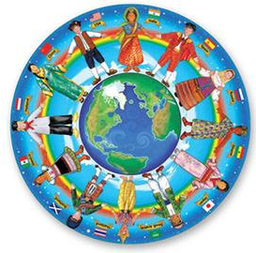
As a class, discuss the diversity in backgrounds, experiences, interests and age of people in your class and school community. Broaden your discussion and talk about your local community and Australia as a whole. Explain to students that developing positive relationships can help build a sense of belonging and inclusion. Provide a range of opportunities for students to share their personal stories to create an atmosphere of cultural respect and acknowledgement of diversity.
- What do you like about being part of your school community?
- What makes you feel safe in your school community?
- How do you welcome new students to your school community?
- What are some of your school’s values?
- Describe some of your school’s traditions. Why are they important?
- What are the advantages of belonging to a culturally diverse community?
- How does your school value and celebrate cultural diversity?

Useful Websites
- Refugee Week 2023 – Refugee Council of Australia
- World Refugee Day – UNHCR
- Refugees in Australia – BTN
- Refugee Week 2019 – BTN

  - Teacher Resource

BTN Transcript: Episode 17 - 20/6/2023

Hey, I'm Amelia Moseley and you're watching BTN. Thanks for hanging out with us again, let’s see what’s coming up on today’s show. Find out why this flu season is so dangerous, what we can do to stop old clothes ending up in landfill and celebrating Refugee Week.

Torres Strait Climate Case

Reporter: Joseph Baronio

INTRO: But first, we're heading to the Torres Strait where locals have teamed up to take the federal government to court. They don't think it's doing enough to protect their communities from climate change, and they want the government to act. Joe found out more.

These are the Torres Strait Islands north of Queensland, near Papua New Guinea, and the people who call this place home think it's pretty great. But even though it looks like a tropical paradise, they're facing a big problem. See, in recent years the islands have been battered by severe weather events and rising sea levels, and many locals reckon it's all to do with climate change.
UNCLE PABAI PABAI: I know that, and I believe that climate change is affecting my islands and my community. This is why I'm taking the government to the court.
Yep, you heard that right. Uncle Pabai Pabai and Uncle Paul Kabai are from the islands of Boigu and Saibai. They're suing the federal government because they reckon the government is responsible for protecting their communities from climate change, and say they aren't doing enough.
UNCLE PABAI PABAI: If I can take you down to the mainland Australia, where they've got a bushfire, they've got a flood in Australia, government quickly respond to that. And for the climate change happening here on my island, government don't respond to that, and, you know, that gives me, that significant ideas, so the government don't, don't really care for us.
So, what exactly is happening here? Well, locals say that more severe weather and rising sea levels creeping across the islands are destroying their homes, infrastructure, food sources and sacred cultural landmarks and gravesites. Many are even worried that in a few years some islands might disappear completely.
UNCLE PAUL KABAI: By 2029, most of low-lying islands in Torres Strait will go under water. Most of the elders here on the island, they say no we can't move. When Sabai go down, we'll go down. Things like this, that's why we say prime minister you come and see with your own eyes what's happening.
Uncle Paul and Uncle Pabai actually began this case back in October 2021, and now, nearly 2 years later, federal court representatives have made their way up to the islands. They visited different spots around the islands, where Uncle Pabai gave the court evidence of king tides flowing over the sea wall, and to show the court the coastal erosion caused by rising sea and wild weather.
UNCLE PABAI PABAI: We don't want to be a climate change refugees.
The government is already aiming for Australia to reach net zero emissions by 2050 but some climate experts think Australia's still not doing enough.
SIMON BRADSHAW, CLIMATE COUNCIL RESEARCH DIRECTOR: We see the sea level in the Torres Strait and surrounds rising much faster than the global average, we've already seen seas rise about six centimetres over the last decade. It's so critical that now, next year, through this make-or-break decade, we are doing far more to drive down our emissions.
Torres Strait locals hope that if they win the courts will order the government to step up their climate game. The government says it doesn't dispute the climate science and acknowledges that the Torres Strait Islands are vulnerable but also that it hasn't breached its duty of care. It's a complex case but residents reckon it's worth the fight for future generations.
BENNY DAU, BOIGU RESIDENT: I want to see changes done here on the island, not only for myself, but for my kids, and my kids' kids and our future generations to come. I believe that if the government will see how we live up here maybe they can do something about it and save what little we have left of our precious island.

News Quiz

It’s decided. Aussies will vote in their first referendum since 1999. The senate passed legislation this week to hold the big nation-wide vote on whether Australia should create an Indigenous Voice to Parliament. It'll be an independent body that can advise the parliament and government on matters that affect the lives of Aboriginal and Torres Strait Islander Australians. So, when does the vote have to happen? Next month, in the next six months or at the end of next year? The referendum has to happen in the next six months and no sooner than the next two months, but the exact date is the prime minister’s call.

Who is this former US President? Yup it’s Donald Trump. He faced a Miami court on 37 federal criminal charges after being accused of breaking the law by hiding top secret documents from his presidency in his Florida home. Mr Trump pleaded not guilty to all the charges and says it’s a ploy to affect his chances in the upcoming 2024 US presidential election. And while the timing for the trial isn't locked in yet, some experts reckon it won’t actually happen until after next year's November election.

What’s the name of this iconic band that rose to fame in the 1960s? It’s the Beatles. And despite only two members of the most famous pop band in the world still being alive they’re about to release their final song together thanks to AI. Sir Paul McCartney says the tech has been used to take John Lennon’s voice from an old demo to finish it decades after it was recorded and decades after he died. Kinda creepy, but fun.

And speaking of famous musicians, Beyonce is on her Renaissance World Tour right now. But in one country, the pop superstar was blamed for causing something unexpected. Was it traffic jams in Germany, high cost-of-living in Sweden or economic issues in New Zealand? Queen B was blamed for increasing the cost-of-living in Sweden. She started her world tour in Stockholm last month and that lead to higher demand for hotel stays and restaurant meals which pushed up prices at least according to some European economists.

Flu Season Concerns

Reporter: Joseph Baronio

INTRO: Flu season has started early and it's worse than usual for kids. Experts say one of the reasons is vaccination rates are down since COVID-19. Joe finds out more about the flu, and how we can better protect ourselves this winter.

ANNOUNCER: Alright, ladies and gentlemen, it's showdown time. In the red corner, standing at a very average height, we have jovial Joe. And, over there in the blue corner we have, oh, where is it? Oh, there it is. We have the furious flu. Alright, get set. Round one. Go. That was, um, too easy.
Yeah, the flu sure can pack a punch, and in 2023 it's come out swinging. See, even though the flu wreaks havoc every winter, health experts reckon that this year there's been a very early and quick rise in cases. In fact, more than a million Aussies have already battled the illness in 2023, and nearly 500,000 of them are people under the age of 14, with kids aged five to nine at the greatest risk.
Prof. Steve Robson, Australian Medical Association: It has been a major issue around the country. It's putting pressure on our public hospitals and there's still a lot of winter to play out yet.
So, why is the flu running rampant? Well, there are a few reasons, starting with our old friend, or enemy, I guess, COVID. During the pandemic there was much less exposure to the flu since people were spending more time inside, wearing masks, and just generally being more hygienic. There's also been a big drop in flu vaccination rates in young children, meaning that many kids are now being exposed to the flu virus for the first time and their bodies aren't prepared to protect them from infection.
See, our bodies rely on the immune system; a network of cells, chemicals, tissues, and organs which fights infections and diseases. Literally a bodyguard. Get it? Alright. If the flu gets the upper hand on our immune system, it can be really dangerous. People have died because of the flu or ended up in hospital.
Prof. Julie Leask, University of Sydney: Flu is a slightly unpredictable disease.
Mark Veitch, Tasmanian Public Health Director: It's a relatively frequent cause of hospitalisation of young children, from either influenza infection, exacerbation of asthma, bronchiolitis and the like, and children can get seriously unwell.
For our immune system to have the best chance at beating infections, it needs to know the game plan, which is where vaccines come in. See, vaccines contain a weaker version of the virus that essentially trains our immune systems to deal with it. So, health experts and officials across the country are encouraging young people and their parents to roll up their sleeves and get the jab.
Roger Cook, WA Premier: Get your flu jab, it protects you, it protects your family.
Danielle McMullen, Australian Medical Association: I know that everyone's a bit sick of talking about respiratory illness, but flu was definitely a deadly, life-threatening illness long before COVID was on the radar.
Prof. Steve Robson, Australian Medical Association: If you haven't been vaccinated, it is not too late, and it's a critical thing for your health.
Fashion Waste Scheme

Reporter: Justina Ward

INTRO: Some of the biggest brands in Australia have signed up to help deal with the huge amount of wasted clothing that ends up in landfill each year. But can we, as shoppers, do something about all that waste, too? Well, Justina found out.
JUSTINA WARD, REPORTER: Australia, we've got a big retail waste problem. Every year we each take home about 15 kilograms of new stuff. But we throw out about 90 percent of that in just 12 months.

And just 2 percent of the clothes we throw out are recycled with more than 200,000 tonnes of it ending up in landfill every year.
Paolo Bartolomei, Textile Recyclers Australia: It's just too much. And it's this constant need of new stuff, at the lower prices.
Leila Naja, Australian Fashion Council CEO: A huge part of it is cultural. If you look at influencers on social media and so on, it's all about wearing something new. You put it on, you know, for one occasion and you throw it away.
JUSTINA: This quick turnover of fashion trends, plus the move towards cheap, mass-produced clothing is something called fast fashion. Oh, see what I did there? Fast fashion? Anyway, it's the reason why we buy and throw away so many clothes. But clothes ending up in landfill isn't the only problem.
Making clothes uses a lot of natural resources, making the industry one of the biggest polluters in the world, accounting for about 10 percent of global carbon emissions and 20 percent of global water pollution. And to cut production costs a lot of companies have their clothes made in developing countries. Although it's created more jobs and helped grow the economies of those countries, it's also led to some big problems like poor working conditions, low wages, and forced labour.
JUSTINA: So, you can see why people say the way we make, use and throw away our clothes needs to change. Actually, I reckon I can make something out of this.
Now, the Australian Fashion Council has come up with a plan called Seamless, where retail brands give up 4 cents on every garment towards thing like recycling and reuse.
Tanya Plibersek, Environment Minister: There is no way on gods earth that Australian consumers are going to object to 4 cents on an item of clothing to stop it going into landfill.
If most brands join the scheme the AFC says it could divert around 60 percent of old clothing away from landfill by 2027.
Michael Scott, Rip Curl: We've got a responsibility to lead and we're really comfortable doing that.
But after asking 30 clothing brands to join the scheme only 6 brands have come on board, and the federal government says if more big brands don't get behind it, they'll face tougher regulation.
Tanya Plibersek, Environment Minister: You take charge, or I'll do it. This is your one-year warning.
The council hopes the scheme will drive the fashion industry towards clothing circularity by 2030, which is all about making clothes that last, making new materials out of old materials, and using what we have.
Leila Naja, Australian Fashion Council CEO: At the moment we have a linear model where we take, we use and we dispose, we need to move to a circular model where we rethink, we reuse and we recycle.
JUSTINA: But it's not all on the government and big brands, we need to change our shopping behaviour, too. I think I've got something like this at home already.
Leila Naja, Australian Fashion Council CEO: We’re going to actually work with consumers to help them, to educate them on how to maintain their clothing longer, how to ensure that the clothing doesn't end up in landfill.
Bianca Spender, Fashion designer: It's a problem that we've all been aware of and only together can we solve it.
So, what can we do to help?
student 1: Maybe try not to be as like cool all the time and maybe, like, keep some old clothes and not just throw them away straight away.
Student 2: Handing down your clothes to younger like family or friends.
Student 3: It's important to recycle because we only have a limited amount of materials.
Refugee Week 2023

Reporter: Lyeba Khan

INTRO: It's Refugee Week which is all about celebrating the amazing things refugees have contributed to our country and it’s about shining a light on some of the difficulties they face. Lyeba found out what it means to be a refugee and met some kids who now call Australia home. Check it out.

Fariba: I'm Fariba and I'm 12 years old.
FATIMA: Hi. My name is Fatima. I'm 11 years old.
Fatima and Fariba are close friends living in Adelaide. They love reading, dancing and playing soccer. But they still remember a time when things were different. You see, Fatima and Fariba came here as refugees.
Fariba: We came here because Taliban said that girls are not allowed to study and go to university. And also, it was not safe to live in Afghanistan, so, my uncle applied for a visa, and then we came here.
FATIMA: In Pakistan there was like fighting and my dad came earlier, and my dad applied for us to come to Australia, and we came by an aeroplane with my mum, my 4 older sisters, my one older brother and myself.
Fatima and Fariba aren't alone. There are about 35 million people around the world who are refugees, which means they've been forced to leave their home countries because of natural disasters, wars or mistreatment due to their race, gender or beliefs. Refugees often have to live in camps like this, or move from country to country, trying to find a safe home.
Sadly violence, disasters and persecution are nothing new, and there have always been refugees, but it was only in the 1950s that countries decided to work together to look after them. The Second World War forced a lot of people out of their countries. So, the newly created United Nations decided to set up an organisation devoted to taking care of refugees. It was called the UNCHR.
They also created the Refugee Convention, an international treaty that sets out what a refugee is, what rights they have, and what governments have to do to protect them. Things like, providing free access to the courts, identity papers, helping them settle into their new country and not sending them back to a dangerous place. More than 146 countries have signed onto the Refugee Convention, including Australia. Every year thousands of people arrive here as refugees.
Fariba: When I came here, I felt safe, very safe. And the people were very different. In Afghanistan, they sell fruit in fruit boxes, and we would buy it. In Australia they sell fruit in like plastics, I think.
FATIMA: When I came to Australia, I feel safe and very happy to live here. And it's a bit different from Pakistan, like, there are a lot of trees and beautiful flowers and the roads, and the shops are different than Pakistan.
While leaving their home was hard, Fatima and Fariba say they're really happy to be in Australia. But there are lots of other people around the world who are still looking for a safe place. They often don't have enough food, water or medicine, and kids can miss out on the chance to go to school. Refugee Week is about recognising their struggles, as well as celebrating all the great things refugees and former refugees have done throughout Australia's history. And it might surprise you to know just how many well-known Aussies arrived here that way, from entertainers, to scientists, to sports people. As for Fatima and Fariba, they've got their own big plans for the future.
Fariba: I want to be a doctor in the future.
FATIMA: In the future I'd like to be actress, K-pop dancer, doctor and lawyer.

Sport

International cricket's oldest rivalry, the Ashes, is well underway in England. The first innings of the first match turned out to be a pretty even contest. England scored quickly declaring at 8 for 393 on the first day. The Aussies got off to a bit of a shaky start, but a big hundred from Usman Khawaja, his first on English soil, helped them to a total of 386. There's a whole six weeks of this for cricket fans to enjoy, including the women's Ashes, which starts this week. It's a mixed format tournament and the Aussies are hoping for another big win, they haven't lost a series to England since 2014. The men's side are focused on retaining the ashes, too after coming off a big win at the World Test Championship.
The team for the 2023 Netball World Cup has been released with twelve players selected to travel to South Africa. The Diamonds will be led by captain Liz Watson and vice-captain, Steph Wood. They're favourites to win the World Cup which begins next month.
Finally, to these daredevils with fans on their backs. Okay, it's a bit more technical than that. This is paramotoring which is basically like motor powered paragliding and these pilots have been working hard to prepare for this glide about 200 metres above Egypt's great pyramids. They're hoping to promote the sport and get more paramotor enthusiasts on board before their next big event in October. Hm, maybe I should sign up.

Cattle Club

Reporter: Lyeba Khan

INTRO: And finally, today, students at a school in Victoria are getting some lunchtime lessons. They're taking part in Cattle Club, where they're learning how to raise and show cattle. Here's Lyeba.

Every Wednesday, this is how Isla spends her lunchtime.

STUDENT: This is Fiya. So, she's three years old this month.
She's part of Cattle Club, a program by Saint Francis of Assisi Primary School. She loves it, and she's not the only one.
STUDENT: So, I was like, aw, may as well give it a go, you know, so, once I started, I just couldn't stop because it was so much fun.
STUDENT: So, I tried, and I just couldn't stop.
TEACHER: They just love it. When's Cattle Club? Is Cattle Club on today?
The club raises a type of cow called Dexter cows, which only grow to around a metre tall. So, they're not too much of a handful, but they need all the attention and care of any other show cow.
TEACHER: The school initially bought two little bottle baby calves and realised they didn't really have the facilities to handle them. So, I was able to break those two little calves in with the kids. And then we grew into a Cattle Club, and then we started going to shows.
STUDENT: So basically, we train the cows, we practice our leading, we brush them, get them looking perfect and then every couple month there's like a show season. We get to take the cattle to shows and parade them around and it's just lots of fun.
TEACHER: Having such smaller animals, it's usually pretty interesting to see them out in the ring against the larger framed animals.
STUDENT: You get a lot of learning and stuff with how to deal with cattle and public speaking and stuff.
STUDENT: Well, I just love cattle in general. But I love like just showing off your animal once you've done all that hard work and stuff. So, yeah, just lots of fun, you know. And you learn a lot.
TEACHER: Alright, who’s got an under? Alright, can you show me the udder on Stormy?
STUDENT: He doesn't have an udder.
TEACHER: That's a trick question isn’t it. So, Stormy's a steer, he doesn't have an udder.
Younger grades, who aren't quite ready yet to look after cows, help raise goats.
STUDENT: Both of these goats are very, very, very fat.
STUDENT: He doesn't care about anything, he just cares about food.
STUDENT: Ay. Don't eat my jumper.
The school wants to get kids more involved with agriculture, which basically means anything related to farming and maybe one day, some of them will want to make it a career.
STUDENT: Yeah, 100 percent. Definitely something to do with cattle.
STUDENT: Like, sometimes once we've finished washing and drying them and stuff, they'll sit down in there, and we’ll just, they'll lay down and we'll just cuddle with them.
Closer

Well, that's it for this week. We'll be back next week with our final episode of the term, but until then, you can stay up to date with Newsbreak every weeknight and you can check out more content on our website. Have a really great week and I'll catch you soon. Bye.

