EPISODE 4
23rd February 2021

KEY LEARNING
Students will view a range of BTN stories and use comprehension skills to respond to a series of focus questions.

CURRICULUM
English – Year 4
Use comprehension strategies to build literal and inferred meaning to expand content knowledge, integrating and linking ideas and analysing and evaluating texts.

English – Year 5
Use comprehension strategies to analyse information, integrating and linking ideas from a variety of print and digital sources.

English – Year 6
Use comprehension strategies to interpret and analyse information and ideas, comparing content from a variety of textual sources including media and digital texts.

English – Year 7
Use comprehension strategies to interpret, analyse and synthesise ideas and information, critiquing ideas and issues from a variety of textual sources.
  - Teacher Resource

Focus Questions
As a class, discuss the stories featured in the episode of BTN Classroom and record the main points of the discussion. Students will then respond to the following focus questions.

Vaccine Q&A
- Discuss the BTN story as a class. Record the main points of your discussion.
- What is the name of the COVID-19 vaccine being given to people in Australia this week?
- Approximately how many different COVID-19 vaccines are being developed around the world?
  - 27
  - 270
  - 2,700
- How does the vaccine work?
- How many doses of the Pfizer vaccine has the Australian Government ordered?
- How many shots of the vaccine do you need to make it work?
- Who will be the first Australians to get the vaccine?
- Complete the following sentence. Most Australians will get AstraZeneca which will start to roll out in _________.
- The vaccines have only been approved for people who are 16 years old and over. True or false?
- What are some side effects of the vaccine?

Juice Health Star Rating
- Briefly summarise the BTN story.
- Who introduced the health star rating system?
- Why was the health star rating system introduced?
- Companies don't have to display their health star rating. True or false?
- What impact can too much sugar have on our health? Give an example.
- Why has orange juice been given a lower health star rating?
- Why are a lot of people in the fruit juice industry angry about the new health star rating?
- What is the different between eating one orange or drinking a glass of orange juice?
- It is recommended that children only drink half a glass of orange juice a day. True or false?
- What questions do you have about the story?

Check out the Juice Health Star Rating resource on the Teachers page.

Period Poverty
- Discuss the BTN story as a class. Record the main points of your discussion.
- TABOO is dedicated to changing peoples' attitudes towards periods. True or false?
- What is a period?
- When did Eloise and Isobel get the idea to start TABOO?
- What is period poverty?
- What per cent of girls in developing countries drop out of school as soon as they get their period?
  - 3%
  - 13%
  - 30%
- Where in Africa do the profits from TABOO go?
- How does the charity help girls in these countries?
- Which Australian state is about to make sanitary pads and tampons available for free in all public schools?
- How did this story make you feel?

Kaurna with Tiyana
- Retell the BTN Kaurna with Tiyana story to another student.
- Kaurna people are the traditional owners of which area in South Australia? Find on a map.
- Complete the following sentence. Since _______________ a lot of Indigenous languages have been lost.
- Why was the Kaurna language nearly lost?
- Who taught Tiyana how to speak Kaurna?
- How does Tiyana feel about teaching other kids about Kaurna culture and language?
- What does the Kaurna word for Torrens River mean?
- What does Ngai Nari mean?
- Who are the traditional custodians of the land in your local area?
- Find the words for ‘hello’ and ‘goodbye’ in the Indigenous language local to your area.

Check out the Kaurna with Tiyana resource on the Teachers page.

Museum Taxidermy
- What did the BTN Museum Taxidermy story explain?
- At what age did Jo start as a taxidermist at the museum?
- What is taxidermy?
- Why did people in the Victorian era taxidermy animals?
- Jo does not kill any of the animals that he is going to taxidermy. True or false?
- Explain the process of how-to taxidermy an animal.
- Why does Jo say that eyes are an important part of the taxidermy process?
- Why was an exhibit at the Melbourne Museum recently closed down?
- What was surprising about this story?
- What questions do you have about this story?

EPISODE 4
23rd February 2021

KEY LEARNING
Students will investigate the heath star rating system in Australia.

CURRICULUM
Health and PE – Years 3 & 4
Identify and practise strategies to promote health, safety and wellbeing.

Discuss and interpret health information and messages in the media and internet.

Health and PE – Years 5 & 6
Plan and practise strategies to promote health, safety and wellbeing.

Health and PE – Years 7 & 8
Investigate and select strategies to promote health, safety and wellbeing.

Evaluate health information and communicate their own and others’ health concern.

Plan and use health practices, behaviours and resources to enhance health, safety and wellbeing of their communities.

Mathematics – Year 6
Interpret and compare a range of data displays, including side-by-side column graphs for two categorical variables.

Design & Technologies – Year 5/6
Investigate how and why food and fibre are produced in managed environments and prepared to enable people to grow and be healthy.

Design & Technologies – Year 7/8
Analyse how characteristics and properties of food determine preparation techniques and presentation when designing solutions for health eating.
  - Teacher Resource

Juice Health Star Rating

Focus Questions
Discuss the BTN story as a class and record the main points of the discussion. Students will then respond to the following:
- Briefly summarise the BTN story.
- Who introduced the health star rating system?
- Why was the health star rating system introduced?
- Companies don't have to display their health star rating. True or false?
- What impact can too much sugar have on our health? Give an example.
- Why has orange juice been given a lower health star rating?
- Why are a lot of people in the fruit juice industry really angry about the new health star rating?
- What is the different between eating one orange or drinking a glass of orange juice?
- It is recommended that children only drink half a glass of orange juice a day. True or false?
- What questions do you have about the story?

Activity: Pre-viewing questions
Before watching the BTN Juice Health Star Rating story facilitate a class discussion using the following questions to get the discussion started:
- What do you know about the health star rating system?
- Why do you think we need a health star rating?
- How many teaspoons of sugar do you think are in a glass of freshly squeezed orange juice? Make an estimation and compare with your classmates.

Activity: Class Discussion
After watching the BTN story students will reflect on the story and then respond to the following:
- What do you THINK about what you saw in the BTN story?
- What did you find surprising or interesting about the story?
- Think of three questions you have about the BTN Juice Health Star Rating story.
- Why do you think BTN covered this story?

Activity: Inquiry based-learning
The KWLH organiser provides students with a framework to explore their knowledge on the issues explored in the BTN story and consider what they would like to know and learn.

What do I know? | What do I want to know? | What have I learnt? | How will I find out?

Students will develop their own question/s for inquiry about sugary drinks and the health star rating in Australia. Students will collect and record information from a wide variety of sources. Students may develop their own question for inquiry or select one of the questions below.

- What is a health star rating? Why do we need it?
- What is the difference between orange juice and diet cola? How many grams of sugar are in each? Explore, analyse and compare the nutrition labels for each product. Investigate the sugar content in other drinks. How do they compare? Rate the drinks from the greatest to least amount of sugar.
- Are all sugars the same? Explore the different types of sugar (i.e. fructose, sucrose, lactose, glucose). Give some examples of foods that you drink or eat that contain these sugars.
- Did you know there are many different names for sugar? Analyse a range of food packaging and make a list of different names for sugar. For example: Agave nectar, cane sugar, fructose, honey, maple syrup, rice bran syrup, sucrose.
- Is naturally occurring sugar healthier than added sugar?
What happens if you consume too much sugar? Investigate the impact that excessive sugar can have on your health. Create a poster which highlights the health problems.

Activity: Nutrition Labels
As a class collect a range of food packaging that includes nutrition labels and health star ratings if possible. Collect packaging from products within the same category. For example, your students could compare packaging from the following products:
- juice with no added sugar and diet cola
- juice with no added sugar and fruit drink
- flavoured yoghurt and plain Greek yoghurt
- 2 different types of cereal

Use the following as a guide, as students explore and analyse the food packaging. Students can work in pairs and then report their findings to the class. Materials needed include a range of packaging (recycled from home or the school canteen), sugar, a teaspoon, and cups.

Instructions:
- Explore the packaging that comes from products within the same category.
- Predict and record how much sugar you think is in each of the products.
- Locate the nutrition labels on the food packaging.
- How many grams of sugar are there per serving? Calculate and then measure the number of teaspoons there are of sugar in each serving.
- Compare the amount of sugar per 100 grams in each of the products. Which product has more sugar per 100 grams? Did you find your results surprising? Why or why not?
How many grams of sugar are there in 1 teaspoon?
- Is there a health star rating on the packaging? If so, record your findings.
- What else can you determine from the information provided on the nutrition label?
- Make a judgement as to what is the healthier food option.

Activity: Sugary drink intake
Students will keep a diary of their sugary drink intake for a week. Begin by asking students to think about drinks that may contain sugar. Collect some empty bottles of soft drinks, iced tea, fruit juice, flavoured milks and sports drinks and look at the nutrition information on the packaging. Ask students to look at the list of ingredients and identify the sugars. Explain they will be recording their sugary drink intake for a week including the grams of sugar in each drink they consume.

Day | Drink/s | Grams of sugar
Monday
Tuesday
Wednesday
Thursday
Friday
Saturday
Sunday
 | Total

After completing the activity students will respond to the following:
- What is the recommended daily intake of sugar for children?
- What is your daily sugar intake (from sugary drinks)? Is it above or below the recommended amount?
- What was surprising about the results?
- How could you reduce your sugary drink intake?
- What are some healthier alternatives?

Activity: Choose a project

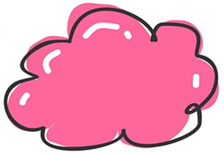

Meal Plan
Create a meal plan (for a day) which includes healthy food/drink options from the 5 food groups. Calculate the amount of sugar content in each meal. Ensure your meal plan does not exceed the recommend daily sugar intake for kids.
Campaign
Educate kids in your school about the sugar content in different drinks. Explain how sugary drinks affect the body. What drinks should kids avoid and which are healthy?

Classroom experiment
What impact do different drinks have on your teeth? Conduct this fun and simple experiment in your classroom with water, juice, cola and eggshells.
Is juicing good for you?
Compare the sugar content in a glass of orange juice and an orange. Experiment in the classroom. How many oranges are in a glass of juice? Analyse the results and make recommendations.

Useful Websites
- New heath star rating system ranks fruit juice below diet cold in shift to sugar-based grading – ABC News
- What you need to know about the health star rating on foods – ABC News
- Fresh Facts – BTN
- Health Star Rating System – Commonwealth of Australia

EPISODE 4
23rd February 2021

KEY LEARNING
Students will learn more about the local Indigenous languages where they live.

CURRICULUM
English – Year 3
Understanding that languages have different written and visual communication systems, different oral traditions and different ways of constructing meaning.

English – Year 4
Understand that Standard Australian English is one of many social dialects used in Australia, and that while it originated in England it has been influeced by many other languages.
English – Year 6
Understand that different social and geographical dialects or accents are used in Australia in addition to Standard Australian English.

History – Year 3
The importance of Country/Place to Aboriginal and/or Torres Strait Islander Peoples who belong to a local area.
  - Teacher Resource

Kaurna with Tiyana

Focus Questions
Discuss the BTN story as a class and record the main points of the discussion. Students will then respond to the following:
- Retell the BTN Kaurna with Tiyana story to another student.
- Kaurna people are the traditional owners of which area in South Australia? Find on a map.
- Complete the following sentence. Since _______________ a lot of Indigenous languages have been lost.
- Why was the Kaurna language nearly lost?
- Who taught Tiyana how to speak Kaurna?
- How does Tiyana feel about teaching other kids about Kaurna culture and language?
- What does the Kaurna word for Torrens River mean?
- What does Ngai Nari mean?
- Who are the traditional custodians of the land in your local area?
- Find the words for ‘hello’ and ‘goodbye’ in the Indigenous language local to your area.

Activity: See, think and wonder
After watching the BTN Kaurna with Tiyana story hold a class discussion, using the following as discussion starters:
- What do you THINK about what you saw in the BTN Kaurna with Tiyana story?
- What does this video make you WONDER about Indigenous languages?
- Think of three QUESTIONS you have about the story.
- What did you LEARN from the BTN story?

Activity: Class Discussion
Continue the class discussion, asking students to respond to the following questions:
- What language/s do you speak? Write a list of all the languages students speak in your class.
- What do you know about Indigenous languages?
- What Indigenous languages are spoken where you live?
- Why do you think it’s important to keep Indigenous languages alive?
- Why is preserving Indigenous languages difficult?
- What are the benefits of learning an Indigenous language?

Further Learning
Students research their own cultural heritage and the languages in their family history. Ask students if they think it’s important to celebrate cultural heritage and to know their family's languages and histories?

Activity: Local Indigenous Languages
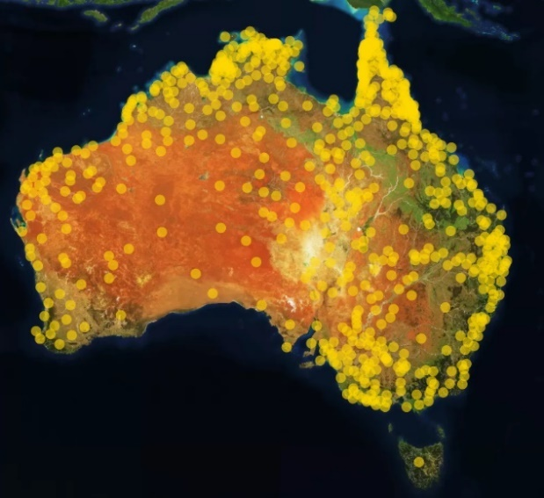
Who are the traditional custodians of the land where you live and what languages do they speak?

Students will learn more about their local Indigenous languages by exploring the Gambay – First Languages Map. Enter the place they live to find out the Indigenous languages in their area. Many of the Indigenous languages have videos or resources to support students to learn more about the language.
Learn words in your local Indigenous language! The 50 Words Project provides words in Indigenous languages. Use the map to search the local language and learn 50 words. All words have audio recordings provided by language speakers.

Further Learning
Invite an Indigenous language speaker to your school to learn more about the local languages.

Activity: Learn First Languages through song
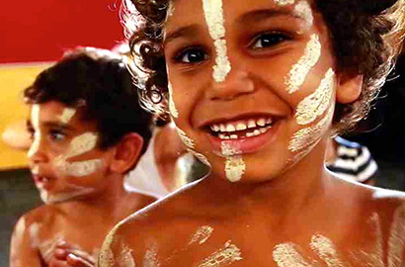
The Marrin Gamu song was created to introduce people to the diversity of Australia’s first languages. The song incorporates words from several different Indigenous language groups within Australia. Follow the instructions to get involved in creating and sharing your song.
- Watch the song and translate it into your local Indigenous language.
- Learn the song in your local language.
- Record a film clip of your song.
- Upload the video.

Activity: Learning our First Words on Country
Listen to the diverse languages, stories and Countries of Indigenous Australia in these Little Yarns audio resources. Teachers can check out the educators notes for ideas to get the most out of the Little Yarns podcast series.

Activity: This Place
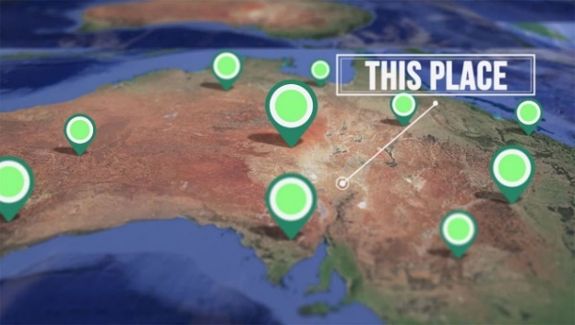
Around Australia, many places are known by their Aboriginal and Torres Strait Islander names. Indigenous communities share the stories behind place names of their country in the This Place series. Do you know the meaning of the place names where you live?

Students can explore the place names where they live using the Gambay interactive map.
Check out ABC Education’s English resources that explore Aboriginal and Torres Strait Islander culture. Learn about language conventions while discovering various Australian Indigenous languages and cultures.

BTN Indigenous Language Stories
Students can watch one or more of the BTN stories below to learn more about Indigenous languages.
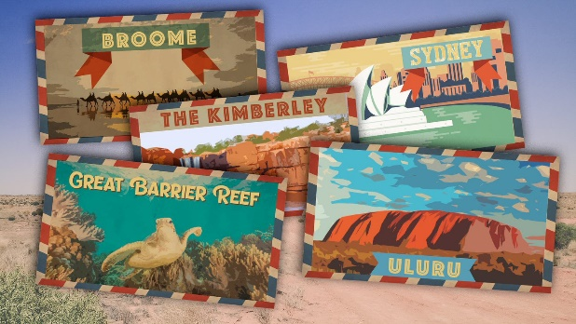  Indigenous Place Names | 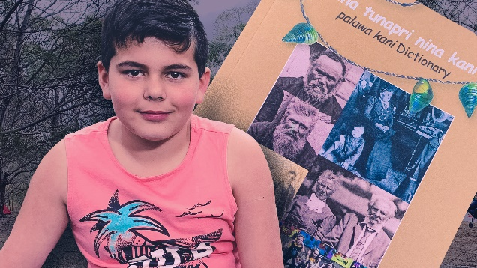  Palawa Kani
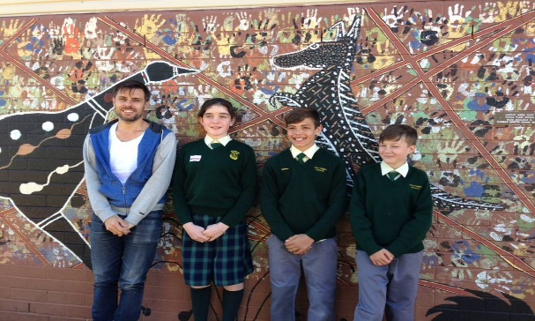  Indigenous Art and Language | 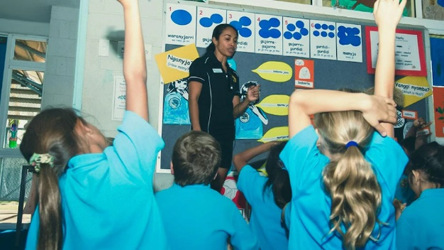  Indigenous Language Lessons

Useful Websites
- Kaurna for Kids – YouTube
- Gambay – First Languages Map - First Languages Australia
- 50 Words Project – University of Melbourne
- Little Yarns – ABC Listen
- Marrin Gamu – First Languages Song

  - Teacher Resource

BTN Transcript: Episode 4 - 23/2/2021

Aboriginal and Torres Strait Islander viewers are advised that the following program contains images and voices of people who have died.

Hey, I’m Amelia Moseley and you’re watching BTN. Here's what's coming up. We find out about the fight over fruit juice, meet a young YouTuber keeping her language alive and learn about the creepily fascinating art of taxidermy.

Vaccine Q&A

Reporter: Olivia Mason

INTRO: But, first today to the big story of the week, vaccinations. After a long wait Aussies have started rolling up their sleeves and getting a jab to protect them from the virus that's been making the 20s not much fun. So, this week we thought we'd answer some of your questions about the vaccine and what will happen next. Take a look.

It's the moment we've all been waiting for.
GREG HUNT, MINSTER FOR HEALTH: The eagle has landed.
After a really, well, average year and a monumental effort from scientists around the world, Australians are getting their first COVID-19 vaccinations. We figured you guys, like a lot of Aussies, might have some questions about it all.
DJANGO: Hi BTN, my question is how does the vaccine work?
You mean, vaccines. There are actually more than 270 of them being developed around the world. Whoa. But the two we're getting here in Australia were developed by Pfizer BioNTech and Oxford AstraZeneca. Like all vaccines they work by teaching your body how to fight coronavirus. The Pfizer vaccine does that using a brand new and pretty cool method involving mRNA a teeny tiny piece of genetic code that can sneak into cells and tell them to grow spikes just like a coronavirus. Your immune system sees that nasty looking thing and attacks it with an army of antibodies, which are now ready and waiting if the real thing comes along.
The Oxford AstraZeneca vaccine is a little bit different. It uses double stranded DNA instead of RNA and hides it inside a harmless virus. From there it's a similar story. It gets into cells and tells them to make spikes so your body learns how to fight the real thing.
AVA: I want to know how many vaccines Australia will get.
The Australian government has ordered 20 million doses of the Pfizer vaccine, which is enough to vaccinate 10 million of us. You need 2 shots to make it work. 142,000 doses have already arrived from overseas. The AstraZeneca vaccine will mostly be made here and the government's ordered around 54 million doses of it which means there's more than enough for all 26 million of us.
THOR: Who is going to get the vaccine?
The idea is we all will eventually. The first in line will be people that are most at-risk of coming into contact with the virus, like healthcare and quarantine workers or people who are more likely to get seriously sick if they get COVID. They'll all get the Pfizer vaccine, but most Australians will get AstraZeneca which will start to roll out in March.
ELLIE: I want to know when I will get the vaccine?
Well there's good news and bad news for kids. The good news is you're in a low-risk group when it comes to getting seriously sick with COVID-19. Nice. But that means you're at the end of the queue for a vaccine. At this stage, the vaccines have only been approved for people who are 16 and over so we're not sure when you'll get the jab, but probably towards the end of the year if authorities decide kids should have them.
AVA: Are the vaccines safe?
While they’ve been made in record time, that doesn't mean any safety checks have been missed along the way. Both the Pfizer and AstraZeneca vaccines have gone through lots of different tests in the lab and on thousands of volunteers. Plus, millions of people around the world have already had their jab. Australian authorities have also done their own research before approving the vaccines.
SCOTT MORRISON: Our vaccination program has the backing of Australia’s best medical experts.
While there have been side effects like headaches and tiredness, experts say it's usually really mild.
PETA: Will the vaccine work?
We're really, really hoping so. So far it looks like the Pfizer vaccine is about 95% effective and AstraZeneca is between 62 and 90 per cent, which is pretty good. There are some worries as the virus mutates, the vaccines might not be as effective on new strains which is why it's important to roll out the vaccines quickly, so we can hopefully get life back to normal.
Ask a Reporter

If you want to know more about the vaccines, you can ask me live on Ask a Reporter. Head to our website for all the details.

News Quiz

Which social media platform has banned Australians from sharing news? Twitter, WhatsApp or Facebook? It’s Facebook. It made the huge move because of some proposed Australian laws which would have forced Facebook and Google to pay news organisations for their content.

SIMON MILNER, FACEBOOK: What we’ve actively done today, we’ve done with a very heavy heart but, the law as it stands fundamentally misunderstands the way that news works on Facebook.

But the government was not impressed.

JOSH FRYDENBERG, FEDERAL TREASURER: Facebook sanctions were unnecessary. They were heavy handed, and they will damage its reputation here in Australia.

What’s the name of NASA’s robotic rover that landed on Mars last week? Is it Curiosity, Perseverance or Opportunity? It’s Perseverance. Now its job is to roll around this ancient lakebed hunting for signs of life and collect rock samples that hopefully, one day, will be brought back to Earth.
Can you name this Southern US state that’s been shivering through unusually cold weather? It’s Texas. The usually balmy state has been blanketed with snow and thousands of people lost power and running water. Other parts of the US and Europe have been hit by dangerously cold weather, which is the result of a polar vortex bringing cold air from the Arctic.

And Mount Etna has been earning its reputation as one of the world’s most active volcanoes, spewing out lava and ash. What country is it in? Italy, Indonesia or New Zealand? It’s in Italy.

Juice Health Star Rating

Reporter: Amelia Moseley

INTRO: Now to a juice fight. Recently there's been a lot of debate about some changes to Australia's health star rating system that have seen juices lose some of their stars. Let's find out more.
What's your favourite juice?
KID 1: Apple juice.
KID 2: Tomato juice.
KID 3: Orange juice.
KID 4: Pineapple juice.
KID 5: Grapefruit juice.

KID 6: Cranberry juice.
AMELIA, REPORTER: Umm, prune juice?
KIDS: Prune juice, ew.
Well, whatever sort of juice is your jam, a glass of sweet, fruity goodness has been an Aussie favourite for a long time. But Australian juices are set to lose some of their star power here at the supermarket.
AMELIA, REPORTER: All fruit and veggie juices are about to drop down to 2.5 stars on the health star rating system. You know the one. You can find it right here on lots of processed and packaged foods at the supermarket.
It's a system that the government brought in a few years back to help shoppers make healthier choices. A product gets fewer stars for higher amounts of saturated fat, salt and sugars. But it gains stars the more fibre, protein, fruit, veggies, nuts and legumes or beans you have in your product. That's worked into an overall score out of five from as healthy as it gets to a sometimes food. Companies don't have to display their rating but a lot of them do. Recently, there was a big review into these little stars, which recommended more of a focus on this stuff when rating foods, sugar.
Experts say too much of it can lead to obesity and serious health problems. And that's where these come in. You see, fruit juice has quite a bit of sugar in it, naturally, even when it hasn't been sweetened. It's why it'll soon have a lower health star rating than diet cola, which uses artificial sweetener instead of sugar. But that's made a lot of people in the fruit juice industry really angry.
Kevin Cock, Sunraysia Citrus Grower: The fact that they've rated orange juice the same as or worse than soft drink. I really can't explain what sort of committee would've made that decision.
Even though there's sugar in juice there is also a lot of healthy stuff like vitamins and minerals and some say that's way better than drinking diet soft drinks that are made with chemicals and aren't nutritious. But hang on, that's not to say that drinking a lot of this is the healthiest option.
AMELIA, REPORTER: You see, to make a whole bottle of this, you need this many oranges which contains about this much sugar. But if you eat just one orange, you'd have this much juice and just this much sugar, plus all of this lovely pulpy stuff right here is full of fibre, which helps your body absorb the sugar and fills you up more.
Of course, drinking juice is quicker, easier and less messy which is part of the reason why it's popular. But experts say it's definitely a sometimes drink.
LEANNE ELLISTON, NUTRITION AUSTRALIA: If you do have fruit juice, limit to only half a cup a day. Anything more than half a cup is just too much sugar to consume at once.
Some fruit juice brands say they might choose to remove the star rating from their packaging altogether, but others reckon the system needs to change again to take all of a food or drink's nutritional value into account. But that could get pretty complicated. Who knew these little stars could cause so much controversy? At least there's one thing no one's arguing about. Water is still a solid five stars.
Quiz

Which of these fruit have the least amount of sugar? Apples, strawberries or grapefruit? It's strawberries. They also have heaps of fibre in them and they're delicious which makes them a pretty good snack, really.

Period Poverty

Reporter: Olivia Mason

INTRO: Now to South Australia which is about to become the second state in the country to provide free sanitary products to all public schools. It's a move designed to tackle something called period poverty. Liv found out what that is and met some young Aussies who've dedicated their lives to fighting it.
KID 1: It's surprising because it jumps up on you. So you could be shy about it. You could be confident saying like, wow, I'm finally growing.
KID 2: Girls can easily be embarrassed about them, it's new to them. It's weird. It's their lives are changing.
OLIVIA MASON, REPORTER: Yep, periods, they're something that half the population experiences. But not everyone's comfortable talking about them.
ELOISE HALL, TABOO CO-OWNER: I think attitudes around menstruation or periods is different everywhere. So, a lot of people are really comfortable with the conversation. There are some people who are quite ashamed about the topic and don't really feel comfortable talking about periods.
Eloise and Isobel are definitely not those people, they're the founders of TABOO, a not-for-profit company dedicated to changing peoples' attitudes towards periods.
OLIVIA: For those who might not know, what is a period?
ISOBEL MARSHALL, TABOO CO-OWNER: The uterine lining, so the lining of the uterus is made up of like this thick blood material, and every month that sheds so that a new landing can be created. And the purpose is so that if a baby was to be born and develop in that uterus, it's got the right environment to grow in the nutrients.
The idea for Taboo came about when Isobel and Eloise were in high school and they learnt about period poverty. That's when people don't have access to or can't afford sanitary products which can make life really difficult.
ISOBEL: We learnt that in other countries, 30% of girls in developing countries drop out of school as soon as they get their period. So for us, that was a real wake up call.
ELOISE: So, we thought, why don't we sell our own products and use that profit to go back into supporting these girls.
They donate all of the money they make to a charity that helps girls in Sierra Leone and Uganda get an education and learn how to manage their periods. But they say period poverty isn't just a problem overseas.
ELOISE: Thankfully, in Australia, there's a higher expectation that people should have access to this product. But unfortunately, that's not always the case when you're in a financially restraining situation.
They say it's especially important that kids can access sanitary products whenever they need them without feeling embarrassed.
ELOISE: So often they'll conceal the fact that they do have their period and use things like toilet paper or whatever else they might have access to instead, which is obviously not very dignified, and it's not comfortable. And it shouldn't be something that we rely on.
That's why they're really happy that their home state South Australia is about to make sanitary pads and tampons available for free in all public schools. It follows Victoria's move to install free pad and tampon vending machines in schools.
DAN ANDREWS, PREMIER VICTORIA: I really think this probably should've happened a long time ago.
ELOISE: We know that the lack of pads does prevent a lot of girls from going to school. So, we're really excited to see that girls can walk into school and know that there's something there for them if they get caught out.
And these girls agree.
KID 1: I personally think it's a great program. It helps teenagers and older with cost concern, as some people can't afford pads and tampons for outside of school and school itself.
KID 3: It means that people might feel a bit more comfortable when they get it for the first time.
KID 4: I think it's a good idea because some people might not be prepared.
KID 2: A lot of girls go through period poverty when they don't have enough money to get supplies for their periods. And so this will be good for them.
Isobel and Eloise would like to see similar schemes all around Australia. They also want workplaces to offer free pads and tampons because they say women and girls should never have to feel caught out or embarrassed by this natural part of life.

Kaurna with Tiyana

Rookie Reporter: Tiyana

INTRO: Did you know Sunday was International Mother Language Day. It’s all about celebrating the thousands of languages that we humans use to talk to each other. Today you're going to meet a kid who's been helping to preserve one of Australia's Indigenous languages by teaching it to others. Here's Tiyana.

TIYANA: Niina Marni BTN. Ngai nari Kangkapina. Ngai Kaurna Warra Tirkalirkala. Okay, let me translate that to English. "Niina Marni BTN" you might have guessed, that means "Hello BTN". "Ngai Nari Kangkapina" that means "My name is". "Kangkapina" which means "The Caring One" that’s my Kaurna name, but you can call me Tiyana. "Ngai Kaurna Warra Tirkalirkala" that means "I'm a learner of Kaurna Language".
Kaurna is the language of the Kaurna people, including my family. They're the traditional owners of Adelaide and the Adelaide Plains. There are hundreds of different Indigenous languages here in Australia. But since colonisation, a lot them have been lost and Kaurna was nearly one of them. Kaurna people were forced from their traditional land and were forbidden from speaking their own language, and because of this it was nearly lost.
But thanks to a team of passionate people, the language was brought back to life. I learnt to speak Kaurna from my mum. She and the KWP team create Kaurna resources at the University of Adelaide. She and my grandmother have made videos for people to learn Kaurna words and so have I. I wanted to make these videos to show little kids and share my culture. It makes me feel happy and proud of myself knowing that I've done this and I’m teaching people. I know that my mum and my Nan are really proud of me.
If you've ever been to Kaurna country, you might have seen a few Kaurna words without even realising. Some places have even been given dual names, which means they have an English name and a Kaurna name. For example, there is a big river that flows through Adelaide, the Torrens River. But I know it as Karrawirra Parri which means red gum forest river.
There are a couple of words that I reckon you guys could learn right now. Let’s start with "Ngai Nari" which means "my name is" "Ngai Nari". "Ngaityalya" which means "thank you" "Ngaityalya". And lastly "Nakutha" which means "See you later". Nakutha.

Did You Know?

Did you know different languages have different words for animal sounds? For example, in English we say dogs go “woof woof”, of course, but in Japanese they say, “wan wan”. In Albanian pigs go “hunk hunk” and in Spanish roosters go “ki-keriki”.
Sport

After a massive two weeks of competition, the Australian Open is over. Novak Djokovic, the clear men's favourite, and world number 1 defeated Daniil Medvedev in straight sets in just one hour and 53 minutes.
Naomi Osaka got it done in straight sets as well, beating Jennifer Brady 6-4, 6-3. So how did she celebrate?

NAOMI OSAKA: I just washed my face and tried to go to sleep.

Hmm. Well, that's one way to do it.
And Dylan Alcott gave us Aussies something to cheer about when he absolutely thrashed world number 3 Dutchman Sam Schroder 6-1, 6-nil.

DYLAN ALCOTT: I still feel really lucky to be here, and I’ll play on at 3am on the carpark to be honest, because it’s a privilege to come out here every time and get an opportunity to play the Australian Open.
Museum Taxidermy

Reporter: Amelia Moseley

INTRO: Finally, today to taxidermy the art of preserving dead animals. It's been in the news after Melbourne Museum closed its much-loved taxidermy exhibit. But that doesn't mean dead animal displays are, dead. Let's find out more.

AMELIA, REPORTER: Tigers, monkeys, polar bears, lions, elephants, they're all here. But many of these creatures died centuries ago. But here they are living on in a way for everyone to see. I guess that’s the magic of taxidermy.
It's the art of preserving a dead animal's body for display. And for at least 500 years, it's been a somewhat strange, but popular thing to do to our dearly departed friends.
AMELIA, REPORTER: Now I know what you're thinking. Well, I know what you’re thinking, why? Well, I know exactly who to ask. A real-life taxidermist.
Jo’s been preserving animals here since he was 15.

JO BAIN, TAXIDERMIST SA MUSEUM: Hi Amelia how are you doing?
AMELIA, REPORTER: Hi Jo. Thanks so much for having me here. This is amazing. Well, I guess my first question for you as a taxidermist is, why do we do this?
JO BAIN, TAXIDERMIST SA MUSEUM: Well, taxidermy is a very old art, it has a very long history and originally it was to aid zoologists in describing new animals from distant lands. They were travelling to all corners of the globe, they were bringing back all this material to be described scientifically. Now, during the Victorian period, people thought, wouldn't it be great to have an elephant in the dining room? And so, they went out, got these animals and Victorian taxidermists made a huge business putting these things in everyone's houses, and it became quite the thing, every house had to have their taxidermied items.
While dead animals in the dining room isn't as fashionable as it used to be. Jo says taxidermy is still a great way to learn about animals without the risk of getting eaten or anything. And don't worry, Jo doesn't kill any of them. In fact, some of these guys lived long lives at the local zoo.
JO BAIN, TAXIDERMIST SA MUSEUM: So, we try and take animals that have died of natural causes, present them in museums so people can understand what they do, where they come from, and why they're important.
It can take anywhere from a day to months to make creatures come to life. First, they have to be fresh and free from decay, so they're kept in this freezer. The insides are removed, and the skin is treated with chemicals. Then very carefully glued and sewn over a foam body, like this one. And then it’s time for the finishing touch.
JO BAIN, TAXIDERMIST SA MUSEUM: Starting with eyes you start here.
AMELIA, REPORTER: Wow. Look at that. That's amazing.

When anyone looks at someone else the first thing they look at is their face and it’s the same with animals and faces portray character and you can deduce a lot about that animal by looking at the face. I really like the owl eyes.

AMELIA, REPORTER: Yep, I can see that.
Of course, taxidermists have sometimes stuffed it up. For example, the extinct dodo didn't really look like this but for a long-time people thought they did based on some bad taxidermy. And then there's Melbourne Museum's famous Sad Otter. It was part of the museum's Wild display, which recently closed after many years. Part of the reason was that taxidermied animals need a lot of care and protection from insects. See, Adelaide's sad bunny.
JO BAIN, TAXIDERMIST SA MUSEUM: And that's what two weeks of clothes moths can do to a mounted animal.
Jo says it helps a lot that most of his museum's animals are behind glass. But these guys are only one part of Jo's job. As a taxidermist he also puts together skeletons and makes replicas. And while taxidermy might seem like a dying art, ha ha. Jo says it's definitely a career to consider if you're interested in the business of giving creatures a second life.
JO BAIN, TAXIDERMIST SA MUSEUM: Pictures in books are fine and movies are great. But standing next to the animal, there's nothing like it.
Closer

What a cool job. Well, that's it for this week but we'll have another show for you soon that's stuffed with good stories. And in the meantime, you can jump online whenever you like to check out more stories or specials or daily episodes of Newsbreak. And if you're 13 or over you can subscribe to our YouTube channel where there's heaps of extra stuff. I'll catch you next week. Bye.

